Statistical Data Analysis Using R
Question Bank – Solved Study Material
SY B.Tech • PCCOE Pune • AY 2026-27 • Summative exam (30 marks)

Unit I – Understanding Data and Installation of R
Unit II – Data Wrangling
Unit III – Data Visualization
Unit IV – Data Analysis

How to use this material
Summative exam: 30 marks, 1 hr 15 min, 4 questions (one block per unit), all compulsory, with options inside Q3 and Q4. Questions carry 2, 4 or 5 marks.
Question | Parts | Marks
Q.1 (compulsory) | A: i), ii) B: i), ii) | 5 + 2
Q.2 (compulsory) | A and B | 4 + 4
Q.3 | A: any one of i)/ii) B: compulsory | 5 + 2
Q.4 | Any two of A, B, C | 4 + 4

How long should my answer be?
Marks | Write about | Must include
2 marks | 4–6 lines (≈50–70 words) | Definition + 2 key points or one example
4 marks | ≈ 1 page (≈120–160 words) | Definition, 4–5 points, a diagram or table if it fits
5 marks | 1–1.5 pages (≈160–220 words) | Intro, 5–6 points / steps, labelled diagram, example, short conclusion
6 marks | 1.5 pages (≈220–260 words) | Everything for 5 marks + comparison table or worked example

Exam tips: underline key words, draw neat labelled diagrams (they earn marks even when text is short), use point-wise answers, and end long answers with a one-line conclusion. The green "Remember" boxes give a short trick to recall each answer.

Contents
How to use this material 2
Contents 3
Unit I: Understanding the data and Installation of R 14
Q1. Explain the importance of data in R programming 14
Q2. What are the advantages of storing data in a data frame? 14
Q3. Why is it important to check the structure of a dataset? 14
Q4. How can you load a .csv file in R? Write syntax of the same. 15
Q5. Write syntax to check inbuilt dataset in R; also write the command to check details of any dataset out of it. 15
Q6. How do you install and load a package in R? 15
Q7. How can you load a .xls/.xlsx file in R? OR How to import an Excel or CSV file in R, write all the steps in detail? 16
Q8. Write syntax to check inbuilt dataset in R; also how to view a particular dataset 16
Q9. Tell the use of any two of following Easy commands from base R package a. str(dataset name) b. summary(dataset name) c. View(dataset name) 17
Q10. data.frame() is important command in base R package. Explain this command with syntax and one example 17
Q11. data.frame() is important command in base R package. Explain this command with syntax and one example 18
Q12. Import the dataset credit data to R studio and check its summary. Save it as a data frame `CD'. Identify the Columns having missing values. 18
Q13. Find minimum, maximum and average price of houses from data set Indian Houses. 18
Q14. You want to view the minimum, mean, median, and maximum values for all columns in the airquality dataset, including how many missing values are present. Apply single R command to view this? 18
Q15. Write a command to display all unique plant names from the Plant column in the CO2 dataset. 19
Q16. Identify the error in the following code used to display the first six rows. In data "students". head[students] 19
Q17. Identify the error in the following code used to access the Age column in data "students". students(Age) 19
Q18. Identify the error in the following code used to display the first six rows. In data "students". head[students] 19
Q19. Identify the error in the following code used to access the Age column in data "students". students(Age) 20
Q20. Write the command to display students who scored more than 75 marks. 20
Q21. Write the command to calculate the average marks in data "students". 20
Q22. Write an R command to find the length of a vector x 20
Q23. Write an R command to find the number of rows and columns in the data "students". 20
Q24. Identify the error in the following code used to access the second row. students(2, ) 21
Q25. What is data? What is the difference between data and information? Explain importance of data analysis. 21
Q26. What is data analysis? Explain steps of data analysis. 21
Q27. What are the methods of data collection? Describe in details. 22
Q28. What is the difference between quantitative and qualitative data? Explain their subtypes. 23
Q29. What are the advantages of R programming amongst all. 24
Q30. What are applications of Data Analysis? Explain in detail. 24
Q31. Give introduction of R software and describe GUI of R-studio 25
Q32. What is difference between R software and R-Studio 25
Q33. Explain all four windows of R-studio along with their functioning 26
Q34. Write in detail about `Environment Window'. In a dataset what is the meaning of observation and variable. 26
Q35. Explain nominal, ordinal, discrete, and continuous data in detail with examples. 27
Q36. Explain working of the following commands with syntax 1. rbind 2. as.factor 3. Replace_na 4.class 5. is.numeric 6.cbind() 28
Q37. Sample data (picture of the mtcars dataset viewed in RStudio) 28
Q38. Consider the inbuilt dataset mtcars and answer the following questions. i)Write the R command to display only the mpg, cyl, and hp columns. 29
Q39. Write the R command to display cars having 6 cylinders. 29
Q40. Write the R command to arrange the cars in descending order of mpg. 29
Q41. Write the script/commands for the following: How to access inbuilt dataset in R? Select one of the dataset storms' and View it. Which commands can be used to find structure of the dataset storms' and also write the command to find the statistical summary of the same dataset. Write the command to get first few observations of `storms' data set 30
Q42. Write the step wise process of primary data collection for any one of the following topic: a. Effect of Social media on young generation b. Health habits of working women 30
Q43. Access the inbuilt data `airquality' and answer the following questions: Whether this data set has NA values? How many NA values are there? At what places? 31
Q44. What is the difference between apply(), lapply(), and sapply()with examples. 32
Q45. A data frame named mtcars_data contains the built-in mtcars dataset. Write R commands to: i) Export the data as mtcars.csv without row names. ii) Export the data as an R data file named mtcars.RData. iii) Save the data frame as an RDS file named mtcars.rds. 33
Q46. Write the step wise process of primary data collection for any one of the following topic: a. Effect of Social media on young generation b. Health habits of working women 33
Q47. Access the inbuilt data `airquality' and answer the following questions: Whether this data set has NA values? How many NA values are there? At what places? 33
Q48. What is the difference between apply(), lapply(), and sapply()with examples. 34
Q49. A data frame named mtcars_data contains the built-in mtcars dataset. Write R commands to: i) Export the data as mtcars.csv without row names. ii) Export the data as an R data file named mtcars.RData. iii) Save the data frame as an RDS file named mtcars.rds. 34
Q50. Sample data (picture of the mtcars dataset viewed in RStudio) 34
Q51. Identify the car with the maximum horsepower 34
Q52. Count the number of cars with automatic transmission (am = 0). 34
Q53. Store all cars with gear >= 4 in a new data frame called selected_cars. 35
Q54. Identify the errors in the following R commands and rewrite them correctly. head[mtcars, 10] and mean[mtcars$mpg] 35
Q55. Identify the errors in the following R commands and rewrite them correctly mtcars(mtcars$cyl == 8, ) and mtcars[, mpg, hp] 35
Q56. Correct the following code snippets. Incorrect Code: i) mtcars(mtcars$mpg > 20, ) ii) mtcars[, mpg, hp] iii) mtcars[mtcars$cyl = 6, ] iv) mtcars[mtcars$hp > 100] v) mtcars$Efficiency == mtcars$mpg / mtcars$wt 35
Q57. Identify and correct the errors. i) write.csv[mtcars, "cars.csv"] ii) read.csv("cars.csv", row.names = FALSE) iii) setwd("D:\R_Data") iv) write.csv(mtcars, "cars.csv", row.names = TRUE) v) saveRDS(mtcars, "cars.rds") followed by read.csv("cars.rds") 36
Quick Revision – Unit I 37
Unit II: Data Wrangling 38
Q1. State any two differences between the unite () and gather () functions in R 38
Q2. What different commands can be used to identify the `NA' values from the dataset? Write any two commands with proper syntax. 38
Q3. Describe the function and syntax of the commands: 1. Slice 2. mutate 3.group_by 4.arrange 5. Summarise 38
Q4. What is the command to extract data from the top 30 rows of `airquality'? 39
Q5. Write a command to get the month wise average of wind speed for `airquality' 39
Q6. Check whether NA values are there in `Parking' variable. Also find count of NA values. 39
Q7. Convert Placement data into data frame, and verify whether minimum and maximum values of all percentage are same or different 40
Q8. What is the average salary as per the gender 40
Q9. How many students are there who are having more than 70% in MBA; what is average salary of these students. 40
Q10. Write a command to extract data , row wise from 101 to 250 rows from dataset `mpg' 41
Q11. If the given data is `table1' write syntax to spread population year wise 41
Q12. Consider the inbuilt dataset mtcars in R. i)Write the R command to select cars having mpg greater than 20. ii)Select only the columns mpg, cyl, and hp from the dataset. 41
Q13. Consider the inbuilt dataset mtcars in R. i) Arrange the cars in descending order of hp. ii) Find the average mpg for each cylinder group (cyl). 42
Q14. Consider the inbuilt dataset iris. 1. Extract the observations where Species is "setosa" and Sepal.Length is greater than 5. 2. Select Sepal.Length, Petal.Length, and Species. 42
Q15. Consider the inbuilt dataset iris. i)Arrange the data in ascending order of Petal.Length. ii) Calculate the average Petal.Width for each species. 42
Q16. Consider the inbuilt dataset airquality, which contains daily air-quality measurements. 1. Identify the rows where Ozone is greater than 50. 2. Display only the columns Ozone, Solar.R, and Temp. 43
Q17. Identify the error in the code to remove rows containing missing values from airquality. library(tidyr) airquality %>% drop_na(Ozone = Solar.R) 43
Q18. Identify the error in the code to calculate average tooth length for each supplement type in ToothGrowth. ToothGrowth %>% group_by(supp) %>% summarise(avg_len = mean(len, na.rm = FALSE)) %>% arrange(avg_len, decreasing = TRUE) 43
Q19. Correct the code to combine Sepal.Length and Sepal.Width into a new column named Sepal_Size. iris %>% unite(Sepal_Size, Sepal.Length + Sepal.Width) 44
Q20. Correct the code to replace missing values in Ozone with the mean of the available values: airquality$Ozone[is.na(airquality$Ozone)] = mean(airquality$Ozone) 44
Q21. Define Data wrangling. Explain the processes in data wrangling in detail. Also, write advantages of data wrangling. 44
Q22. Which commands are used in the `dplyr' package? Describe any two with their purposes and syntax with an example. 45
Q23. Which are commands used in package tidyr to make data tidy? Explain its uses and syntax 46
Q24. What is tidy data? Differentiate between purposes of gather and unite command with their syntax. 47
Q25. What is the main objective of the package dplyr' in the data analysis process? Give any two commands from dplyr' with examples 48
Q26. Write uses and difference between commands: gather and unite. 48
Q27. How many semi-furnished houses are having more than 4 parking? Write the command for this. 49
Q28. Write the code to find the count of houses as per locality? 49
Q29. What is average price of the Indian houses according to Transaction? 50
Q30. Calculate the average percentage of Operating Systems, Programming, and Algorithms observed for each suggested job role 50
Q31. Create a new data with following properties, Remove the unnecessary variable 32 and 36 and extract students with good coding skills rating greater than 5 50
Q32. Create a data without applying any filter consider observation 101 to 200 containing only percentage with suggested job 51
Q34. Consider the inbuilt dataset ChickWeight. 1. Extract observations where weight is greater than 200. 2. Select the columns weight, Time, and Diet. 51
Q35. Consider the inbuilt dataset ChickWeight. i) Find the average weight for each diet. ii) Arrange the average weights in descending order. 51
Q36. Refer the dataset healthcare_data' and write the commands to get the new data for the following: Create a subset of above dataset for age' greater than 65 and save as H1. Use H1, to find mean of bmi' as per categories under gender'. 52
Q37. Refer the dataset healthcare_data' and write the commands to get the new data for the following: 1. Create a subset of above dataset for age' greater than 65 and save as H1. 2. Use H1, to find mean of bmi' as per categories under gender'. 53
Q38. For the dataset airquality'-Write command to get a new data 1. Find average of Ozone' for wind speed greater than 7.5 2. Sort the data for "month" in descending order and remove if any NA values. 53
Q39. Write the code for the following: Import the given dataset of car_price_prediction, do we need to change the data type for a few variables? If yes, change the data type (Paste the code generated in console). Extract the number of observations from 101-250 from the given dataset and create a new file Data1'. Generate multiple columns using Gear.box.type as a Key column and Price as a Value column and save it as a new data frame Data2'. 54
Q40. Consider the data of A data frame with 234 rows and 11 variables. It contains only models which had a new release every year between 1999 and 2008 - this was used as a proxy for the popularity of the car. Explain the method stepwise to get a data by the manufacturer audi' and class compact' , exclude column year' and drv' 54
Q41. Cluster the columns of inbuilt dataset 'billboard' into Week and its Value; where billboard dataset has 317 observations and 79 columns about Song rankings for billboard top 100 in the year 2000 55
Q42. Following is the data for IndianHouses'. Which command can be used to extract average price of houses and standard deviation as per the Furnishing' status. Write the syntax for it. 56
Q43. Using iris Dataset Write a single R command using the pipe operator (%>%) to: 1. Select flowers with Petal.Length greater than 4. 2. Retain only Sepal.Length, Petal.Length, and Species. 3. Group the data by Species. 4. Calculate the maximum Petal.Length for each species. 5. Arrange the results in descending order of maximum petal length. 57
Q44. Consider the inbuilt dataset Titanic, which is a four-dimensional contingency table. 1. Convert the Titanic table into a data frame. 2. Rename the columns Freq and Survived to Frequency and Survival_Status, respectively. 3. Display only the records where Survival_Status is "Yes" and Frequency is greater than 50. 58
Q45. Consider the inbuilt dataset USArrests. 1. Convert the row names (state names) into a separate column called State. 2. Select the states where Murder is greater than 10. 3. Calculate the average Assault value for each group formed by categorizing UrbanPop as "Below 50" or "50 and Above". 4. Arrange the results in descending order of average Assault. 58
Q46. Consider the following dataset student (Student, Branch, Math, Science: Amit COMP 85 78; Neha IT 72 NA; Ravi COMP NA 82; Priya IT 65 70; Karan COMP 90 NA; Sneha IT NA 85; Raj COMP 75 88; Pooja IT 80 NA). Write R command to 1. Count the number of missing values in Math and Science for each branch. 2. Replace missing Math marks with the branch-wise average Math marks. 59
Q47. Write R command to (Use above data) 3.Replace missing Science marks with the branch-wise average Science marks. 4.Calculate the average Math and Science marks for each branch after replacing missing values. 60
Q48. Consider the dataset employee (Emp_ID, Department, Gender, Salary, Experience: 101 HR F 45000 3; 102 IT M 65000 5; 103 IT F NA 7; 104 HR M 50000 NA; 105 Sales F 48000 4; 106 Sales M NA 6; 107 IT M 80000 NA; 108 HR F NA 5). Write R command to: 1.Count missing Salary and Experience values department-wise. 61
Q49. Write R command to: 2.Replace missing Salary values with the median salary of the respective department. 3.Replace missing Experience values with the mean experience of the respective department. 62
Q50. Write R command to: Find the maximum salary and average experience for each department after handling missing values. 62
Quick Revision – Unit II 63
Unit III: Data Visualization in R Software 64
Q1. Using visualization show number of houses according to their 'Type'. 64
Q2. Visualize the relation between area and price according to their furnishing status with title 'Relation between Area and Price'. Also comment on Area depends on price. 64
Q3. Find which jobs profiles are suggested more and also compare it with visualization with appropriate plot 65
Q4. By visualization check whether percentage of Operating system and communication are related for this new data 66
Q5. Plot the graph for 'mba_p' and 'salary' as per the 'workex' by omitting NA values if any and put suitable labels (Use Placement Data) 66
Q6. Find the graph of 'specialization' as per the placement 'status' and put suitable labels (Use Placement Data) 67
Q7. Explain the following any two plots by their uses and interpretation: I. Bar-plot II. Violin plot III. Scatter Plot 68
Q8. Create a data frame 'Student_count' (group: Arts 30, Commerce 23, Science 16, Engineering 21), and get a Pie chart by ggplot showing strength of the students as per group. 68
Q9. Differentiate between the following plots as per the data type also explain how this plot can be interpreted: 1. Boxplot 2. Histogramme 3. Barplot 4. Scatterplot 69
Q10. Write syntax to get the following plot for data 'mpg' (stacked bar chart titled "Composition": x = factor(cyl), fill = factor(gear)) 70
Q11. What combination of carat, cut, color, and clarity results in the highest diamond prices? 71
Q12. Create a data to get count of diamonds to get color variations across different clarity grades. (Use data Diamonds) 71
Q13. How many diamonds exist in the dataset for each color grade, compare it. (Use data Diamonds) 72
Q14. Does the impact of carat weight on price differ depending on the diamond's cut quality (Fair, Good, Very Good, etc.)? 72
Q15. 500 students are enrolled for sports as follows (Cricket 121, Baseball 90, Hockey 110, Athletics 91, Chess 88). Write the code to describe the participation with Pie chart. Also, tell significance of Pie chart for Data visualization. 73
Q16. How does the distribution of diamond color vary across different clarity grades, and which color grades are more in all clarity categories? 74
Q17. What is the relationship between a diamond's carat weight and its price? Does the price increase linearly with carat? 74
Q18. Identify the error and rewrite the correct code to create a scatter plot using the mtcars dataset. ggplot(mtcars, aes(x = wt, y = mpg)) + geom_point 75
Q19. Identify the error and rewrite the correct code to create a scatter plot using the iris dataset. ggplot(iris, aes(x = Sepal.Length, y = Petal.Length)) + geom_point(color = blue) 75
Q20. Identify the error and rewrite the correct code to give a title to the scatter plot. ggplot(mtcars, aes(x = wt, y = mpg)) + geom_point() + ggtitle = "Weight vs Mileage" 75
Q21. Differentiate between geom_point() and geom_line() with suitable applications. 76
Q22. Comment on frequency according to the status of the houses and show it with a graph. Also give title 'Count of House as per Status' for the graph 76
Q23. Why is ggplot used as an effective package for data visualization? Describe all the components of ggplot 77
Q24. Whether suggested job roles are affected by extra courses done, visualize it and comment on the same 78
Q25. What is the Jitter plot? Explain uses of it? Write a syntax to get the following Jitter plot for variable 'cyl' and 'displ' of 'mpg' data. If the same command runs multiple times is there any change observed in the output plot? 79
Q26. What information can be obtained from a box plot? Explain with suitable points 79
Q27. Find the trend between two variables 'etest_p' and 'mba_p', and put suitable labels. What inference can be derived from it. 80
Q28. Write the R syntax to: 1. Create a scatter plot with wt on the X-axis and mpg on the Y-axis. 81
Q29. Write the R syntax to: 1. Display the count of each flower species. 2. Give different colours to the bars. 3. Add the title "Flower Species Count". 82
Q30. Write the R syntax to: 1. Display Petal.Length for each flower species. 2. Create a box plot. 3. Give the boxes a green fill colour. 83
Q31. Write the R syntax to: 1. Display Sepal.Length on the X-axis. 2. Display Petal.Length on the Y-axis. 3. Represent each species using a different colour. 83
Q32. Identify the error and rewrite the correct code to create a scatter plot with different colours for different species. Incorrect code: ggplot(iris, aes(x = Sepal.Length, y = Petal.Length)) + geom_point(color = Species) 84
Q33. Write the R syntax to: 1. Display date on the X-axis. 2. Display unemploy on the Y-axis. 3. Draw the line in blue colour. 85
Q34. What is the relationship between a diamond's carat weight and its price? Does the price increase linearly with carat? 85
Q35. Write syntax to get the following plot for data 'Sales' (scatter plot of x vs y with points coloured by group A, B, C) 86
Q36. Write 5 inferences from following Boxplot for Frequencies of passenger as per their gender and Class in Titanic. 86
Q37. Write interpretation of the following plot (box plot "Miles per Gallon for All Vehicles") 87
Q38. Write interpretation of the following plot (stacked bar chart "Compare sales strategy": Products A–D for Strategies 1–5) 88
Q39. Write interpretation of the following plot (density plot of mpg by factor(gear)) 89
Q40. Write interpretation of the following plot (scatter plot of Sales vs Temperature °C) 89
Q41. The following table shows the mean and standard deviation of car mileage (mpg) based on transmission type (Automatic: mean 27, SD 2.3; Manual: mean 18.1, SD 4.17) for the dataset mtcars in R. Write any four inferences based on the mean and standard deviation. 90
Q42. The following table shows the mean and standard deviation of ozone concentration based on month from the inbuilt dataset airquality in R (May 23.62/22.22, June 29.44/18.21, July 59.12/31.64, August 60.00/39.68, September 31.45/24.14). Write any four inferences based on the mean and standard deviation. 91
Q43. The following table shows the mean and standard deviation of tooth length based on supplement type (OJ: 20.66, SD 6.61; VC: 16.96, SD 8.27) from the inbuilt dataset ToothGrowth in R. Write any four inferences based on the mean and standard deviation. 91
Q44. Write four inferences based on given boxplot (shootarea for nitrogen levels low, medium, high). 92
Q45. Density Plot showing 'price' distribution as per 'number_of_doors' and coefficient of skewness for price distribution as per number of doors is given (four: 1.574059, two: 1.935925) for the data set 'Car_Price'. Write a syntax to get following plots and coefficient of skewness for price as per number of doors and also comment on the skewness of the price 93
Q46. Find the mistake in the code and rewrite again to generate the given graph. Also write inferences for it. ggplot(bodyPerformance, aes(x = height_cm, y = weight_kg)) + geom(color = "purple") + facet_wrap(gender) + labs(title = Height vs. Weight, xlab = "Height (cm)", ylab = "Weight (kg)") 93
Q47. Write three inferences for the following plot for 'mtcars' dataset where mpg is miles per gallon and wt is weight. Also, write the command to obtain the given graph 94
Q48. Identify the error and correct the following code to create a scatter plot of Sepal.Length against Petal.Length, with different colours for each species. ggplot(iris, aes(x = Petal.Length, y = Sepal.Length)) + geom_point(color = Species) 95
Q49. Correct the code to display a histogram of mpg with a density curve. ggplot(mtcars, aes(x = mpg)) + geom_histogram(fill = "orange") + geom_density() 96
Q50. Correct the following code to display the relationship between disp and mpg with a linear regression line. ggplot(mtcars, aes(x = disp, y = mpg)) + geom_point() + geom_smooth(method = lm, se = FALSE) 97
Quick Revision – Unit III 98
Unit IV: Data Analysis 99
Q1. What is significance of skewness and kurtosis in data analysis 99
Q2. If for two groups of employees, data of dispersion for High-Income and Easy-income Earners is as follows (SD 100,000 and 5,000; CV 16.66 and 14.28; Mean 600,000 and 35,000). If the number of observation are same in both the groups which measure of dispersion to be used. Write inferences from the following table. 99
Q3. If for two groups of employees, data of dispersion for High-Income and Easy-income Earners is as follows. If the number of observation are same in both the groups which measure of dispersion to be used. Write inferences from the following table. 100
Q4. If for two groups of employees, data of dispersion for High-Income and Easy-income Earners is as follows. If the number of observation are same in both the groups which measure of dispersion to be used. Write inferences from the following table. 100
Q5. Describe the relationship between the variables 'car_price' and 'horsepower' of engine in the following scatter plot, also write syntax to get following plot if data set name is 'Car_price' 100
Q6. What is the correlation coefficient? How would it help in the understanding of the relationship between two variables? 100
Q7. Write the code to generate the following corrplot for 'airquality' data set. Comment on the correlation of Ozone with other variables. 101
Q8. What is the use of sampling in inferential statistics? Explain methods of sampling. 101
Q9. What is the difference between probability and nonprobability sampling? 102
Q10. Write an R command to calculate the skewness of the variable mpg from the inbuilt dataset mtcars. 102
Q11. Identify the error in the following R code and rewrite it correctly. library(moments); skewness(mtcars) 103
Q12. Consider the following R code: library(moments); x <- c(10, 20, 30, 40, 50, 60); result <- skewness(x); print(result). What is the purpose of the skewness() function? 103
Q13. Write an R command to calculate the skewness of the variable Ozone from the airquality dataset after removing missing values. 103
Q14. Write an R command to calculate the kurtosis of the variable mpg from the mtcars dataset. 103
Q15. Identify the error in the following R code and rewrite it correctly. library(moments); kurtosis(iris) 104
Q16. Consider the following R code: library(moments); x <- c(5, 10, 15, 20, 25, 30); k <- kurtosis(x); print(k). What does the kurtosis() function measure? 104
Q17. Consider the following output: library(moments); x <- c(10, 20, 30, 40, 50); skewness(x). What can you infer about the distribution? 104
Q18. Consider the following output: library(moments); x <- c(10, 12, 15, 18, 50); skewness(x). What does positive skewness indicate? 104
Q19. Write an R command to calculate the correlation between mpg and disp variables from the inbuilt dataset mtcars. 105
Q20. Identify the error in the following R code and rewrite it correctly. cor(mtcars$mpg, disp) 105
Q21. What is the role of measures of central tendency in descriptive statistics? What are the criteria to use either of mean, median or mode as central tendency for the given data? 105
Q22. What is significance of measure of variability in Data analysis. Explain standard deviation in detail. 106
Q23. For data set 'Car_price' write a syntax to get correlation of the following variable and also below correlation plot. Comment on the correlation of all variables with 'price' 107
Q24. A data set provides measurements of the diameter, height and volume of timber in 31 felled black cherry trees. Following is data of descriptive analysis (Std.Dev, Min, Q1, Median, Q3, Max, MAD, IQR, CV for Girth, Height, Volume). Make inferences from dispersion measures for variables Girth (Diameter), height and Volume 107
Q25. Write syntax to get average of 'Freq' as per the 'Class' for dataset 'Titanic' which has shown in table (1st 40.625/58.08, 2nd 35.625/54.27, 3rd 88.250/124.59, Crew 110.625/235.51). Freq shows number of passengers as per class. Comment on variation in frequencies Class wise 108
Q26. How Skewness and Kurtosis will help to describe distribution of the data. Write syntax to get values of Skewness and Kurtosis for distribution of variable 'wind' [that describes speed of wind] of the dataset 'storms'. 109
Q27. Correlation matrix of 'storms' data is given (wind, pressure, lat, long). Write inferences from the correlation matrix. 109
Q28. Explain uses of qnorm, pnorm and dnorm commands for probability distribution 110
Q29. A data set provides measurements of the diameter, height and volume of timber in 31 felled black cherry trees. Standard deviation of diameter, height and volume is as given (3.138, 6.372, 16.438). Also its graphical representation in histogram is given. Comment about the central tendency and dispersion in data of all three variables 111
Q30. A data set provides measurements of the diameter, height and volume of timber in 31 felled black cherry trees. Following is Correlation Matrix for numerical data (Diameter–Height 0.519, Diameter–Volume 0.967, Height–Volume 0.598). Comment about correlation ship among variables 111
Q31. Write the code to generate the following corrplot for 'mtcars' data set, where mpg: miles per gallon, cyl: number of cylinders, hp: horsepower of engine, wt: weight of engine. Comment on the correlation of mpg with other variables. 112
Q32. What is regression analysis? What is the importance of regression analysis in data analysis? Write syntax to find regression analysis between one dependent and one independent variable from a dataset 113
Q33. The following table shows the mean and standard deviation of car mileage (mpg) based on transmission type (Automatic 17.15, SD 3.83; Manual 24.39, SD 6.17) for the dataset mtcars in R. Write any four inferences based on the mean and standard deviation. 113
Q34. The following table shows the mean and standard deviation of diamond prices (in USD) based on cut quality for the diamonds dataset in R. Write any four inferences based on the mean and standard deviation. 114
Q35. The following table shows the mean and standard deviation of tooth length based on supplement type (OJ 20.66, SD 6.61; VC 16.96, SD 8.27) for the inbuilt dataset ToothGrowth in R. Write any four inferences based on the mean and standard deviation. 114
Q36. Write a program to get correlation matrix for the data 'storms' given below. Assume that there is NA values present in the data. Also find corrplot with correlation matrix. (Mention required package) 115
Q37. First 5 entries from data 'msleep' related to the mammals sleep dataset of carnivore, omnivore or herbivore. Write a syntax to visualize the relation between sleep_total and bodywt. Also comment on it. 116
Q38. Write a syntax to get average of 'sleep_total' and average & coefficient of variation of 'bodywt' as per eating nature (vore). Compare variation of bodywt as per vore type. 116
Q39. A data set provides measurements of the diameter, height and volume of timber in 31 felled black cherry trees, coefficient of kurtosis and density curves are given below (Girth −0.71, Height −0.72, Volume 0.25). Write minimum 3 comments on distribution of the data based on kurtosis 117
Q40. 'faithful' is the data set involving 'waiting' [time between eruptions] and 'eruptions' [the duration of the eruptions] for the Old Faithful geyser. Statistical Analysis is given in the table (eruptions: skewness −0.4158, kurtosis 1.4994, mean 3.488, SD 1.141; waiting: skewness −0.4163, kurtosis 1.8574, mean 70.90, SD 13.59). Also, related graphs are given. Write the inferences based on skewness and kurtosis. 118
Q41. The CO2 uptake and concentration of six plants from 'Quebec' and six plants from 'Mississippi' was measured at several levels of ambient CO2. Correlation matrix plantwise is given below (Quebec r = 0.710, Mississippi r = 0.471). Write a syntax to get this output and also comment on correlation. 118
Q42. Write a syntax to get following statistical analysis of average of 'sleep_total' and 'bodywt', similarly coefficient of variation 'bodywt' as per eating nature (vore) of the 'msleep' dataset. Compare variation of bodywt as per vore type. 119
Q43. What is the difference between standard deviation and coefficient of variation? After conducting a systematic investigation on high-income earners and low-income earners in a community, a researcher has the following results (SD $100,000 and $5,000; CV 16.66 and 14.28; Mean $600,000 and $35,000). Then Analyse the outcomes. 120
Q44. Take into account the data below (As a sample first 6 observations are given), where there are 5 different types of trees (Tree, age, circumference). Create a programme that will yield the mean, median, and standard deviation for each form of tree. 120
Q45. A regression model is applied on 'storms' data set for variable 'Pressure' as dependant variable and 'wind' as independent variable. Write syntax to get this regression model. Write Null hypothesis and inferences from the given summary of the regression model. 121
Q46. For variables concentration and uptake a data set 'CO2', summary of the regression model is given below. Comment on dispersion of residual, accuracy of the model and dependency of the variable (Residuals: Min −358.75, 1Q −177.93, Median −92.14, 3Q 140.33, Max 735.11; RSE 260.3 on 82 df; R² 0.2354, Adj R² 0.2261; F 25.25 on 1 and 82 DF, p = 2.906e-06) 122
Q47. Comment on below outputs of simple linear regression model for 'p value', 'R Squared', residual and their distribution (lm(Volume ~ Height, data = trees)) 122
Q48. Following is the output of regression model applied for 'airquality' dataset where Ozone is dependent variable and Temp and Wind are independent variables. Write syntax for this regression model and also write the inferences from the given summary 123
Q49. A regression model is applied on the dataset "mtcars" with mpg as dependent variable and disp as independent variable. Write the R syntax for the following output and any two inferences based on the output. 124
Q50. A regression model is applied to the dataset diamonds in R, with price as the dependent variable and carat as the independent variable. 1. Write the R syntax to fit the regression model. 2. Write any two inferences based on the regression output. 124
Quick Revision – Unit IV 125

Unit I: Understanding the data and Installation of R

Q1. Explain the importance of data in R programming
Easy • CO1
Data is a collection of raw facts and figures (numbers, text, dates) that R stores, cleans, analyses and visualises. R is built mainly to work with data, so data is the starting point of every R program.
1. Basis of analysis – every statistical test, model or graph in R needs data as input.
2. Decision making – results from data (averages, trends) support correct decisions.
3. Data structures – R keeps data in vectors, factors, matrices, lists and data frames, so it can handle any type of data.
4. Reproducibility – data plus an R script gives the same result every time.
5. Built-in datasets such as iris, mtcars, airquality help in learning and testing.
Remember: No data, no analysis: data is the fuel, R is the engine.

Q2. What are the advantages of storing data in a data frame?
Easy • CO1
A data frame is a two-dimensional table in R where rows are observations and columns are variables; each column can have a different data type.
1. Mixed data types – numeric, character, factor and logical columns in one table.
2. Easy access – df$col, df[row, col], df[df$Marks > 75, ].
3. Like a spreadsheet – easy to read, view with View() and import/export (CSV, Excel).
4. Works with packages – dplyr, tidyr, ggplot2 and modelling functions such as lm() all take data frames.
5. Quick summaries – str(), summary(), head(), nrow() work directly.
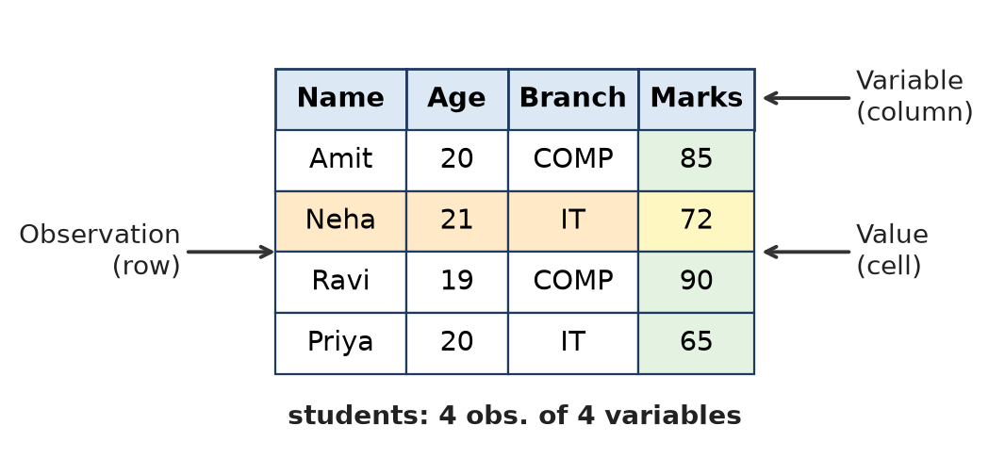
Figure: Parts of a data frame
Remember: Data frame = Excel sheet inside R: rows = cases, columns = variables.

Q3. Why is it important to check the structure of a dataset?
Easy • CO1
Checking the structure means seeing the size, column names, data types and sample values of a dataset, usually with str(df) or glimpse(df).
1. Know the size – number of observations (rows) and variables (columns).
2. Check data types – a number stored as character (e.g. "1,200") must be converted before calculation.
3. Find factors – categorical columns should be factors for grouping and plotting.
4. Spot problems early – NA values, wrong formats, extra columns.
5. Choose correct methods – e.g. mean for numeric, frequency table for categorical.
str(airquality) # 'data.frame': 153 obs. of 6 variables
Remember: Check the structure before you analyse, just as a doctor checks the pulse before treatment.

Q4. How can you load a .csv file in R? Write syntax of the same.
Easy • CO1
A CSV (Comma Separated Values) file is loaded with the base R function read.csv() (or read_csv() from the readr package).
Syntax: df <- read.csv("path/file.csv", header = TRUE, sep = ",")
setwd("D:/R_Data") # set working folder (use / not \)
students <- read.csv("students.csv", header = TRUE)
head(students) # view first 6 rows
# or choose the file from a dialog box
students <- read.csv(file.choose())
- header = TRUE – first row has column names.
- RStudio way: Environment → Import Dataset → From Text (base/readr).
Remember: read.csv reads it, head() checks it.

Q5. Write syntax to check inbuilt dataset in R; also write the command to check details of any dataset out of it.
Easy • CO1
R comes with many built-in (inbuilt) datasets in the datasets package.
data() # lists all built-in datasets
data(package = "dplyr") # datasets of a particular package
data(mtcars) # load a dataset
?mtcars # help page: description of all columns
help(mtcars) # same as ?mtcars
str(mtcars) # structure: 32 obs. of 11 variables
summary(mtcars) # statistical summary
head(mtcars) # first 6 rows
- ?dataset or help() gives the details (source, meaning of each variable).
- str() and summary() give the structure and statistics.
Remember: data() to list, ? to learn, str() to look inside.

Q6. How do you install and load a package in R?
Easy • CO1
A package is a collection of R functions, data and help files (e.g. dplyr, readxl, ggplot2). It is installed once and loaded in every new session.
install.packages("dplyr") # 1. install once from CRAN (needs internet)
library(dplyr) # 2. load in every session
require(dplyr) # also loads; returns TRUE/FALSE
installed.packages() # list installed packages
update.packages() # update packages
- RStudio way: Packages tab → Install → type name → Install, then tick the box to load.
- Package name is in quotes in install.packages() but not needed in library().
Remember: Install once (buy the book), library every time (open the book).

Q7. How can you load a .xls/.xlsx file in R? OR How to import an Excel or CSV file in R, write all the steps in detail?
Easy • CO1
Excel files are read with the readxl package; CSV files with read.csv().
Steps (Excel):
1. Install the package: install.packages("readxl").
2. Load it: library(readxl).
3. Set the working directory: setwd("D:/R_Data").
4. Read the file: df <- read_excel("houses.xlsx", sheet = 1) (works for both .xls and .xlsx).
5. Check it: head(df), str(df), View(df).
Steps (CSV): df <- read.csv("houses.csv") then check with head(df).
RStudio menu: Environment → Import Dataset → From Excel / From Text → Browse → preview → Import (RStudio also shows the code).
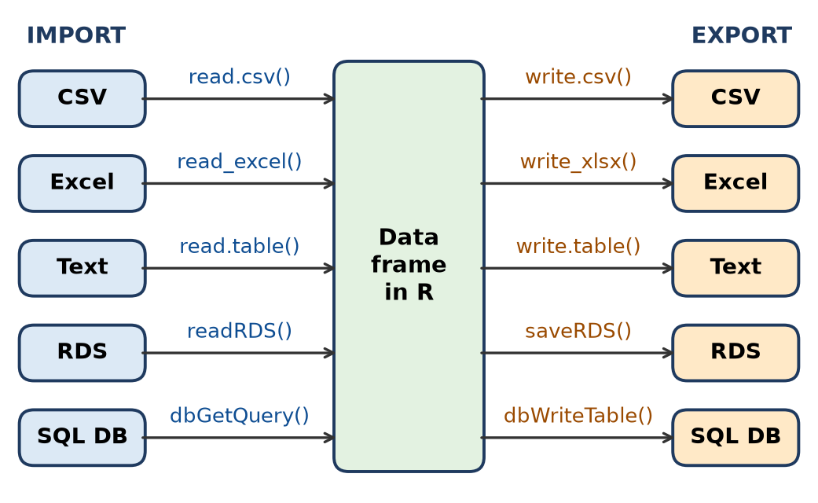
Figure: Import and export functions in R
Remember: Excel → readxl → read_excel(); CSV → read.csv().

Q8. Write syntax to check inbuilt dataset in R; also how to view a particular dataset
Easy • CO1
data() # list all inbuilt datasets
View(iris) # opens iris in a spreadsheet-like viewer (capital V)
iris # prints whole data in the Console
head(iris, 10) # first 10 rows
tail(iris) # last 6 rows
- data() shows dataset names with short titles.
- View() opens the data in a new tab of the Source pane; it is read-only.
- head() / tail() show only part of the data, useful for large datasets.
Remember: View with a capital V shows the full table.

Q9. Tell the use of any two of following Easy commands from base R package a. str(dataset name) b. summary(dataset name) c. View(dataset name)
Easy • CO1
Command | Use | Example output (iris)
str(iris) | Shows structure: class, no. of rows and columns, type and first values of each column | 'data.frame': 150 obs. of 5 variables; Species: Factor w/ 3 levels
summary(iris) | Statistical summary: Min, 1st Qu., Median, Mean, 3rd Qu., Max for numeric columns; counts for factors; NA count | Species: setosa 50, versicolor 50, virginica 50
View(iris) | Opens the dataset as a spreadsheet in RStudio for browsing, sorting and filtering | –

Remember: str = skeleton, summary = statistics, View = full picture.

Q10. data.frame() is important command in base R package. Explain this command with syntax and one example
Easy • CO1
data.frame() creates a data frame: a table of equal-length vectors, where each vector becomes a column.
Syntax: df <- data.frame(col1 = vector1, col2 = vector2, ..., stringsAsFactors = FALSE)
students <- data.frame(
Name = c("Amit", "Neha", "Ravi"),
Age = c(20, 21, 19),
Marks = c(85, 72, 90)
)
print(students)
Output:
Name Age Marks
1 Amit 20 85
2 Neha 21 72
3 Ravi 19 90
- All columns must have the same length.
- Check with str(students) → 3 obs. of 3 variables.
Remember: data.frame(): vectors side by side make a table.

Q11. data.frame() is important command in base R package. Explain this command with syntax and one example
Easy • CO1
Same as Q10 above.
Remember: Same vectors, same length, one table.

Q12. Import the dataset credit data to R studio and check its summary. Save it as a data frame `CD'. Identify the Columns having missing values.
Easy • CO1
CD <- read.csv("credit_data.csv") # import and save as CD
CD <- as.data.frame(CD) # make sure it is a data frame
summary(CD) # NA's row appears under columns with missing values
colSums(is.na(CD)) # number of NA in every column
names(CD)[colSums(is.na(CD)) > 0] # names of columns having missing values
- is.na(CD) gives TRUE where a value is missing.
- colSums() adds the TRUEs column-wise, so any column with a count above 0 has missing values.
- In summary(CD) such columns show an extra line NA's : n.
Remember: summary shows NA's; colSums(is.na()) counts them.

Q13. Find minimum, maximum and average price of houses from data set Indian Houses.
Easy • CO1
IH <- read.csv("IndianHouses.csv")
min(IH$Price, na.rm = TRUE) # minimum price
max(IH$Price, na.rm = TRUE) # maximum price
mean(IH$Price, na.rm = TRUE) # average price
summary(IH$Price) # Min, Max, Mean together
# dplyr way
library(dplyr)
IH %>% summarise(Min = min(Price), Max = max(Price), Avg = mean(Price))
- na.rm = TRUE ignores missing values; otherwise the answer is NA.
- range(IH$Price) gives min and max together.
Remember: min, max, mean — always add na.rm = TRUE.

Q14. You want to view the minimum, mean, median, and maximum values for all columns in the airquality dataset, including how many missing values are present. Apply single R command to view this?
Easy • CO1
Command: summary(airquality)
It gives Min, 1st Qu., Median, Mean, 3rd Qu., Max for every column and an NA's line for columns with missing values.
Column | Min | Median | Mean | Max | NA's
Ozone | 1.00 | 31.50 | 42.13 | 168.00 | 37
Solar.R | 7.0 | 205.0 | 185.9 | 334.0 | 7
Wind | 1.70 | 9.70 | 9.958 | 20.70 | –
Temp | 56.00 | 79.00 | 77.88 | 97.00 | –
Month | 5.000 | 7.000 | 6.993 | 9.000 | –
Day | 1.0 | 16.0 | 15.8 | 31.0 | –

Remember: One command, six statistics plus NA count: summary().

Q15. Write a command to display all unique plant names from the Plant column in the CO2 dataset.
Easy • CO1
unique(CO2$Plant) # unique plant names
levels(CO2$Plant) # Plant is a factor, so levels also list them
length(unique(CO2$Plant)) # 12
- CO2 has 84 rows; Plant is an (ordered) factor with 12 plants: Qn1, Qn2, Qn3, Qc1, Qc2, Qc3 (Quebec) and Mn1, Mn2, Mn3, Mc1, Mc2, Mc3 (Mississippi).
- unique() removes repeated values; dplyr way: CO2 %>% distinct(Plant).
Remember: unique() removes repeats; levels() lists factor categories.

Q16. Identify the error in the following code used to display the first six rows. In data "students". head[students]
Easy • CO1
- Wrong line: head[students]
- Why wrong: head is a function. Functions are called with round brackets ( ). Square brackets [ ] are used only for indexing (subsetting) vectors and data frames. R gives: Error: object of type 'closure' is not subsettable.
- Correct code:
head(students) # first 6 rows (default n = 6)
head(students, 10) # first 10 rows
Remember: ( ) to call a function, [ ] to pick elements.

Q17. Identify the error in the following code used to access the Age column in data "students". students(Age)
Easy • CO1
- Wrong line: students(Age)
- Why wrong: students is a data frame, not a function. Writing name( ) makes R look for a function called students, so it gives Error: could not find function "students".
- Correct code: use the $ operator (or brackets) to take a column.
students$Age # Age column as a vector
students[, "Age"] # same
students[["Age"]] # same
Remember: Data frame + $ + column name = that column.

Q18. Identify the error in the following code used to display the first six rows. In data "students". head[students]
Easy • CO1
Same as Q16 above.
Remember: head() is a function, so it needs ( ).

Q19. Identify the error in the following code used to access the Age column in data "students". students(Age)
Easy • CO1
Same as Q17 above.
Remember: students$Age — the dollar picks the column.

Q20. Write the command to display students who scored more than 75 marks.
Easy • CO1
students[students$Marks > 75, ] # base R
subset(students, Marks > 75) # base R, simpler
library(dplyr)
filter(students, Marks > 75) # dplyr
- students$Marks > 75 gives a logical vector (TRUE/FALSE for each row).
- Putting it before the comma selects the rows that are TRUE; blank after the comma keeps all columns.
Remember: [rows , columns] — condition goes before the comma.

Q21. Write the command to calculate the average marks in data "students".
Easy • CO1
mean(students$Marks) # average marks
mean(students$Marks, na.rm = TRUE) # if some marks are NA
- mean() adds all values and divides by their count.
- Example: Marks 85, 72, 90 → (85 + 72 + 90) ÷ 3 = 82.33.
- dplyr: summarise(students, avg = mean(Marks)).
Remember: mean() + na.rm = TRUE = safe average.

Q22. Write an R command to find the length of a vector x
Easy • CO1
x <- c(4, 8, 15, 16, 23, 42)
length(x) # 6
- length() returns the number of elements in a vector (or number of columns of a data frame, or items of a list).
- length(x) <- 3 can also shorten a vector.
Remember: length() counts the elements.

Q23. Write an R command to find the number of rows and columns in the data "students".
Easy • CO1
nrow(students) # number of rows (observations)
ncol(students) # number of columns (variables)
dim(students) # both: rows, columns
- For the 3-student data frame of Q10: nrow = 3, ncol = 3, dim = 3 3.
- Example: dim(mtcars) gives 32 11.
Remember: nrow = rows, ncol = columns, dim = both.

Q24. Identify the error in the following code used to access the second row. students(2, )
Easy • CO1
- Wrong line: students(2, )
- Why wrong: round brackets mean a function call; students is a data frame, so R gives could not find function "students". Rows and columns are selected with square brackets [row, column].
- Correct code:
students[2, ] # second row, all columns
students[2, "Marks"] # second row, Marks column
Remember: [2, ] = row 2, all columns.

Q25. What is data? What is the difference between data and information? Explain importance of data analysis.
Moderate • CO1
Data are raw, unorganised facts and figures (numbers, words, images) collected by observation or measurement. Information is data that has been processed, organised and given meaning.
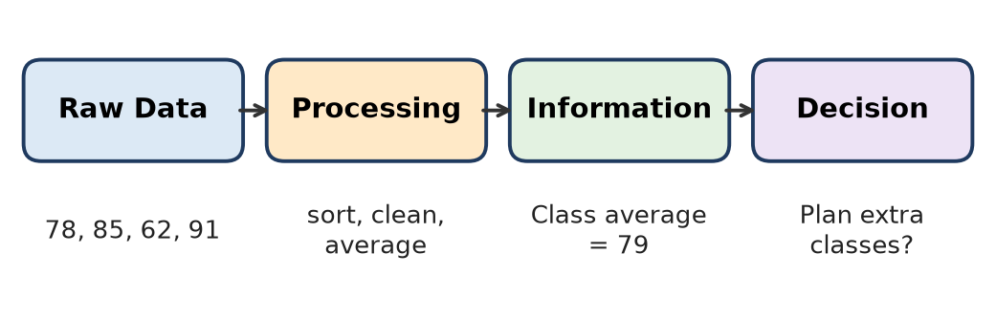
Figure: From data to information to decision
Basis | Data | Information
Meaning | Raw facts | Processed, meaningful facts
Form | Unorganised | Organised, structured
Dependence | Independent | Depends on data
Use | Not directly useful | Directly useful for decisions
Example | Marks 78, 85, 62, 91 | Class average = 79

Importance of data analysis:
1. Better decisions based on facts, not guesswork.
2. Finds patterns and trends (e.g. sales rising in festive months).
3. Predicts the future using models (forecasting demand).
4. Solves problems by finding causes (why customers leave).
5. Saves cost and time by improving processes.
Remember: Data is the raw rice; information is the cooked meal.

Q26. What is data analysis? Explain steps of data analysis.
Moderate • CO1
Data analysis is the process of inspecting, cleaning, transforming and modelling data to find useful information, draw conclusions and support decisions.
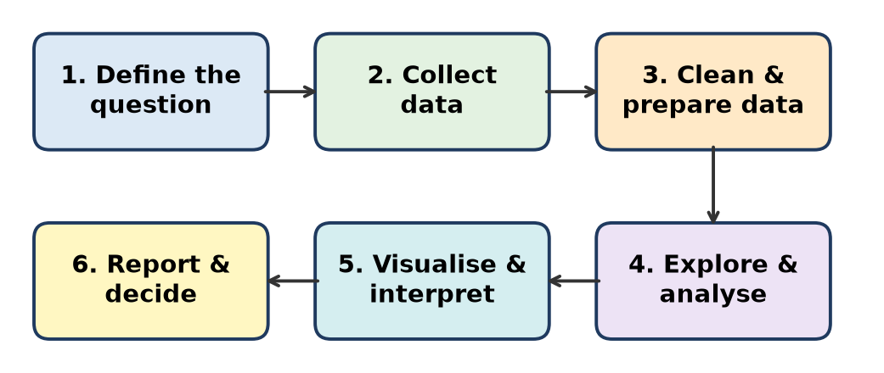
Figure: Steps of data analysis
1. Define the question – decide what to find (e.g. "Which car features affect mileage?").
2. Collect data – from surveys, files, databases or built-in datasets (mtcars).
3. Clean and prepare – handle missing values, wrong types, duplicates (is.na(), as.numeric()).
4. Explore and analyse – summary statistics, grouping, correlation, regression (summary(), lm()).
5. Visualise and interpret – histograms, box plots, scatter plots; explain what they show.
6. Report and decide – share findings and take action.
Remember: Ask – Collect – Clean – Analyse – Visualise – Act.

Q27. What are the methods of data collection? Describe in details.
Moderate • CO1
Data collection is the systematic gathering of information for analysis. Methods are of two types: primary and secondary.
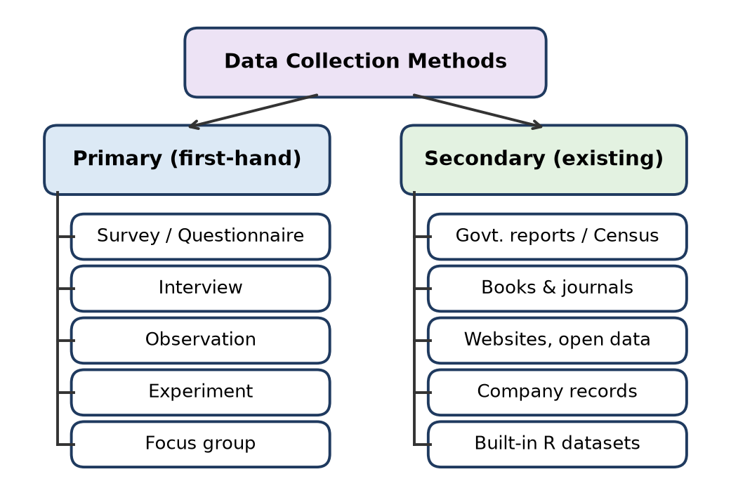
Figure: Methods of data collection
A. Primary data (collected first-hand for the purpose):
1. Survey / Questionnaire – printed or online form (Google Forms); cheap for large groups.
2. Interview – face-to-face or phone questions; detailed answers.
3. Observation – watching and recording behaviour (e.g. traffic count).
4. Experiment – change one factor and measure the effect (e.g. fertiliser and crop yield).
5. Focus group – discussion with 6–10 people on a topic.
B. Secondary data (already collected by others):
- Government reports and Census, books and journals, websites and open data portals, company records, built-in R datasets.
Primary | Secondary
Original, specific, up to date | Already available
Costly and slow | Cheap and fast

Remember: Primary = I collect it; Secondary = someone else already did.

Q28. What is the difference between quantitative and qualitative data? Explain their subtypes.
Moderate • CO1
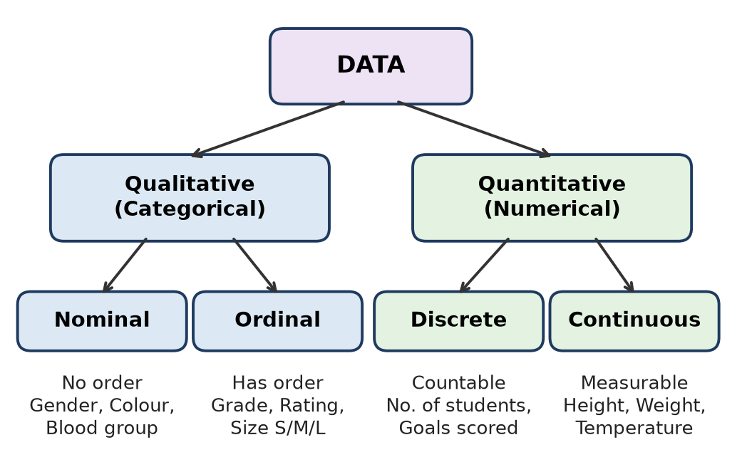
Figure: Types of data
Basis | Qualitative (Categorical) | Quantitative (Numerical)
Meaning | Describes qualities or categories | Measures quantity in numbers
Values | Labels, names | Counts or measurements
Arithmetic | Not meaningful | Mean, SD possible
Analysis | Frequency, mode, bar chart | Mean, median, histogram
R type | factor / character | numeric / integer
Example | Gender, Branch | Height, Marks

Subtypes:
1. Nominal (qualitative) – categories without order: blood group, colour.
2. Ordinal (qualitative) – categories with a natural order: grade A/B/C, rating 1–5.
3. Discrete (quantitative) – countable whole numbers: number of students, cyl in mtcars.
4. Continuous (quantitative) – any value in a range: height, weight, mpg.
Remember: Qualitative = what kind; Quantitative = how much.

Q29. What are the advantages of R programming amongst all.
Moderate • CO1
R is a free, open-source language made for statistical computing and graphics.
1. Free and open source – no licence cost; runs on Windows, Linux and macOS.
2. Made for statistics – built-in tests, regression, ANOVA and time series.
3. Huge package library – over 20,000 packages on CRAN (dplyr, ggplot2, caret).
4. Excellent graphics – high-quality plots with base R and ggplot2.
5. Data handling – reads CSV, Excel, SQL and web data; strong data wrangling (tidyverse).
6. Reproducible reports – R Markdown and Shiny dashboards.
7. Large community – lots of help online, used in research and industry.
8. Integration – works with Python, C++, SQL, Hadoop/Spark.
R | Excel
Handles very large data, scriptable | Limited rows, manual work
Advanced statistics free | Limited statistics

Remember: R = Free + Statistics + Packages + Plots.

Q30. What are applications of Data Analysis? Explain in detail.
Moderate • CO1
Data analysis turns data into decisions in almost every field.
1. Business and marketing – customer segmentation, sales forecasting, market-basket analysis (e.g. product recommendations in online shopping).
2. Healthcare – disease prediction, patient-risk analysis, drug trials, hospital resource planning.
3. Banking and finance – credit scoring, fraud detection, risk analysis.
4. Education – tracking student performance, predicting placement, improving teaching.
5. Sports – player performance and strategy analysis.
6. Government – census analysis, policy planning, traffic and pollution monitoring (like the airquality data).
7. Manufacturing – quality control, predictive maintenance.
8. Social media – sentiment analysis and trend detection.
Field | Example
Bank | Detect unusual card transactions
Hospital | Predict diabetes risk
College | Predict placement chances

Remember: Wherever there is data — business, health, bank, sports — analysis adds value.

Q31. Give introduction of R software and describe GUI of R-studio
Moderate • CO1
R is a free, open-source programming language and environment for statistical computing and graphics, created by Ross Ihaka and Robert Gentleman (University of Auckland). It is maintained by the R Core Team and packages are shared through CRAN.
RStudio is an IDE (Integrated Development Environment) that makes R easy to use. Its GUI has a menu bar, toolbar and four panes:
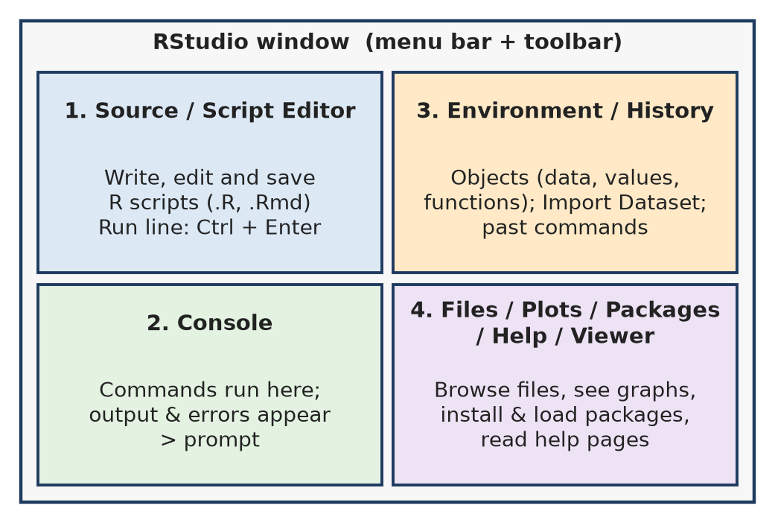
Figure: RStudio GUI – four panes
1. Source (Script editor) – write and save scripts; run with Ctrl + Enter.
2. Console – commands are executed and results/errors are shown.
3. Environment / History – lists objects (data frames, variables); Import Dataset button; History of commands.
4. Files / Plots / Packages / Help / Viewer – manage files, see graphs, install/load packages, read help.
Remember: R is the engine; RStudio is the car dashboard with four windows.

Q32. What is difference between R software and R-Studio
Moderate • CO1
Basis | R software | RStudio
What it is | Programming language and interpreter | IDE (front end) for R
Need | Works alone | Needs R installed first
Interface | Simple console (RGui) | Four-pane GUI: Script, Console, Environment, Files/Plots
Features | Runs code, statistics, graphics | Code completion, syntax colours, plot viewer, package manager, Import Dataset
Developer | R Core Team (CRAN) | Posit (formerly RStudio, PBC)
Install order | Install first | Install second

R does all the computing; RStudio only makes writing and managing R code easier.
Remember: R = engine, RStudio = steering and dashboard.

Q33. Explain all four windows of R-studio along with their functioning
Moderate • CO1
RStudio's screen is divided into four windows (panes).
Figure: Four windows of RStudio
1. Source / Script window (top-left) – write, edit and save R scripts (.R) and R Markdown files; run a line with Ctrl + Enter; View() data also opens here.
2. Console window (bottom-left) – where R actually runs commands after the > prompt; shows output, warnings and errors; also has Terminal tab.
3. Environment / History window (top-right) – Environment lists all objects in memory (data, values, functions) with size; Import Dataset and broom (clear) buttons. History keeps all previous commands; Connections tab for databases.
4. Files / Plots / Packages / Help / Viewer (bottom-right) – browse and set working folder; view and export graphs; install, update and load packages; read help pages (?mean); view HTML output.
Remember: S-C-E-F: Script, Console, Environment, Files/Plots.

Q34. Write in detail about `Environment Window'. In a dataset what is the meaning of observation and variable.
Moderate • CO1
Environment window (top-right pane of RStudio) shows the objects currently stored in memory.
1. Lists Data (data frames with "n obs. of m variables"), Values (vectors, numbers) and Functions.
2. Click the blue arrow to see column names; click the table icon to open View().
3. Import Dataset button – import CSV, Excel, SPSS, SAS, Stata files.
4. Save / Load workspace (.RData) and broom icon to clear all objects (rm(list = ls())).
5. Global Environment drop-down shows objects of loaded packages too.
6. Tabs: History (past commands), Connections (databases).
Observation and variable:
- Observation = one row; one unit/case on which data is recorded (one student, one car).
- Variable = one column; a characteristic measured for every observation (Age, Marks).
- Example: mtcars shows 32 obs. of 11 variables → 32 cars, 11 features.
Figure: Observation, variable and value
Remember: Row = Observation, Column = Variable, Cell = Value.

Q35. Explain nominal, ordinal, discrete, and continuous data in detail with examples.
Moderate • CO1
Data is qualitative (nominal, ordinal) or quantitative (discrete, continuous).
Figure: Types of data
1. Nominal data – categories with no order; only names/labels. Only counting and mode are possible. Examples: gender, blood group, city, Species in iris. In R: factor().
2. Ordinal data – categories with a meaningful order, but the gap between levels is not equal. Examples: grade (A > B > C), rating (poor/average/good), T-shirt size S/M/L. In R: factor(x, levels = c("Low","Medium","High"), ordered = TRUE).
3. Discrete data – countable whole numbers, no fractions. Examples: number of children, goals scored, cyl or gear in mtcars.
4. Continuous data – measurable, can take any value within a range (decimals). Examples: height, weight, temperature, mpg, wt.
Type | Order? | Numbers? | Example
Nominal | No | No | Blood group
Ordinal | Yes | No | Grade
Discrete | Yes | Counts | No. of students
Continuous | Yes | Measurements | Height

Remember: NODC: Names, Order, Discrete counts, Continuous measures.

Q36. Explain working of the following commands with syntax 1. rbind 2. as.factor 3. Replace_na 4.class 5. is.numeric 6.cbind()
Moderate • CO1
1. rbind() – joins objects row-wise (adds rows); columns must match. rbind(df1, df2)
2. as.factor() – converts a vector to a factor (categorical). as.factor(x)
3. replace_na() (tidyr) – replaces NA with a given value. replace_na(x, value)
4. class() – returns the class/type of an object. class(x)
5. is.numeric() – checks whether an object is numeric; returns TRUE/FALSE. is.numeric(x)
6. cbind() – joins objects column-wise (adds columns); rows must match. cbind(df, newcol)
a <- data.frame(Name = "Amit", Marks = 85)
b <- data.frame(Name = "Neha", Marks = 72)
d <- rbind(a, b) # 2 rows, 2 columns
d <- cbind(d, Grade = c("A", "B")) # adds Grade column
d$Grade <- as.factor(d$Grade) # Factor w/ 2 levels "A","B"
class(d) # "data.frame"
is.numeric(d$Marks) # TRUE
library(tidyr)
replace_na(c(5, NA, 7), 0) # 5 0 7
Remember: rbind = rows, cbind = columns; class asks "what are you?", is.numeric asks "are you a number?".

Q37. Sample data (picture of the mtcars dataset viewed in RStudio)
Sample data for Q38–Q40
The bank shows the mtcars dataset opened with View(mtcars). It has 32 cars (rows) and 11 variables; car names are row names.
Variable | Meaning
mpg | Miles per gallon (mileage)
cyl | Number of cylinders (4, 6, 8)
disp | Displacement (cu. in.)
hp | Gross horsepower
drat | Rear axle ratio
wt | Weight (1000 lbs)
qsec | Quarter-mile time (seconds)
vs | Engine: 0 = V-shaped, 1 = straight
am | Transmission: 0 = automatic, 1 = manual
gear | Number of forward gears
carb | Number of carburettors

Remember: mtcars: 32 cars × 11 features; am 0 = auto, 1 = manual.

Q38. Consider the inbuilt dataset mtcars and answer the following questions. i)Write the R command to display only the mpg, cyl, and hp columns.
Moderate • CO1
mtcars[, c("mpg", "cyl", "hp")] # base R: blank rows = all rows
library(dplyr)
select(mtcars, mpg, cyl, hp) # dplyr
Output (first rows):
(car) | mpg | cyl | hp
Mazda RX4 | 21.0 | 6 | 110
Mazda RX4 Wag | 21.0 | 6 | 110
Datsun 710 | 22.8 | 4 | 93

- Column names go inside c() as strings after the comma.
- Result: 32 rows × 3 columns.
Remember: Columns after the comma, inside c().

Q39. Write the R command to display cars having 6 cylinders.
Moderate • CO1
mtcars[mtcars$cyl == 6, ] # base R
subset(mtcars, cyl == 6) # base R
filter(mtcars, cyl == 6) # dplyr
- == is the comparison operator (a single = is assignment and gives an error).
- Output: 7 cars – Mazda RX4, Mazda RX4 Wag, Hornet 4 Drive, Valiant, Merc 280, Merc 280C, Ferrari Dino.
Remember: Compare with == ; condition before the comma.

Q40. Write the R command to arrange the cars in descending order of mpg.
Moderate • CO1
mtcars[order(mtcars$mpg, decreasing = TRUE), ] # base R
mtcars[order(-mtcars$mpg), ] # same
arrange(mtcars, desc(mpg)) # dplyr
- order() returns the row positions in sorted order; they are used as row index.
- Top of output: Toyota Corolla (33.9), Fiat 128 (32.4), Honda Civic (30.4), Lotus Europa (30.4); last: Cadillac Fleetwood and Lincoln Continental (10.4).
Remember: Base: order(decreasing = TRUE); dplyr: arrange(desc()).

Q41. Write the script/commands for the following: How to access inbuilt dataset in R? Select one of the dataset storms' and View it. Which commands can be used to find structure of the dataset storms' and also write the command to find the statistical summary of the same dataset. Write the command to get first few observations of `storms' data set
Difficult • CO1
storms is a built-in dataset of the dplyr package (NOAA Atlantic hurricane track data: name, year, month, day, hour, lat, long, status, category, wind, pressure, etc.).
# 1. Access inbuilt datasets
data() # list datasets of loaded packages
data(package = "dplyr") # datasets inside dplyr
# 2. Select 'storms' and view it
library(dplyr) # storms comes with dplyr
data(storms)
View(storms) # spreadsheet view in RStudio
# 3. Structure of the dataset
str(storms) # types and first values of each column
glimpse(storms) # dplyr version of str()
dim(storms); names(storms) # size and column names
class(storms) # "tbl_df" "tbl" "data.frame"
# Statistical summary
summary(storms) # Min, Q1, Median, Mean, Q3, Max, NA's
# 4. First few observations
head(storms) # first 6 rows
head(storms, 10) # first 10 rows
Purpose | Command
List datasets | data()
Open dataset | View(storms)
Structure | str(), glimpse()
Summary | summary()
First rows | head()

- summary() shows NA counts, e.g. for category (it is NA for storms that are not hurricanes) and the diameter columns.
Remember: data → View → str → summary → head: the five first looks at any dataset.

Q42. Write the step wise process of primary data collection for any one of the following topic: a. Effect of Social media on young generation b. Health habits of working women
Difficult • CO1
Topic chosen: (a) Effect of social media on the young generation.
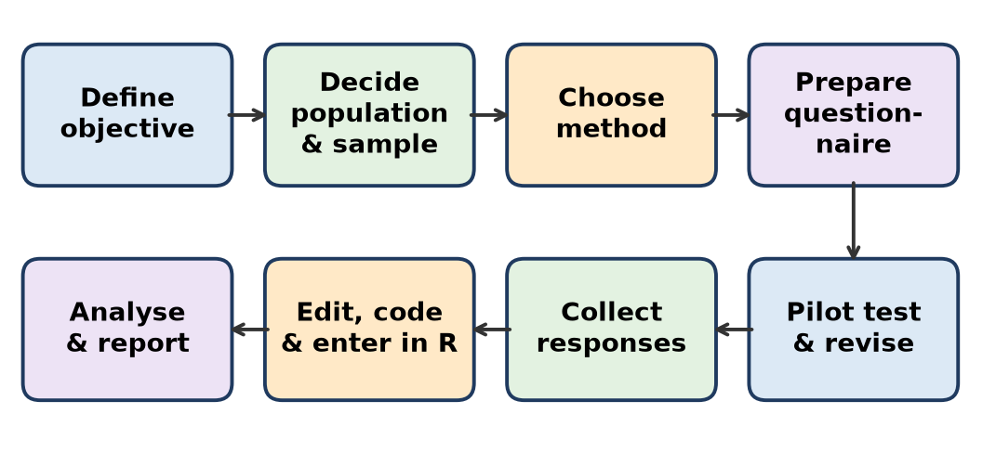
Figure: Steps of primary data collection
1. Define the objective – e.g. "Study the effect of daily social-media use on sleep, study hours and mood of students aged 16–25."
2. Decide population and sample – population: college students in Pune; sample: 200 students chosen by stratified random sampling (by year and gender).
3. Choose the method – online questionnaire (Google Forms) plus a few interviews for deeper views.
4. Prepare the questionnaire – demographic questions (age, gender, course); usage (hours/day, platforms – Instagram, YouTube, WhatsApp); effects (sleep hours, marks, stress on a 1–5 Likert scale).
5. Pilot test – try with 15–20 students, remove confusing questions.
6. Collect data – share the link, give a deadline, ensure consent and anonymity.
7. Edit, code and enter – remove incomplete forms, code answers (Yes = 1, No = 0), export to CSV, read.csv() into R.
8. Analyse and report – summary(), bar charts of platforms, correlation of usage hours with sleep/marks; write conclusions.
Variable | Type
Hours on social media | Continuous
Platform used | Nominal
Stress level (1–5) | Ordinal

(For topic b, use the same steps with questions on diet, exercise, sleep, stress and work hours of working women.)
Conclusion: a clear objective, a good sample and a tested questionnaire give reliable primary data.
Remember: O-S-M-Q-P-C-E-A: Objective, Sample, Method, Questionnaire, Pilot, Collect, Enter, Analyse.

Q43. Access the inbuilt data `airquality' and answer the following questions: Whether this data set has NA values? How many NA values are there? At what places?
Difficult • CO1
airquality has 153 rows and 6 columns (Ozone, Solar.R, Wind, Temp, Month, Day) — daily New York air readings, May to September 1973.
data(airquality)
anyNA(airquality) # TRUE -> yes, NA values exist
sum(is.na(airquality)) # 44 -> total NA values
colSums(is.na(airquality)) # NA count per column
which(is.na(airquality$Ozone)) # row numbers of NA in Ozone
which(is.na(airquality$Solar.R)) # row numbers of NA in Solar.R
which(is.na(airquality), arr.ind = TRUE) # (row, col) of every NA
sum(!complete.cases(airquality)) # 42 rows have at least one NA
Answers:
1. Yes, the dataset has NA values (anyNA() = TRUE).
2. Total 44 NA values: Ozone = 37, Solar.R = 7, Wind/Temp/Month/Day = 0.
3. Places:
- Solar.R NA rows: 5, 6, 11, 27, 96, 97, 98.
- Ozone NA rows: 5, 10, 25, 26, 27, 32–37, 39, 42, 43, 45, 46, 52–61, 65, 72, 75, 83, 84, 102, 103, 107, 115, 119, 150.
- Rows 5 and 27 have both missing, so 42 rows are incomplete and 111 rows are complete (nrow(na.omit(airquality)) = 111).
Column | NA count
Ozone | 37
Solar.R | 7
Others | 0
Total | 44

Remember: airquality: 37 + 7 = 44 NA; 111 complete rows.

Q44. What is the difference between apply(), lapply(), and sapply()with examples.
Difficult • CO1
These apply-family functions run a function on many elements without writing a loop.
1. apply(X, MARGIN, FUN) – works on a matrix/data frame by rows (MARGIN = 1) or columns (MARGIN = 2); returns a vector or matrix.
2. lapply(X, FUN) – works on each element of a list/vector; always returns a list.
3. sapply(X, FUN) – same as lapply but simplifies the result to a vector or matrix.
m <- matrix(1:6, nrow = 2) # 2 x 3 matrix: rows (1,3,5) and (2,4,6)
apply(m, 1, sum) # row sums: 9 12
apply(m, 2, sum) # column sums: 3 7 11
L <- list(a = 1:3, b = 4:6)
lapply(L, mean) # list: $a 2 $b 5
sapply(L, mean) # named vector: a b -> 2 5
sapply(mtcars[, 1:3], mean) # mean of mpg, cyl, disp
Basis | apply() | lapply() | sapply()
Input | Matrix / data frame | List / vector | List / vector
MARGIN needed | Yes (1 or 2) | No | No
Output | Vector / matrix | Always list | Vector / matrix (simplified)
Use | Row/column totals | When list output wanted | Quick readable result

Conclusion: use apply for rows/columns, lapply when you need a list, sapply when you want a simple vector.
Remember: apply = Array, lapply = List, sapply = Simple.

Q45. A data frame named mtcars_data contains the built-in mtcars dataset. Write R commands to: i) Export the data as mtcars.csv without row names. ii) Export the data as an R data file named mtcars.RData. iii) Save the data frame as an RDS file named mtcars.rds.
Difficult • CO1
mtcars_data <- mtcars
setwd("D:/R_Data") # folder where files will be saved
# i) CSV without row names
write.csv(mtcars_data, "mtcars.csv", row.names = FALSE)
# ii) R data file (.RData) - can hold one or many objects
save(mtcars_data, file = "mtcars.RData")
# iii) RDS file - stores one object
saveRDS(mtcars_data, file = "mtcars.rds")
# Reading them back (to check)
d1 <- read.csv("mtcars.csv")
load("mtcars.RData") # restores object 'mtcars_data'
d3 <- readRDS("mtcars.rds") # assign to any name
Format | Save | Read | Feature
.csv | write.csv() | read.csv() | Text; opens in Excel
.RData | save() | load() | Many objects, original names kept
.rds | saveRDS() | readRDS() | One object, any new name

- Note: with row.names = FALSE the car names are lost. To keep them, first add a column: mtcars_data$car <- rownames(mtcars_data).
- .RData and .rds keep data types (factors etc.) exactly; CSV does not.
Conclusion: CSV for sharing, RData/RDS for saving R objects exactly.
Remember: CSV = share, RData = many objects, RDS = one object.

Q46. Write the step wise process of primary data collection for any one of the following topic: a. Effect of Social media on young generation b. Health habits of working women
Difficult • CO1
Same as Q42 above. For topic (b) Health habits of working women: objective – study diet, exercise, sleep and stress of working women aged 25–50; sample – 150 women from IT, banking and teaching; method – questionnaire + short interviews; variables – meals skipped/day (discrete), exercise minutes (continuous), sleep quality (ordinal), job type (nominal); then pilot, collect, code, analyse in R and report.
Remember: Same eight steps, only the questions change with the topic.

Q47. Access the inbuilt data `airquality' and answer the following questions: Whether this data set has NA values? How many NA values are there? At what places?
Difficult • CO1
Same as Q43 above.
Remember: airquality: Ozone 37 NA + Solar.R 7 NA = 44.

Q48. What is the difference between apply(), lapply(), and sapply()with examples.
Difficult • CO1
Same as Q44 above.
Remember: apply = rows/columns, lapply = list, sapply = simplified.

Q49. A data frame named mtcars_data contains the built-in mtcars dataset. Write R commands to: i) Export the data as mtcars.csv without row names. ii) Export the data as an R data file named mtcars.RData. iii) Save the data frame as an RDS file named mtcars.rds.
Difficult • CO1
Same as Q45 above.
Remember: write.csv(row.names = FALSE), save(), saveRDS().

Q50. Sample data (picture of the mtcars dataset viewed in RStudio)
Sample data for Q51–Q57
Same as Q37 above (the mtcars dataset: 32 cars, 11 variables; used in Q51–Q57).
Remember: 32 cars, 11 columns, row names = car names.

Q51. Identify the car with the maximum horsepower
Difficult • CO1
mtcars[which.max(mtcars$hp), ] # base R
rownames(mtcars)[which.max(mtcars$hp)] # only the name
library(dplyr)
mtcars %>% filter(hp == max(hp)) # dplyr
- which.max() returns the position (row number) of the largest value; using it as the row index gives the full row.
Output:
(car) | mpg | cyl | disp | hp | wt | gear | carb
Maserati Bora | 15.0 | 8 | 301 | 335 | 3.57 | 5 | 8

Answer: Maserati Bora, 335 hp. (Second highest is Ford Pantera L, 264 hp.) Similarly which.min() finds the minimum.
Remember: which.max gives the row; mtcars[row, ] gives the car.

Q52. Count the number of cars with automatic transmission (am = 0).
Difficult • CO1
sum(mtcars$am == 0) # 19
table(mtcars$am) # 0: 19 1: 13
nrow(mtcars[mtcars$am == 0, ]) # 19
mtcars %>% filter(am == 0) %>% count() # dplyr: n = 19
- mtcars$am == 0 gives TRUE/FALSE for each car; sum() counts TRUE as 1 and FALSE as 0.
- Answer: 19 cars are automatic and 13 are manual (total 32).
Remember: Sum of TRUEs = count.

Q53. Store all cars with gear >= 4 in a new data frame called selected_cars.
Difficult • CO1
selected_cars <- mtcars[mtcars$gear >= 4, ] # base R
selected_cars <- subset(mtcars, gear >= 4) # same
selected_cars <- filter(mtcars, gear >= 4) # dplyr
nrow(selected_cars) # 17
table(selected_cars$gear) # 4: 12 5: 5
- <- stores the result in a new object which appears in the Environment pane.
- Result: 17 cars (12 with 4 gears + 5 with 5 gears), all 11 columns.
Remember: Filter, then store with <- to keep it.

Q54. Identify the errors in the following R commands and rewrite them correctly. head[mtcars, 10] and mean[mtcars$mpg]
Difficult • CO1
Wrong code | Error / reason | Correct code
head[mtcars, 10] | head is a function; square brackets try to subset it → "object of type 'closure' is not subsettable" | head(mtcars, 10)
mean[mtcars$mpg] | mean is a function; needs round brackets | mean(mtcars$mpg)

head(mtcars, 10) # first 10 cars
mean(mtcars$mpg) # 20.09062
Rule: functions use ( ); indexing of data uses [ ].
Remember: Function( ) — Data[ ].

Q55. Identify the errors in the following R commands and rewrite them correctly mtcars(mtcars$cyl == 8, ) and mtcars[, mpg, hp]
Difficult • CO1
Wrong code | Error / reason | Correct code
mtcars(mtcars$cyl == 8, ) | mtcars is a data frame, not a function → "could not find function" | mtcars[mtcars$cyl == 8, ]
mtcars[, mpg, hp] | Names without quotes are treated as objects ("object 'mpg' not found"); several columns must be given as one vector | mtcars[, c("mpg", "hp")]

mtcars[mtcars$cyl == 8, ] # 14 cars with 8 cylinders
mtcars[, c("mpg", "hp")] # 32 rows, 2 columns
Remember: Many columns? Wrap them in c(" ", " ").

Q56. Correct the following code snippets. Incorrect Code: i) mtcars(mtcars$mpg > 20, ) ii) mtcars[, mpg, hp] iii) mtcars[mtcars$cyl = 6, ] iv) mtcars[mtcars$hp > 100] v) mtcars$Efficiency == mtcars$mpg / mtcars$wt
Difficult • CO1
No. | Wrong code | What is wrong | Correct code
i | mtcars(mtcars$mpg > 20, ) | Round brackets = function call; mtcars is not a function | mtcars[mtcars$mpg > 20, ]
ii | mtcars[, mpg, hp] | Column names not quoted and not combined with c() | mtcars[, c("mpg", "hp")]
iii | mtcars[mtcars$cyl = 6, ] | Single = is assignment → "unexpected '='" error; comparison needs == | mtcars[mtcars$cyl == 6, ]
iv | mtcars[mtcars$hp > 100] | No comma, so the condition is applied to columns → "undefined columns selected" | mtcars[mtcars$hp > 100, ]
v | mtcars$Efficiency == mtcars$mpg / mtcars$wt | == only compares (prints logical(0)); no column is created | mtcars$Efficiency <- mtcars$mpg / mtcars$wt

mtcars[mtcars$mpg > 20, ] # 14 cars
mtcars[, c("mpg", "hp")]
mtcars[mtcars$cyl == 6, ] # 7 cars
mtcars[mtcars$hp > 100, ]
mtcars$Efficiency <- mtcars$mpg / mtcars$wt # new column (12th)
head(mtcars$Efficiency, 3) # 8.015267 7.304348 9.827586
Key rules: [rows, cols] with a comma; == to compare; <- to assign; c() for many columns.
Remember: Comma for rows, == to compare, <- to create.

Q57. Identify and correct the errors. i) write.csv[mtcars, "cars.csv"] ii) read.csv("cars.csv", row.names = FALSE) iii) setwd("D:\R_Data") iv) write.csv(mtcars, "cars.csv", row.names = TRUE) v) saveRDS(mtcars, "cars.rds") followed by read.csv("cars.rds")
Difficult • CO1
No. | Wrong code | What is wrong | Correct code
i | write.csv[mtcars, "cars.csv"] | Function called with [ ] | write.csv(mtcars, "cars.csv")
ii | read.csv("cars.csv", row.names = FALSE) | row.names = FALSE is an option of write.csv, not a valid choice for reading | read.csv("cars.csv") (or row.names = 1 to use the first column as row names)
iii | setwd("D:\R_Data") | \ is an escape character in R strings → "'\R' is an unrecognized escape" | setwd("D:/R_Data") or setwd("D:\\R_Data")
iv | write.csv(mtcars, "cars.csv", row.names = TRUE) | Writes row names as an extra unnamed first column (read back as column "X") | write.csv(mtcars, "cars.csv", row.names = FALSE)
v | read.csv("cars.rds") | An RDS file is binary, not text; read.csv cannot read it | readRDS("cars.rds")

setwd("D:/R_Data")
write.csv(mtcars, "cars.csv", row.names = FALSE)
cars1 <- read.csv("cars.csv")
saveRDS(mtcars, "cars.rds")
cars2 <- readRDS("cars.rds")
Remember the pairs: write.csv ↔ read.csv, saveRDS ↔ readRDS, save ↔ load.
Remember: Use forward slash in paths; match every save with its own read.

Quick Revision – Unit I
Term / Command | Key fact
Data vs Information | Raw facts vs processed, meaningful facts
Qualitative data | Nominal (no order), Ordinal (order)
Quantitative data | Discrete (counts), Continuous (measurements)
Primary vs Secondary | Collected by you vs already available
R vs RStudio | Language/engine vs IDE with 4 panes
RStudio panes | Source, Console, Environment/History, Files/Plots/Packages/Help
Observation / Variable | Row / Column of a data frame
install.packages() / library() | Install once / load every session
read.csv(), read_excel() | Import CSV / Excel (readxl)
write.csv(), save(), saveRDS() | Export CSV / .RData / .rds
str(), summary(), head(), View() | Structure, statistics, first rows, spreadsheet view
df[rows, cols] | Condition before comma, columns after; == to compare
airquality | 153 × 6; NA: Ozone 37, Solar.R 7 (total 44)
mtcars | 32 × 11; max hp = Maserati Bora (335); am = 0 → 19 cars
apply / lapply / sapply | Rows-cols / list output / simplified output

Unit II: Data Wrangling

Q1. State any two differences between the unite () and gather () functions in R
Easy • CO2
Both are tidyr functions, but they reshape data in different ways.
unite() | gather()
Combines several columns into one column by pasting values | Converts many columns into two columns: key and value
Values joined with a separator, e.g. sep = "_" | Makes data longer (wide → long format)
Number of rows stays the same | Number of rows increases
unite(data, new_col, col1, col2, sep = "_") | gather(data, key, value, col1:colN)

Example: unite(iris, Sepal_Size, Sepal.Length, Sepal.Width, sep = "_") gives "5.1_3.5"; gather(table4a, key = "year", value = "cases", 2:3) stacks the 1999 and 2000 columns.
Remember: unite = glue columns side-ways; gather = stack columns into rows.

Q2. What different commands can be used to identify the `NA' values from the dataset? Write any two commands with proper syntax.
Easy • CO2
NA means "Not Available" – a missing value in R.
Command | Syntax / example | Result
is.na() | is.na(airquality$Ozone) | TRUE where value is NA
sum(is.na()) | sum(is.na(airquality)) | Total NA count → 44
colSums(is.na()) | colSums(is.na(airquality)) | NA per column → Ozone 37, Solar.R 7
anyNA() | anyNA(airquality) | TRUE if any NA
which(is.na()) | which(is.na(airquality$Solar.R)) | Row numbers → 5 6 11 27 96 97 98
complete.cases() | sum(complete.cases(airquality)) | Rows without NA → 111
summary() | summary(airquality) | Shows NA's line

Remember: is.na() finds them, sum() counts them.

Q3. Describe the function and syntax of the commands: 1. Slice 2. mutate 3.group_by 4.arrange 5. Summarise
Easy • CO2
All five are dplyr verbs (load with library(dplyr)).
Command | Function | Syntax / example
slice() | Selects rows by position | slice(airquality, 1:30) – rows 1 to 30
mutate() | Adds new columns or changes existing ones | mutate(mtcars, kpl = mpg * 0.425)
group_by() | Groups rows by a column so later steps work per group | group_by(mtcars, cyl)
arrange() | Sorts rows (ascending; desc() for descending) | arrange(mtcars, desc(hp))
summarise() | Reduces each group to one summary row | summarise(mtcars, avg = mean(mpg))

mtcars %>% group_by(cyl) %>% summarise(avg_mpg = mean(mpg)) %>% arrange(desc(avg_mpg))
Remember: Slice picks, Mutate makes, Group groups, Arrange sorts, Summarise shrinks.

Q4. What is the command to extract data from the top 30 rows of `airquality'?
Easy • CO2
head(airquality, 30) # base R: first 30 rows
airquality[1:30, ] # base R: rows 1 to 30, all columns
library(dplyr)
slice(airquality, 1:30) # dplyr
top30 <- head(airquality, 30) # store for later use
- Result: 30 rows × 6 columns (all from May, Day 1–30).
- head() default is 6 rows; the second argument changes the count.
Remember: head(data, n) = top n rows.

Q5. Write a command to get the month wise average of wind speed for `airquality'
Easy • CO2
library(dplyr)
airquality %>%
group_by(Month) %>%
summarise(avg_wind = mean(Wind))
# base R alternatives
tapply(airquality$Wind, airquality$Month, mean)
aggregate(Wind ~ Month, data = airquality, FUN = mean)
Output:
Month | avg_wind
5 | 11.6
6 | 10.3
7 | 8.94
8 | 8.79
9 | 10.2

Wind has no NA, so na.rm is not needed. May is the windiest month.
Remember: group_by(Month) + summarise(mean) = month-wise average.

Q6. Check whether NA values are there in `Parking' variable. Also find count of NA values.
Easy • CO2
(Parking is a column of the IndianHouses dataset.)
IH <- read.csv("IndianHouses.csv")
anyNA(IH$Parking) # TRUE = NA present, FALSE = none
sum(is.na(IH$Parking)) # count of NA values
which(is.na(IH$Parking)) # rows having NA
summary(IH$Parking) # also shows NA's
- is.na() returns TRUE/FALSE for each value; sum() counts the TRUEs.
- If the count is more than 0, handle it with replace_na() or drop_na().
Remember: anyNA asks "any?", sum(is.na()) answers "how many?".

Q7. Convert Placement data into data frame, and verify whether minimum and maximum values of all percentage are same or different
Easy • CO2
(Placement data = campus placement dataset with percentage columns ssc_p, hsc_p, degree_p, etest_p, mba_p; check exact names with names().)
placement <- read.csv("Placement_Data.csv")
placement <- as.data.frame(placement) # convert to data frame
class(placement) # "data.frame"
pct <- placement[, c("ssc_p", "hsc_p", "degree_p", "etest_p", "mba_p")]
sapply(pct, range, na.rm = TRUE) # row 1 = min, row 2 = max
summary(pct) # Min and Max of each
- sapply(pct, range) returns a 2-row table: minimum and maximum of each percentage column.
- Comparing the columns shows the minimum and maximum are different for each subject, because each exam has its own spread of marks.
Remember: sapply + range = min and max of every column at once.

Q8. What is the average salary as per the gender
Easy • CO2
library(dplyr)
placement %>%
group_by(gender) %>%
summarise(avg_salary = mean(salary, na.rm = TRUE))
# base R
aggregate(salary ~ gender, data = placement, FUN = mean)
- group_by(gender) makes groups M and F; summarise() finds the mean salary of each.
- na.rm = TRUE is needed because not-placed students have NA salary.
- Output: one row per gender with its average salary.
Remember: Group by gender, then mean of salary with na.rm = TRUE.

Q9. How many students are there who are having more than 70% in MBA; what is average salary of these students.
Easy • CO2
library(dplyr)
placement %>%
filter(mba_p > 70) %>%
summarise(count = n(),
avg_salary = mean(salary, na.rm = TRUE))
# base R
sum(placement$mba_p > 70)
mean(placement$salary[placement$mba_p > 70], na.rm = TRUE)
- filter() keeps students with MBA % above 70.
- n() counts rows; mean(..., na.rm = TRUE) averages salary of the placed ones.
Remember: filter → n() → mean().

Q10. Write a command to extract data , row wise from 101 to 250 rows from dataset `mpg'
Easy • CO2
library(ggplot2) # mpg dataset is in ggplot2
mpg[101:250, ] # base R
library(dplyr)
slice(mpg, 101:250) # dplyr
mpg_part <- slice(mpg, 101:250)
nrow(mpg_part) # 150
- 101:250 creates the sequence of row numbers.
- Result: 150 rows × 11 columns (mpg has 234 rows in total).
Remember: start:end inside [ , ] or slice().

Q11. If the given data is `table1' write syntax to spread population year wise
Easy • CO2
table1 (tidyr) has columns country, year, cases, population. To make one column per year holding population, use spread() (key = year, value = population). First remove cases, otherwise rows do not combine.
library(tidyr); library(dplyr)
table1 %>%
select(-cases) %>%
spread(key = year, value = population)
# new style
table1 %>% select(-cases) %>% pivot_wider(names_from = year, values_from = population)
Output:
country | 1999 | 2000
Afghanistan | 19987071 | 20595360
Brazil | 172006362 | 174504898
China | 1272915272 | 1280428583

Remember: spread(key = column that becomes headings, value = column that fills them).

Q12. Consider the inbuilt dataset mtcars in R. i)Write the R command to select cars having mpg greater than 20. ii)Select only the columns mpg, cyl, and hp from the dataset.
Easy • CO2
library(dplyr)
filter(mtcars, mpg > 20) # i) rows where mpg > 20
select(mtcars, mpg, cyl, hp) # ii) only three columns
# both together
mtcars %>% filter(mpg > 20) %>% select(mpg, cyl, hp)
- filter() works on rows, select() works on columns.
- i) gives 14 cars (e.g. Mazda RX4, Datsun 710, Fiat 128, Toyota Corolla); ii) gives 32 rows × 3 columns.
Remember: filter = rows, select = columns.

Q13. Consider the inbuilt dataset mtcars in R. i) Arrange the cars in descending order of hp. ii) Find the average mpg for each cylinder group (cyl).
Easy • CO2
library(dplyr)
arrange(mtcars, desc(hp)) # i) Maserati Bora (335) first
mtcars %>% # ii)
group_by(cyl) %>%
summarise(avg_mpg = mean(mpg))
Output of ii):
cyl | avg_mpg
4 | 26.7
6 | 19.7
8 | 15.1

More cylinders → lower mileage.
Remember: desc() reverses; group_by + summarise averages per group.

Q14. Consider the inbuilt dataset iris. 1. Extract the observations where Species is "setosa" and Sepal.Length is greater than 5. 2. Select Sepal.Length, Petal.Length, and Species.
Easy • CO2
library(dplyr)
filter(iris, Species == "setosa", Sepal.Length > 5) # 1
select(iris, Sepal.Length, Petal.Length, Species) # 2
- In filter(), conditions separated by a comma are joined with AND (same as &).
- The data name (iris) must be the first argument (or use iris %>% filter(...)); the bank's answer misses it.
- Part 2 gives 150 rows × 3 columns.
Remember: Comma inside filter() means AND.

Q15. Consider the inbuilt dataset iris. i)Arrange the data in ascending order of Petal.Length. ii) Calculate the average Petal.Width for each species.
Easy • CO2
library(dplyr)
arrange(iris, Petal.Length) # i) smallest (1.0) first
iris %>% # ii)
group_by(Species) %>%
summarise(avg_width = mean(Petal.Width))
Output of ii):
Species | avg_width
setosa | 0.246
versicolor | 1.33
virginica | 2.03

Remember: arrange() is ascending by default.

Q16. Consider the inbuilt dataset airquality, which contains daily air-quality measurements. 1. Identify the rows where Ozone is greater than 50. 2. Display only the columns Ozone, Solar.R, and Temp.
Easy • CO2
library(dplyr)
airquality %>% filter(Ozone > 50) # 1
select(airquality, Ozone, Solar.R, Temp) # 2
# base R
airquality[which(airquality$Ozone > 50), ]
airquality[, c("Ozone", "Solar.R", "Temp")]
- filter() automatically drops rows where Ozone is NA; in base R use which() to avoid NA rows.
- Part 2 gives 153 rows × 3 columns.
Remember: filter() quietly skips NA rows.

Q17. Identify the error in the code to remove rows containing missing values from airquality. library(tidyr) airquality %>% drop_na(Ozone = Solar.R)
Easy • CO2
- Wrong line: airquality %>% drop_na(Ozone = Solar.R)
- Why wrong: drop_na() takes column names separated by commas. Ozone = Solar.R looks like renaming/assignment, which is not allowed here, so R gives an error.
- Correct code:
library(tidyr)
airquality %>% drop_na(Ozone, Solar.R) # 111 rows remain
airquality %>% drop_na() # all columns: also 111 rows
Remember: drop_na(col1, col2) — commas, not equals.

Q18. Identify the error in the code to calculate average tooth length for each supplement type in ToothGrowth. ToothGrowth %>% group_by(supp) %>% summarise(avg_len = mean(len, na.rm = FALSE)) %>% arrange(avg_len, decreasing = TRUE)
Easy • CO2
Errors:
1. arrange(avg_len, decreasing = TRUE) – arrange() has no decreasing argument (that belongs to base order()); dplyr uses desc().
2. na.rm = FALSE – safer to use na.rm = TRUE so any NA does not make the mean NA.
Correct code:
library(dplyr)
ToothGrowth %>%
group_by(supp) %>%
summarise(avg_len = mean(len, na.rm = TRUE)) %>%
arrange(desc(avg_len))
Output: OJ 20.7, VC 17.0 (orange juice gives longer teeth).
Remember: dplyr sorts down with desc(), not decreasing = TRUE.

Q19. Correct the code to combine Sepal.Length and Sepal.Width into a new column named Sepal_Size. iris %>% unite(Sepal_Size, Sepal.Length + Sepal.Width)
Easy • CO2
- Wrong: unite(Sepal_Size, Sepal.Length + Sepal.Width) – unite() needs column names separated by commas, not an arithmetic +. It pastes values; it does not add them.
- Correct code:
library(tidyr)
iris %>% unite(Sepal_Size, Sepal.Length, Sepal.Width, sep = "_")
- First row becomes "5.1_3.5"; the two old columns are removed (remove = TRUE by default).
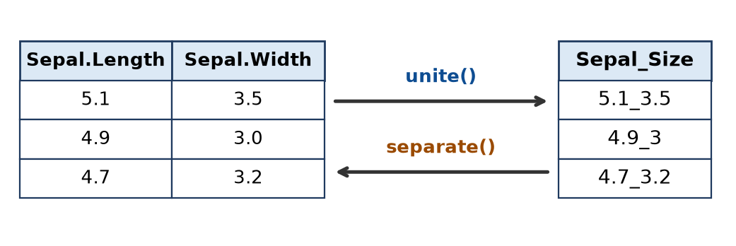
Figure: unite() and separate()
Remember: unite(new, col1, col2, sep) — paste, not plus.

Q20. Correct the code to replace missing values in Ozone with the mean of the available values: airquality$Ozone[is.na(airquality$Ozone)] = mean(airquality$Ozone)
Easy • CO2
- Error: mean(airquality$Ozone) returns NA, because Ozone has 37 NA values. So NA is replaced by NA – nothing changes.
- Correct code: add na.rm = TRUE.
airquality$Ozone[is.na(airquality$Ozone)] <- mean(airquality$Ozone, na.rm = TRUE)
sum(is.na(airquality$Ozone)) # 0
# tidyr way
airquality$Ozone <- replace_na(airquality$Ozone, mean(airquality$Ozone, na.rm = TRUE))
- Mean of available Ozone = 42.13, so all 37 NAs become 42.13.
Remember: Any NA inside makes mean NA — add na.rm = TRUE.

Q21. Define Data wrangling. Explain the processes in data wrangling in detail. Also, write advantages of data wrangling.
Moderate • CO2
Data wrangling (data munging/pre-processing) is the process of cleaning, structuring and transforming raw data into a tidy, usable form for analysis. In R it is done mainly with dplyr and tidyr.
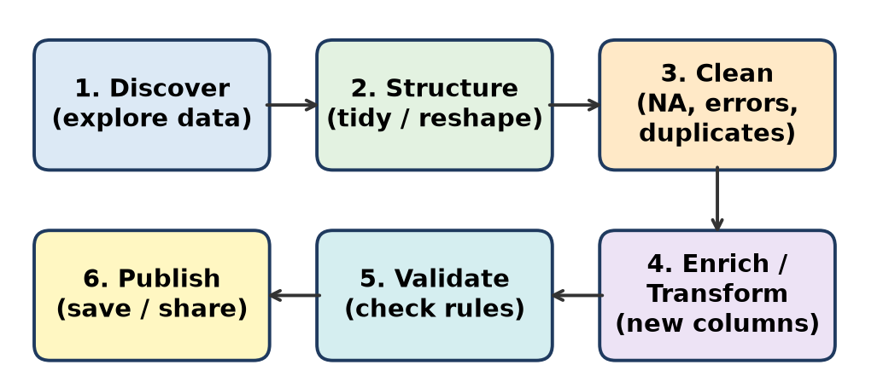
Figure: Data wrangling process
Processes:
1. Discovering – understand the data: str(), summary(), head().
2. Structuring – reshape to tidy form: gather()/pivot_longer(), spread(), separate(), unite().
3. Cleaning – handle missing values (drop_na(), replace_na()), remove duplicates (distinct()), fix wrong entries and data types (as.numeric(), as.factor()).
4. Enriching / Transforming – new columns (mutate()), normalization (min-max, z-score) and binning (cut()).
5. Validating – check ranges and rules (no negative ages, NA count = 0).
6. Publishing – save clean data: write.csv(), saveRDS().
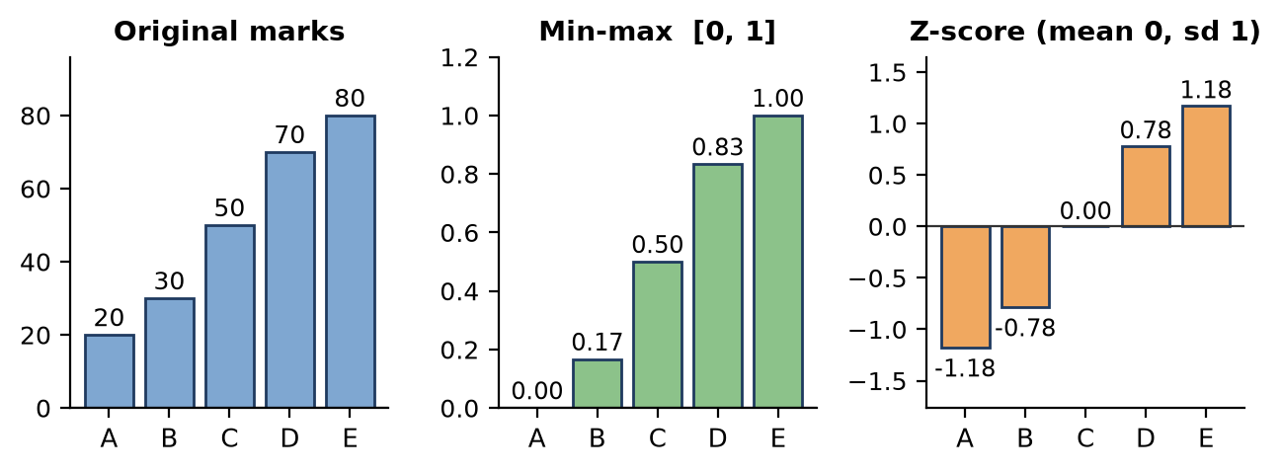
Figure: Normalization: min-max = (x − min) ÷ (max − min); z = (x − mean) ÷ sd
Advantages: accurate results, saves analysis time, consistent format, easy visualisation/modelling, better decisions.
Remember: Discover, Structure, Clean, Enrich, Validate, Publish — "DSCEVP".

Q22. Which commands are used in the `dplyr' package? Describe any two with their purposes and syntax with an example.
Moderate • CO2
dplyr is the "grammar of data manipulation" package of the tidyverse. Main commands (verbs): filter(), select(), mutate(), arrange(), summarise(), group_by(), slice(), rename(), distinct(), count(), joins (left_join(), inner_join()), and the pipe %>%.
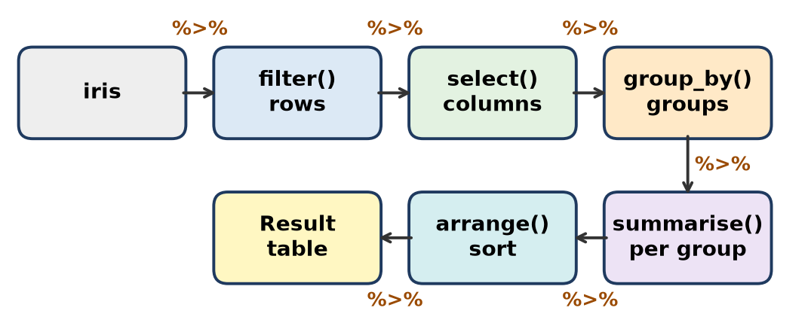
Figure: dplyr verbs joined by the pipe
1. filter() – keeps rows that satisfy conditions.
- Syntax: filter(data, condition1, condition2, ...)
filter(mtcars, cyl == 6, mpg > 20) # 6-cylinder cars with mpg > 20
2. mutate() – creates new columns or modifies existing ones; keeps all rows.
- Syntax: mutate(data, new_col = expression)
mutate(mtcars, power_to_wt = hp / wt) # adds a 12th column
Verb | Works on
filter, slice, arrange | Rows
select, mutate, rename | Columns
group_by + summarise | Groups

Remember: dplyr verbs are action words: filter, select, mutate, arrange, summarise.

Q23. Which are commands used in package tidyr to make data tidy? Explain its uses and syntax
Moderate • CO2
tidyr converts messy data into tidy data (each variable a column, each observation a row).
Command | Use | Syntax
gather() / pivot_longer() | Wide → long: many columns into key-value pair | gather(data, key, value, cols)
spread() / pivot_wider() | Long → wide: key-value pair into many columns | spread(data, key, value)
separate() | Split one column into many | separate(data, col, into = c("a","b"), sep = "-")
unite() | Join many columns into one | unite(data, new, col1, col2, sep = "_")
drop_na() | Remove rows with NA | drop_na(data, cols)
replace_na() | Replace NA by a value | replace_na(x, value)
fill() | Fill NA with previous/next value | fill(data, col, .direction = "down")

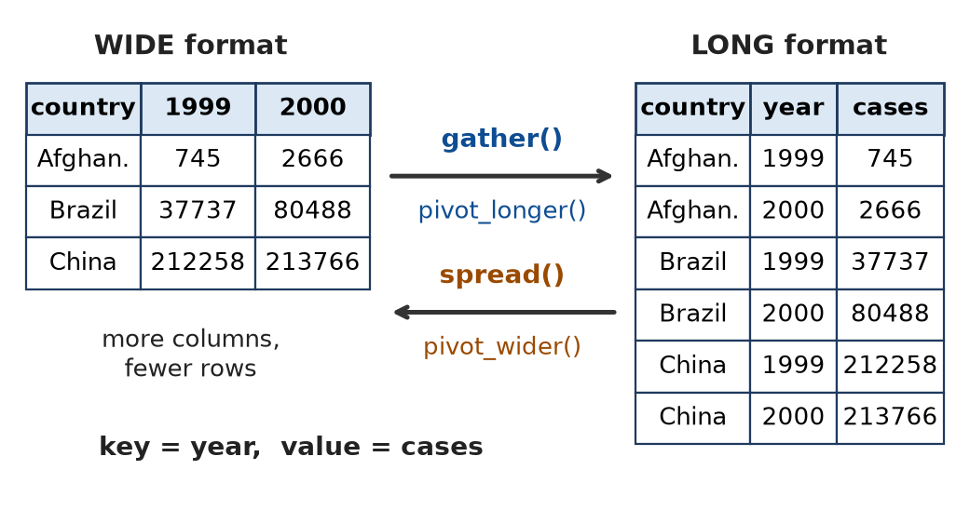
Figure: gather() and spread()
table4a %>% gather(key = "year", value = "cases", `1999`, `2000`)
table3 %>% separate(rate, into = c("cases", "population"), sep = "/")
Remember: Gather–Spread reshape, Separate–Unite split/join, drop/replace NA clean.

Q24. What is tidy data? Differentiate between purposes of gather and unite command with their syntax.
Moderate • CO2
Tidy data is data arranged so that:
1. Each variable is in its own column.
2. Each observation is in its own row.
3. Each value is in its own cell.
Tidy data works directly with dplyr, ggplot2 and models.
Basis | gather() | unite()
Purpose | Converts many columns into key–value rows (wide → long) | Combines several columns into one column
Effect on shape | Rows increase, columns decrease | Rows same, columns decrease
When used | Column names are values (e.g. years 1999, 2000) | One variable split across columns (e.g. century + year)
Syntax | gather(data, key = "k", value = "v", cols) | unite(data, new_col, col1, col2, sep = "_")
Reverse | spread() | separate()

gather(table4a, key = "year", value = "cases", 2:3) # 6 rows x 3 cols
unite(table5, new_year, century, year, sep = "") # "19"+"99" -> "1999"
Remember: Tidy: variable = column, observation = row, value = cell.

Q25. What is the main objective of the package dplyr' in the data analysis process? Give any two commands from dplyr' with examples
Moderate • CO2
Objective: dplyr provides a fast, simple and consistent set of verbs to manipulate data frames – pick rows and columns, create variables, sort, and summarise by groups – so that data is ready for analysis. Code is readable because of the pipe `%>%`.
Key points:
1. One verb = one task (easy to remember).
2. Works on data frames/tibbles and databases.
3. Fast (written in C++), chainable with %>%.
Command 1: select() – choose columns.
select(iris, Species, Petal.Length) # 150 x 2
Command 2: group_by() + summarise() – summary per group.
mtcars %>% group_by(am) %>% summarise(avg_mpg = mean(mpg), n = n())
# am 0 (auto): 17.1 mpg, 19 cars; am 1 (manual): 24.4 mpg, 13 cars
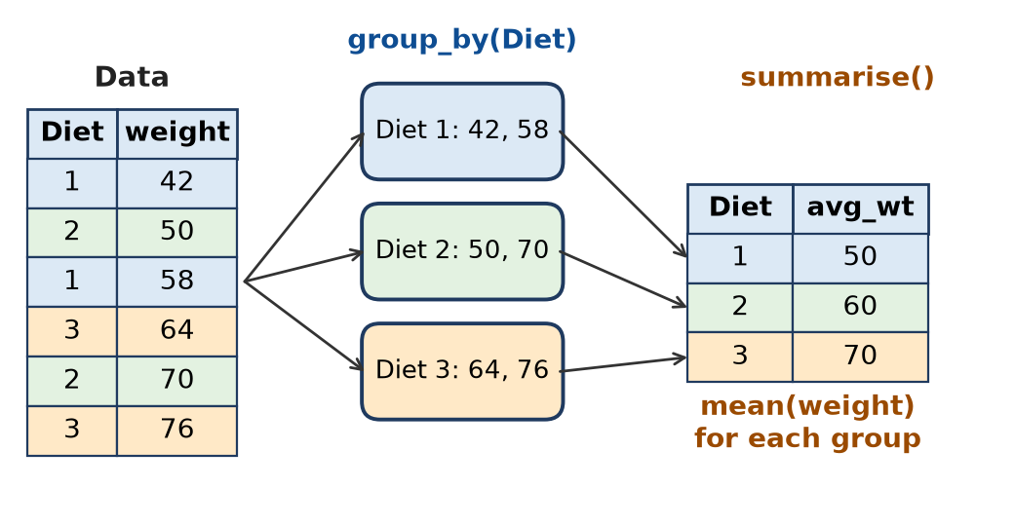
Figure: group_by() then summarise(): split–apply–combine
Remember: dplyr = data pliers: grip, cut and shape the data frame.

Q26. Write uses and difference between commands: gather and unite.
Moderate • CO2
Uses of gather():
1. Reshape wide data to long format for ggplot2 and grouping.
2. Turn column headings that are values (years, weeks, subjects) into a variable.
3. Example: gather(billboard, key = "week", value = "rank", wk1:wk76).
Uses of unite():
1. Paste two or more columns into one (first + last name, day-month-year → date).
2. Create an ID or label column, e.g. unite(df, ID, Branch, Roll, sep = "-") → "COMP-12".
Basis | gather() | unite()
Action | Columns → rows (key-value) | Columns → single column
Output shape | Longer | Narrower, same rows
Arguments | key, value, columns to stack | new name, columns, sep
Opposite | spread() | separate()
Newer function | pivot_longer() | –

Figure: gather() and spread()
Remember: gather makes data long; unite makes columns fewer.

Q27. How many semi-furnished houses are having more than 4 parking? Write the command for this.
Moderate • CO2
(Dataset IndianHouses: columns Area, BHK, Bathroom, Furnishing, Locality, Parking, Price, Status, Transaction, Type, Per_Sqft.)
library(dplyr)
IH <- read.csv("IndianHouses.csv")
IH %>%
filter(Furnishing == "Semi-Furnished", Parking > 4) %>%
count() # or nrow()
# base R
sum(IH$Furnishing == "Semi-Furnished" & IH$Parking > 4, na.rm = TRUE)
- Two conditions (AND): Furnishing is "Semi-Furnished" and Parking > 4.
- The value must match the spelling in the data exactly (check with unique(IH$Furnishing)).
- na.rm = TRUE ignores houses whose Parking is NA.
Remember: filter both conditions, then count().

Q28. Write the code to find the count of houses as per locality?
Moderate • CO2
library(dplyr)
IH %>% count(Locality) # one row per locality with n
IH %>% count(Locality, sort = TRUE) # most common first
IH %>% group_by(Locality) %>% summarise(houses = n())
table(IH$Locality) # base R
- count(x) is a short form of group_by(x) %>% summarise(n = n()).
- sort = TRUE shows localities with most houses at the top.
Remember: count() = group_by + n().

Q29. What is average price of the Indian houses according to Transaction?
Moderate • CO2
library(dplyr)
IH %>%
group_by(Transaction) %>%
summarise(avg_price = mean(Price, na.rm = TRUE)) %>%
arrange(desc(avg_price))
# base R
aggregate(Price ~ Transaction, data = IH, FUN = mean)
- Transaction has categories such as New_Property and Resale; the output has one row per type with its average price.
- This helps compare whether new properties cost more than resale ones.
Remember: Group by Transaction, summarise mean(Price).

Q30. Calculate the average percentage of Operating Systems, Programming, and Algorithms observed for each suggested job role
Moderate • CO2
(Column names as read by read.csv(); confirm with names(sp).)
library(dplyr)
sp <- read.csv("students_placement_Data.csv")
sp %>%
group_by(Suggested.Job.Role) %>%
summarise(
avg_OS = mean(Acedamic.percentage.in.Operating.Systems, na.rm = TRUE),
avg_Prog = mean(Percentage.in.Programming.Concepts, na.rm = TRUE),
avg_Algo = mean(percentage.in.Algorithms, na.rm = TRUE)
)
- group_by() creates one group per job role; summarise() gives the three averages for each role.
- Output: one row per suggested job role with three average percentages.
Remember: One group_by, three means inside one summarise.

Q31. Create a new data with following properties, Remove the unnecessary variable 32 and 36 and extract students with good coding skills rating greater than 5
Moderate • CO2
library(dplyr)
new_data <- sp %>%
select(-c(32, 36)) %>% # drop 32nd and 36th columns
filter(coding.skills.rating > 5) # good coders only
dim(new_data) # fewer rows, 2 fewer columns
# base R
new_data <- sp[sp$coding.skills.rating > 5, -c(32, 36)]
- A minus sign in select() removes columns (by position or name).
- filter() keeps rows with coding skills rating above 5.
- <- saves the result as a new data frame.
Remember: select(-) removes, filter() keeps.

Q32. Create a data without applying any filter consider observation 101 to 200 containing only percentage with suggested job
Moderate • CO2
library(dplyr)
data_pct <- sp %>%
slice(101:200) %>% # rows 101 to 200
select(contains("percentage"), Suggested.Job.Role) # % columns + job role
dim(data_pct) # 100 rows
- slice() selects by position (no condition = no filter).
- contains("percentage") picks every column whose name has the word percentage (case is ignored by default).
- Base R: sp[101:200, c(grep("percentage", names(sp), ignore.case = TRUE), ncol(sp))] (job role is the last column).
Remember: slice for positions, contains() for similar column names.

Q34. Consider the inbuilt dataset ChickWeight. 1. Extract observations where weight is greater than 200. 2. Select the columns weight, Time, and Diet.
Moderate • CO2
ChickWeight has 578 rows and 4 columns: weight (g), Time (days), Chick, Diet (1–4).
library(dplyr)
ChickWeight %>%
filter(weight > 200) %>% # 1. heavy chicks only
select(weight, Time, Diet) # 2. three columns
- filter() first reduces rows, then select() keeps 3 columns.
- Chicks start at about 40 g, so weights above 200 g appear only in the later days of the study.
- Base R: ChickWeight[ChickWeight$weight > 200, c("weight", "Time", "Diet")]
Remember: Rows first (filter), then columns (select).

Q35. Consider the inbuilt dataset ChickWeight. i) Find the average weight for each diet. ii) Arrange the average weights in descending order.
Moderate • CO2
library(dplyr)
ChickWeight %>%
group_by(Diet) %>%
summarise(avg_weight = mean(weight)) %>%
arrange(desc(avg_weight))
Output (approx.):
Diet | avg_weight
3 | 142.95
4 | 135.26
2 | 122.62
1 | 102.65

Steps: group by Diet → mean weight per group → sort highest first. Diet 3 gives the highest average weight.
Figure: group_by() and summarise() idea
Remember: Group, summarise, arrange(desc()) — the classic dplyr trio.

Q36. Refer the dataset healthcare_data' and write the commands to get the new data for the following: Create a subset of above dataset for age' greater than 65 and save as H1. Use H1, to find mean of bmi' as per categories under gender'.
Difficult • CO2
Situation: we need elderly patients (age > 65) and their average BMI for each gender.
library(dplyr)
healthcare_data <- read.csv("healthcare_data.csv")
str(healthcare_data) # check types of age, bmi
# bmi is sometimes stored as text with "N/A"; convert to numeric first
healthcare_data$bmi <- as.numeric(healthcare_data$bmi) # "N/A" -> NA
# 1. Subset for age > 65, saved as H1
H1 <- healthcare_data %>% filter(age > 65)
# base R: H1 <- subset(healthcare_data, age > 65)
nrow(H1)
# 2. Mean bmi by gender using H1
H1 %>%
group_by(gender) %>%
summarise(mean_bmi = mean(bmi, na.rm = TRUE),
patients = n())
# base R
aggregate(bmi ~ gender, data = H1, FUN = mean)
tapply(H1$bmi, H1$gender, mean, na.rm = TRUE)
Explanation:
1. filter(age > 65) keeps only patients older than 65; <- stores them as H1.
2. group_by(gender) splits H1 into gender categories (Male, Female, possibly Other).
3. summarise(mean(bmi, na.rm = TRUE)) gives one average BMI per gender; na.rm ignores missing BMI.
4. as.numeric() is a data type conversion step; without it mean() on a character column gives NA with a warning.
Step | Function | Output
Subset | filter() | H1 data frame
Group | group_by(gender) | grouped H1
Summary | summarise(mean) | one row per gender

Conclusion: filter → group_by → summarise answers "who" and "how much" in three lines.
Remember: Save the subset with <-, then group_by + summarise on it.

Q37. Refer the dataset healthcare_data' and write the commands to get the new data for the following: 1. Create a subset of above dataset for age' greater than 65 and save as H1. 2. Use H1, to find mean of bmi' as per categories under gender'.
Difficult • CO2
Same as Q36 above.
Remember: H1 <- filter(age > 65); then group_by(gender) + mean(bmi).

Q38. For the dataset airquality'-Write command to get a new data 1. Find average of Ozone' for wind speed greater than 7.5 2. Sort the data for "month" in descending order and remove if any NA values.
Difficult • CO2
library(dplyr); library(tidyr)
# 1. Average Ozone when Wind > 7.5
ozone_wind <- airquality %>%
filter(Wind > 7.5) %>%
summarise(avg_ozone = mean(Ozone, na.rm = TRUE))
ozone_wind
# base R
mean(airquality$Ozone[airquality$Wind > 7.5], na.rm = TRUE)
# 2. Remove NA rows and sort by Month (descending)
new_data <- airquality %>%
drop_na() %>% # or na.omit(airquality)
arrange(desc(Month))
nrow(new_data) # 111
head(new_data) # September (Month 9) rows first
Explanation:
1. filter(Wind > 7.5) keeps windy days; mean(Ozone, na.rm = TRUE) is needed because Ozone has NA values. Strong wind disperses pollution, so this average is lower than the overall Ozone mean (42.13).
2. drop_na() removes the 42 rows with any NA (37 Ozone + 7 Solar.R, with 2 rows common), leaving 111 complete rows; arrange(desc(Month)) puts Month 9 first and Month 5 last.
Task | Key function | Result
Average with condition | filter + summarise | one value
Remove NA | drop_na() | 153 → 111 rows
Sort descending | arrange(desc()) | Month 9 → 5

Remember: Clean first (drop_na), then sort (arrange desc).

Q39. Write the code for the following: Import the given dataset of car_price_prediction, do we need to change the data type for a few variables? If yes, change the data type (Paste the code generated in console). Extract the number of observations from 101-250 from the given dataset and create a new file Data1'. Generate multiple columns using Gear.box.type as a Key column and Price as a Value column and save it as a new data frame Data2'.
Difficult • CO2
library(dplyr); library(tidyr)
car <- read.csv("car_price_prediction.csv")
str(car) # check types
# 1. Data type conversion
car$Levy <- as.numeric(na_if(car$Levy, "-")) # "-" means missing
car$Mileage <- as.numeric(gsub(" km", "", car$Mileage)) # "186005 km" -> 186005
car$Manufacturer <- as.factor(car$Manufacturer)
car$Category <- as.factor(car$Category)
car$Fuel.type <- as.factor(car$Fuel.type)
car$Gear.box.type <- as.factor(car$Gear.box.type)
str(car) # verify new types
# 2. Rows 101 to 250 -> Data1 (and save as a file)
Data1 <- slice(car, 101:250) # 150 observations
write.csv(Data1, "Data1.csv", row.names = FALSE)
# 3. Gear.box.type as key, Price as value -> Data2
Data2 <- car %>%
distinct() %>% # duplicate rows would block spread
spread(key = Gear.box.type, value = Price)
# new style: pivot_wider(names_from = Gear.box.type, values_from = Price)
names(Data2) # Automatic, Manual, Tiptronic, Variator columns
Is type change needed? Yes.
1. Levy is read as character because missing values are written as "-".
2. Mileage is character because of the " km" text.
3. Categorical columns (Manufacturer, Category, Fuel.type, Gear.box.type) are better as factors for grouping and plots.
Spread result: each gear-box type becomes a new column filled with that car's Price; other types get NA. Since every row has a unique ID, rows stay separate.
Remember: Check str(), convert types, slice rows, spread(key, value).

Q40. Consider the data of A data frame with 234 rows and 11 variables. It contains only models which had a new release every year between 1999 and 2008 - this was used as a proxy for the popularity of the car. Explain the method stepwise to get a data by the manufacturer audi' and class compact' , exclude column year' and drv'
Difficult • CO2
The data described is the mpg dataset of ggplot2 (234 rows, 11 variables: manufacturer, model, displ, year, cyl, trans, drv, cty, hwy, fl, class).
Steps:
1. Load packages – library(ggplot2) for the data, library(dplyr) for verbs.
2. Look at the data – str(mpg), unique(mpg$manufacturer), unique(mpg$class).
3. Filter rows – keep manufacturer "audi" and class "compact".
4. Remove columns – drop year and drv using select(-year, -drv).
5. Save and check – store as a new data frame and view it.
library(ggplot2); library(dplyr)
audi_compact <- mpg %>%
filter(manufacturer == "audi", class == "compact") %>%
select(-year, -drv)
dim(audi_compact) # 15 rows, 9 columns
View(audi_compact)
# base R
audi_compact <- subset(mpg, manufacturer == "audi" & class == "compact",
select = -c(year, drv))
Result: 15 Audi compact cars (a4 and a4 quattro models); the a6 quattro is "midsize", so it is excluded. Columns left: manufacturer, model, displ, cyl, trans, cty, hwy, fl, class.
Step | Function
Choose rows | filter()
Drop columns | select(-col)
Store | <-

Remember: Filter the rows you want, minus the columns you don't.

Q41. Cluster the columns of inbuilt dataset 'billboard' into Week and its Value; where billboard dataset has 317 observations and 79 columns about Song rankings for billboard top 100 in the year 2000
Difficult • CO2
billboard (tidyr) is wide: columns artist, track, date.entered and wk1 … wk76 (rank in each week). We gather the 76 week columns into two columns: Week (key) and Value (rank).
library(tidyr); library(dplyr)
bb_long <- billboard %>%
gather(key = "Week", value = "Value", wk1:wk76)
dim(bb_long) # 24092 rows (317 x 76), 5 columns
# drop the NA ranks (song not in the chart that week)
bb_long2 <- billboard %>%
gather(key = "Week", value = "Value", wk1:wk76, na.rm = TRUE)
# new style with pivot_longer
bb_long3 <- billboard %>%
pivot_longer(cols = starts_with("wk"), names_to = "Week",
values_to = "Value", values_drop_na = TRUE) # 5307 rows
Output (first rows):
artist | track | date.entered | Week | Value
2 Pac | Baby Don't Cry (Keep... | 2000-02-26 | wk1 | 87
2Ge+her | The Hardest Part Of ... | 2000-09-02 | wk1 | 91
3 Doors Down | Kryptonite | 2000-04-08 | wk1 | 81

- Shape changes from 317 × 79 (wide) to 24,092 × 5 (long); with NAs removed, 5,307 rows remain.
- Long format lets us plot rank versus week or find each song's best week with group_by(track) %>% summarise(best = min(Value)).
Figure: Wide to long with gather()
Remember: 317 songs × 76 weeks = 24,092 rows after gather.

Q42. Following is the data for IndianHouses'. Which command can be used to extract average price of houses and standard deviation as per the Furnishing' status. Write the syntax for it.
Difficult • CO2
The data has columns Area, BHK, Bathroom, Furnishing (Furnished, Semi-Furnished, Unfurnished), Locality, Parking, Price, Status, Transaction, Type, Per_Sqft. We use group_by() + summarise() with mean() and sd().
Syntax: data %>% group_by(group_col) %>% summarise(name1 = mean(col), name2 = sd(col))
library(dplyr)
IH <- read.csv("IndianHouses.csv")
IH %>%
group_by(Furnishing) %>%
summarise(avg_price = mean(Price, na.rm = TRUE),
sd_price = sd(Price, na.rm = TRUE),
houses = n()) %>%
arrange(desc(avg_price))
# base R alternatives
aggregate(Price ~ Furnishing, data = IH,
FUN = function(x) c(mean = mean(x), sd = sd(x)))
tapply(IH$Price, IH$Furnishing, mean)
tapply(IH$Price, IH$Furnishing, sd)
Explanation:
1. group_by(Furnishing) splits houses by furnishing status.
2. mean(Price) gives the average price; sd(Price) gives the spread of prices in that group.
3. n() shows how many houses are in each group; arrange(desc()) lists the costliest category first.
The output is a small table with one row per furnishing status (Furnished, Semi-Furnished, Unfurnished) and columns avg_price, sd_price and houses. A large SD means prices vary a lot within that group (location matters more than furnishing).
Remember: group_by + summarise(mean, sd) = centre and spread per group.

Q43. Using iris Dataset Write a single R command using the pipe operator (%>%) to: 1. Select flowers with Petal.Length greater than 4. 2. Retain only Sepal.Length, Petal.Length, and Species. 3. Group the data by Species. 4. Calculate the maximum Petal.Length for each species. 5. Arrange the results in descending order of maximum petal length.
Difficult • CO2
library(dplyr)
iris %>%
filter(Petal.Length > 4) %>% # 1. rows
select(Sepal.Length, Petal.Length, Species) %>% # 2. columns
group_by(Species) %>% # 3. groups
summarise(max_petal = max(Petal.Length),
.groups = "drop") %>% # 4. maximum
arrange(desc(max_petal)) # 5. sort
Output:
Species | max_petal
virginica | 6.9
versicolor | 5.1

Working:
1. filter() keeps flowers with petal length above 4 cm – no setosa passes (setosa petals are at most 1.9 cm), so only two species remain.
2. select() keeps three columns.
3. group_by(Species) makes groups.
4. summarise(max()) gives one row per species; .groups = "drop" removes grouping afterwards.
5. arrange(desc()) puts the largest first.
The pipe %>% passes the result of each step as the first argument to the next, so the code reads top to bottom like a recipe.
Figure: The dplyr pipeline
Remember: Filter → Select → Group → Summarise → Arrange: "FSGSA".

Q44. Consider the inbuilt dataset Titanic, which is a four-dimensional contingency table. 1. Convert the Titanic table into a data frame. 2. Rename the columns Freq and Survived to Frequency and Survival_Status, respectively. 3. Display only the records where Survival_Status is "Yes" and Frequency is greater than 50.
Difficult • CO2
Titanic is a 4-D table (Class × Sex × Age × Survived) of 2,201 people, not a data frame.
library(dplyr)
# 1. Table -> data frame (32 rows: Class, Sex, Age, Survived, Freq)
data <- as.data.frame(Titanic)
# 2 and 3. Rename (new_name = old_name) and filter
data %>%
rename(Frequency = Freq,
Survival_Status = Survived) %>%
filter(Survival_Status == "Yes",
Frequency > 50)
Output:
Class | Sex | Age | Survival_Status | Frequency
1st | Male | Adult | Yes | 57
3rd | Male | Adult | Yes | 75
Crew | Male | Adult | Yes | 192
1st | Female | Adult | Yes | 140
2nd | Female | Adult | Yes | 80
3rd | Female | Adult | Yes | 76

Explanation:
1. as.data.frame() turns every cell of the 4-D table into a row (4 × 2 × 2 × 2 = 32 rows) with a Freq count column.
2. In rename(), the new name comes first: new = old.
3. filter() with two conditions (AND) gives 6 groups; no child group has more than 50 survivors.
Remember: Table → as.data.frame(); rename(new = old); filter(AND).

Q45. Consider the inbuilt dataset USArrests. 1. Convert the row names (state names) into a separate column called State. 2. Select the states where Murder is greater than 10. 3. Calculate the average Assault value for each group formed by categorizing UrbanPop as "Below 50" or "50 and Above". 4. Arrange the results in descending order of average Assault.
Difficult • CO2
USArrests has 50 rows (states as row names) and 4 columns: Murder, Assault, UrbanPop, Rape.
library(dplyr); library(tibble)
# 1. Row names -> column 'State'
data <- rownames_to_column(USArrests, var = "State")
# 2 to 4 in one pipeline
data %>%
filter(Murder > 10) %>% # 2
mutate(Urban_Group = ifelse(UrbanPop < 50,
"Below 50", "50 and Above")) %>% # 3a
group_by(Urban_Group) %>% # 3b
summarise(avg_assault = mean(Assault), states = n()) %>% # 3c
arrange(desc(avg_assault)) # 4
Working:
1. rownames_to_column() (tibble) moves state names into a real column, because dplyr verbs work on columns, not row names.
2. filter(Murder > 10) keeps high-murder-rate states.
3. mutate() + ifelse() creates a new categorical column (binning UrbanPop into two groups); group_by() + summarise(mean()) gives the average Assault per group.
4. arrange(desc()) shows the group with higher assault first.
Step | Function | Purpose
1 | rownames_to_column() | Row names → column
2 | filter() | Murder > 10
3 | mutate(ifelse()) + group_by + summarise | Bin and average
4 | arrange(desc()) | Sort

(If step 3 is meant for all 50 states, simply remove the filter() line.) The same binning can be done with cut(UrbanPop, breaks = c(0, 49, 100), labels = c("Below 50", "50 and Above")).
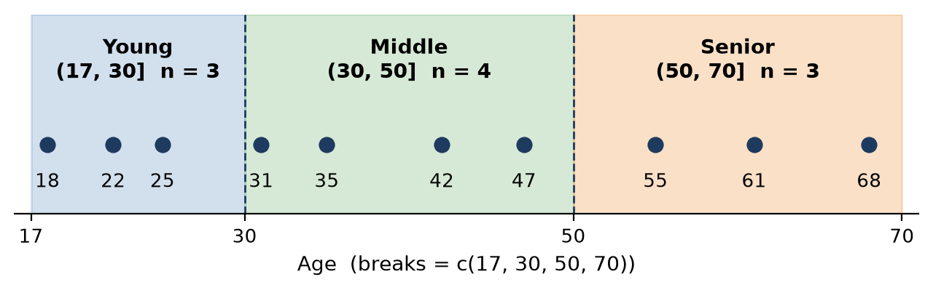
Figure: Binning: numeric values grouped into labelled intervals with cut()
Remember: Row names out, filter, bin with ifelse, summarise, sort.

Q46. Consider the following dataset student (Student, Branch, Math, Science: Amit COMP 85 78; Neha IT 72 NA; Ravi COMP NA 82; Priya IT 65 70; Karan COMP 90 NA; Sneha IT NA 85; Raj COMP 75 88; Pooja IT 80 NA). Write R command to 1. Count the number of missing values in Math and Science for each branch. 2. Replace missing Math marks with the branch-wise average Math marks.
Difficult • CO2
library(dplyr); library(tidyr)
student <- data.frame(
Student = c("Amit","Neha","Ravi","Priya","Karan","Sneha","Raj","Pooja"),
Branch = c("COMP","IT","COMP","IT","COMP","IT","COMP","IT"),
Math = c(85, 72, NA, 65, 90, NA, 75, 80),
Science = c(78, NA, 82, 70, NA, 85, 88, NA))
# 1. Branch-wise missing count
student %>%
group_by(Branch) %>%
summarise(across(c(Math, Science), ~ sum(is.na(.))))
# 2. Replace missing Math with branch-wise mean
student <- student %>%
group_by(Branch) %>%
mutate(Math = replace_na(Math, mean(Math, na.rm = TRUE))) %>%
ungroup()
Output 1:
Branch | Math | Science
COMP | 1 | 1
IT | 1 | 2

Working for 2: COMP mean Math = (85 + 90 + 75) ÷ 3 = 83.33 → Ravi gets 83.33; IT mean Math = (72 + 65 + 80) ÷ 3 = 72.33 → Sneha gets 72.33.
- across() applies the same function to several columns; ~ sum(is.na(.)) counts NAs.
- Because of group_by(), mean() inside mutate() is computed per branch, which is better than one overall mean.
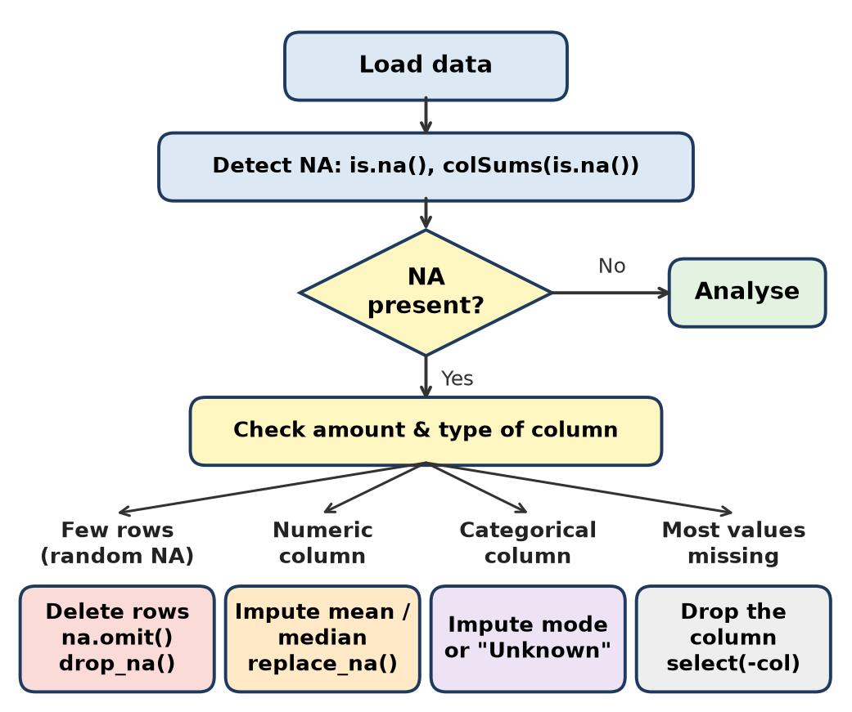
Figure: Handling missing values
Remember: Count NA with sum(is.na()); fill with group mean via group_by + mutate + replace_na.

Q47. Write R command to (Use above data) 3.Replace missing Science marks with the branch-wise average Science marks. 4.Calculate the average Math and Science marks for each branch after replacing missing values.
Difficult • CO2
library(dplyr); library(tidyr)
# 2 and 3. Replace NA with branch-wise mean
student <- student %>%
group_by(Branch) %>%
mutate(
Math = replace_na(Math, mean(Math, na.rm = TRUE)),
Science = replace_na(Science, mean(Science, na.rm = TRUE))
) %>%
ungroup()
# 4. Branch-wise averages after replacement
student %>%
group_by(Branch) %>%
summarise(Avg_Math = mean(Math), Avg_Science = mean(Science))
Working (Science means): COMP = (78 + 82 + 88) ÷ 3 = 82.67 → Karan gets 82.67; IT = (70 + 85) ÷ 2 = 77.5 → Neha and Pooja get 77.5.
Output 4:
Branch | Avg_Math | Avg_Science
COMP | 83.33 | 82.67
IT | 72.33 | 77.50

Observation: filling NA with the group mean does not change the group mean – the averages after imputation equal the averages of the available values. It only makes the data complete so that other functions work without na.rm.
- ungroup() removes grouping so later steps work on the whole data.
Remember: Mean imputation keeps the mean the same.

Q48. Consider the dataset employee (Emp_ID, Department, Gender, Salary, Experience: 101 HR F 45000 3; 102 IT M 65000 5; 103 IT F NA 7; 104 HR M 50000 NA; 105 Sales F 48000 4; 106 Sales M NA 6; 107 IT M 80000 NA; 108 HR F NA 5). Write R command to: 1.Count missing Salary and Experience values department-wise.
Difficult • CO2
library(dplyr)
employee <- data.frame(
Emp_ID = 101:108,
Department = c("HR","IT","IT","HR","Sales","Sales","IT","HR"),
Gender = c("F","M","F","M","F","M","M","F"),
Salary = c(45000, 65000, NA, 50000, 48000, NA, 80000, NA),
Experience = c(3, 5, 7, NA, 4, 6, NA, 5))
# 1. Department-wise missing values
employee %>%
group_by(Department) %>%
summarise(across(c(Salary, Experience), ~ sum(is.na(.))))
Output:
Department | Salary | Experience
HR | 1 | 1
IT | 1 | 1
Sales | 1 | 0

Working:
1. group_by(Department) makes three groups: HR (101, 104, 108), IT (102, 103, 107), Sales (105, 106).
2. is.na(.) marks missing cells as TRUE; sum() counts them; across() repeats this for both columns.
3. Total missing: Salary 3, Experience 2 (check: colSums(is.na(employee))).
Knowing where NAs are helps choose the right fix: median for skewed values like salary, mean for experience.
Remember: across(cols, ~ sum(is.na(.))) = NA count for many columns at once.

Q49. Write R command to: 2.Replace missing Salary values with the median salary of the respective department. 3.Replace missing Experience values with the mean experience of the respective department.
Difficult • CO2
library(dplyr); library(tidyr)
employee <- employee %>%
group_by(Department) %>%
mutate(
Salary = replace_na(Salary, median(Salary, na.rm = TRUE)),
Experience = replace_na(Experience, mean(Experience, na.rm = TRUE))
) %>%
ungroup()
employee
Working:
Department | Median Salary (available) | Filled for | Mean Experience (available) | Filled for
HR | median(45000, 50000) = 47500 | Emp 108 | mean(3, 5) = 4 | Emp 104
IT | median(65000, 80000) = 72500 | Emp 103 | mean(5, 7) = 6 | Emp 107
Sales | median(48000) = 48000 | Emp 106 | no NA | –

Why median for salary? Salary is often skewed by a few high values; the median is not affected by extremes. Experience is fairly symmetric, so the mean is fine.
- group_by() makes median() and mean() work within each department.
- ungroup() at the end returns a normal data frame; sum(is.na(employee)) is now 0.
Remember: Skewed → median, symmetric → mean, always within the group.

Q50. Write R command to: Find the maximum salary and average experience for each department after handling missing values.
Difficult • CO2
library(dplyr)
employee %>%
group_by(Department) %>%
summarise(Max_Salary = max(Salary),
Avg_Experience = mean(Experience))
Output (after Q49 imputation):
Department | Max_Salary | Avg_Experience
HR | 50000 | 4
IT | 80000 | 6
Sales | 48000 | 5

Working:
- HR salaries 45000, 50000, 47500 → max 50000; experience 3, 4, 5 → mean 4.
- IT salaries 65000, 72500, 80000 → max 80000; experience 5, 7, 6 → mean 6.
- Sales salaries 48000, 48000 → max 48000; experience 4, 6 → mean 5.
No na.rm is needed now because all NAs were replaced. The imputed values never exceed the observed maximum, so max() stays the same as before imputation.
Function | Gives
max() | Highest value in group
mean() | Average in group
group_by() | One result per department

Remember: After cleaning, summarise needs no na.rm.

Quick Revision – Unit II
Term / Command | Key fact
Data wrangling | Clean + structure + transform raw data into tidy data
Tidy data | Variable = column, observation = row, value = cell
dplyr verbs | filter (rows), select (cols), mutate (new col), arrange (sort), summarise, group_by, slice
Pipe %>% | Passes result of left side as first argument of right side
gather / pivot_longer | Wide → long (key, value)
spread / pivot_wider | Long → wide
unite / separate | Join columns / split a column
NA detection | is.na(), sum(is.na()), colSums(is.na()), anyNA(), complete.cases()
NA handling | drop_na()/na.omit() remove; replace_na() impute; na.rm = TRUE in mean
Mean vs median imputation | Median for skewed data (salary), mean for symmetric
Type conversion | as.numeric(), as.factor(), as.character(), as.Date()
Min-max normalization | (x − min) ÷ (max − min) → range 0 to 1
Z-score | (x − mean) ÷ sd → mean 0, sd 1
Binning | cut(x, breaks, labels) or ifelse() → numeric to categories
Key outputs | airquality drop_na → 111 rows; billboard gather → 24,092 rows; iris Petal.Length > 4 max: virginica 6.9

Unit III: Data Visualization in R Software

Q1. Using visualization show number of houses according to their 'Type'.
2 Marks • Easy • CO3
A bar chart shows the count of each level of a categorical variable. Here Type (Apartment / Builder_Floor) of the IndianHouses data is counted.
library(ggplot2)
houses <- read.csv("IndianHouses.csv")
ggplot(houses, aes(x = Type, fill = Type)) +
geom_bar() + # bar height = number of houses
labs(title = "Number of Houses by Type", x = "Type", y = "Count")
# base R: barplot(table(houses$Type), col = c("salmon", "turquoise"))
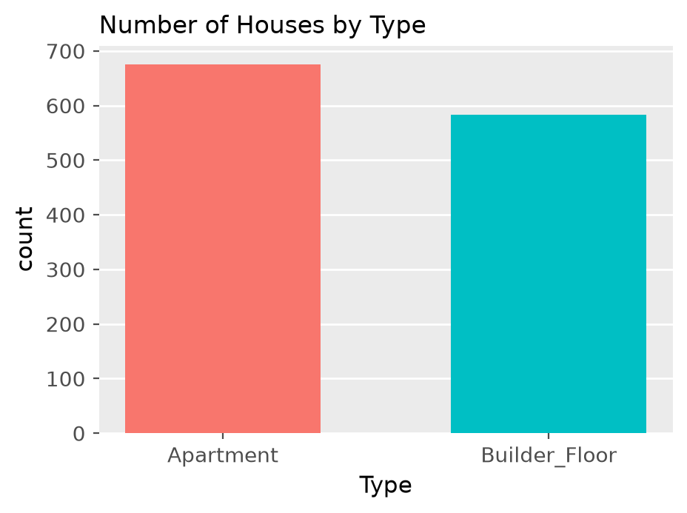
Figure: Bar chart of houses by Type (illustrative data)
- Bar height = count of houses of that type; table(houses$Type) prints the exact numbers.
- The taller bar is the more common house type (apartments in the sketch).
Remember: One categorical variable → geom_bar(); no y needed, R counts for you.

Q2. Visualize the relation between area and price according to their furnishing status with title 'Relation between Area and Price'. Also comment on Area depends on price.
2 Marks • Easy • CO3
Two numeric variables are shown with a scatter plot; the third (categorical) variable Furnishing is shown by colour.
ggplot(houses, aes(x = Area, y = Price, color = Furnishing)) +
geom_point() +
labs(title = "Relation between Area and Price", x = "Area (sq ft)", y = "Price")
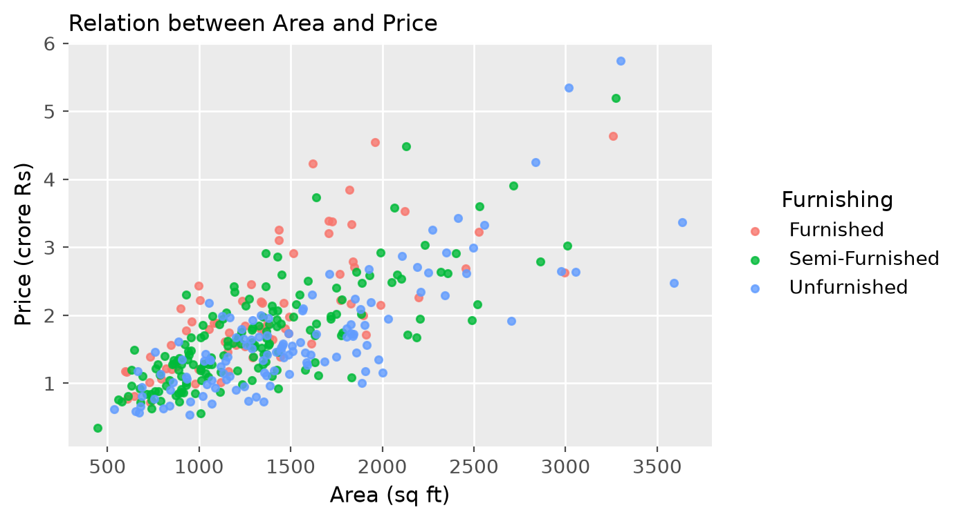
Figure: Area vs Price coloured by furnishing (illustrative data)
Comment:
- Points rise from left to right → positive relationship: bigger houses cost more (strictly, price depends on area, not the other way round).
- Spread widens for large areas, so area alone does not fix the price.
- Furnished houses usually sit a little higher than unfurnished ones of the same area.
Remember: x = cause (Area), y = effect (Price), colour = group.

Q3. Find which jobs profiles are suggested more and also compare it with visualization with appropriate plot
2 Marks • Easy • CO3
Job role is a categorical variable, so count it with table() and compare with a bar chart (horizontal, because names are long).
job <- read.csv("students_placement_Data.csv")
sort(table(job$Suggested.Job.Role), decreasing = TRUE) # most suggested first
ggplot(job, aes(y = Suggested.Job.Role)) +
geom_bar(fill = "steelblue") +
labs(title = "Suggested Job Roles", x = "Count", y = "Job role")
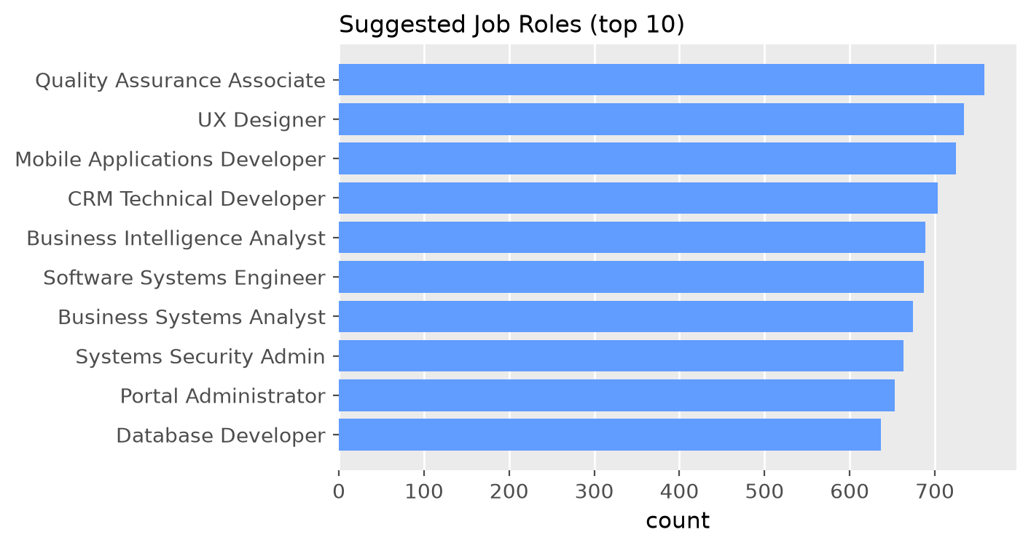
Figure: Horizontal bar chart of suggested job roles (illustrative)
- The longest bar (first row of the sorted table) is the most suggested job profile.
- Bars of almost equal length mean the roles are suggested about equally often.
Remember: Long category names → put them on the y-axis.

Q4. By visualization check whether percentage of Operating system and communication are related for this new data
2 Marks • Easy • CO3
Relation between two numeric variables → scatter plot, with a trend line to judge direction.
ggplot(job, aes(x = Acedamic.percentage.in.Operating.Systems,
y = Percentage.in.Communication.skills)) +
geom_point() +
geom_smooth(method = "lm", se = FALSE) +
labs(x = "OS %", y = "Communication %")
cor(job$Acedamic.percentage.in.Operating.Systems, job$Percentage.in.Communication.skills)
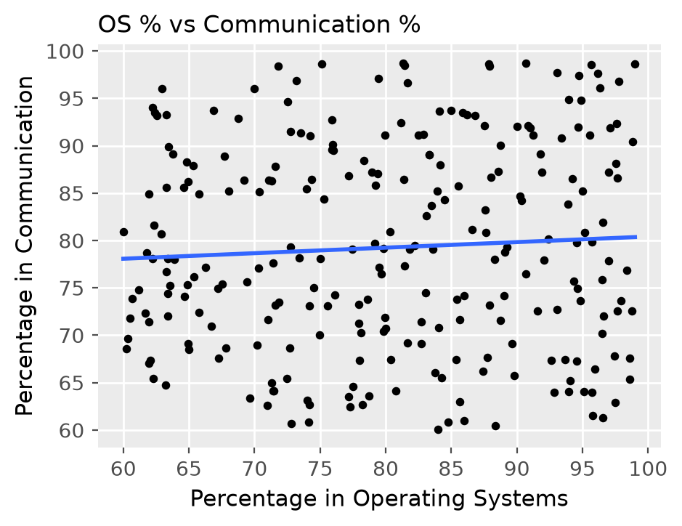
Figure: OS % vs Communication % – no pattern
- Points form a shapeless cloud and the line is almost flat.
- So OS marks and communication marks are not related (r close to 0).
Remember: Flat line + round cloud = no relationship.

Q5. Plot the graph for 'mba_p' and 'salary' as per the 'workex' by omitting NA values if any and put suitable labels (Use Placement Data)
2 Marks • Easy • CO3
salary is NA for students who were not placed, so remove NA rows first, then draw a scatter plot coloured by work experience.
placement <- read.csv("Placement_Data_Full_Class.csv")
pl <- na.omit(placement[, c("mba_p", "salary", "workex")])
ggplot(pl, aes(x = mba_p, y = salary, color = workex)) +
geom_point() +
labs(title = "MBA % vs Salary by Work Experience",
x = "MBA percentage", y = "Salary (Rs)", color = "Work exp.")
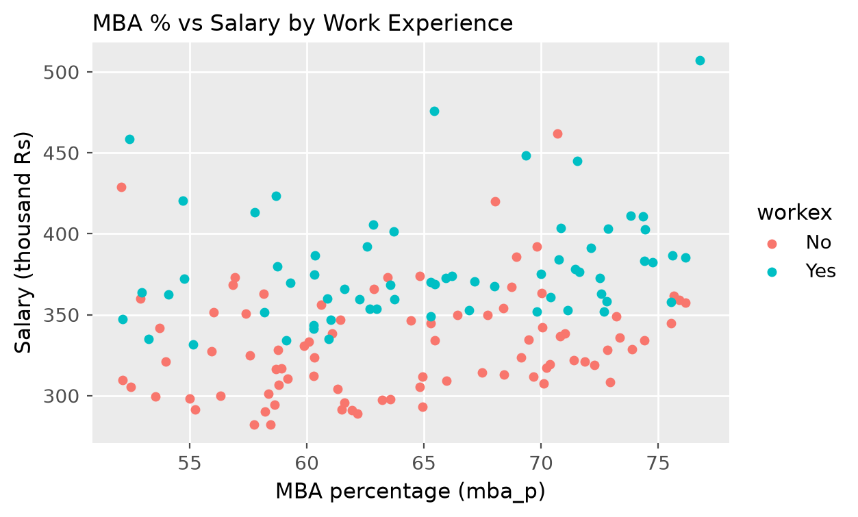
Figure: MBA % vs salary by workex (illustrative)
- Only placed students remain after na.omit().
- Salary rises only slightly with MBA %; students with work experience tend to get somewhat higher salaries.
Remember: na.omit() before plotting avoids the "rows removed" warning.

Q6. Find the graph of 'specialization' as per the placement 'status' and put suitable labels (Use Placement Data)
2 Marks • Easy • CO3
Two categorical variables → grouped (dodged) bar chart. (In the Placement file the column is spelt specialisation.)
ggplot(placement, aes(x = specialisation, fill = status)) +
geom_bar(position = "dodge") +
labs(title = "Specialisation vs Placement Status",
x = "Specialisation", y = "Number of students", fill = "Status")
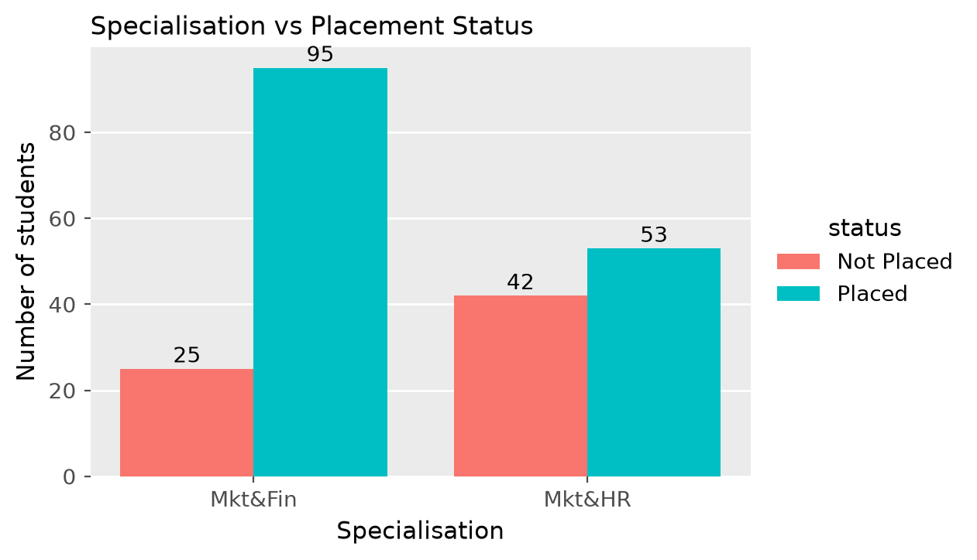
Figure: Specialisation by placement status (illustrative counts)
- Compare the two bars inside each specialisation.
- Mkt&Fin has many more placed than not-placed students; Mkt&HR has a larger share of not placed → Finance students are placed more often.
Remember: position = "dodge" = side by side, default = stacked.

Q7. Explain the following any two plots by their uses and interpretation: I. Bar-plot II. Violin plot III. Scatter Plot
2 Marks • Easy • CO3
1. Bar plot – geom_bar() / barplot()
- Use: compare counts (or totals) of categories, e.g. number of cars per cyl.
- Read: taller bar = more frequent category; bars are separated by gaps.
2. Violin plot – geom_violin()
- Use: show the shape of a numeric distribution for each group; it is a boxplot + mirrored density curve.
- Read: wide part = many values there; narrow neck = few values; two bulges = two peaks (bimodal).
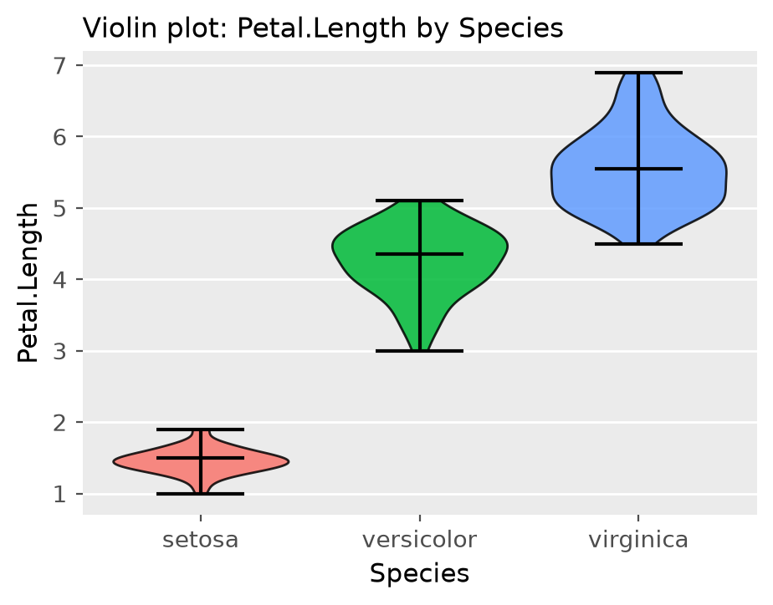
Figure: Violin plot of iris Petal.Length by species
3. Scatter plot – geom_point(): shows the relationship between two numeric variables; upward cloud = positive, downward = negative, no pattern = no relation; far points = outliers.
Remember: Bar = count, Violin = shape per group, Scatter = relation.

Q8. Create a data frame 'Student_count' (group: Arts 30, Commerce 23, Science 16, Engineering 21), and get a Pie chart by ggplot showing strength of the students as per group.
2 Marks • Easy • CO3
ggplot has no geom_pie; a pie is a one-bar stacked bar chart in polar coordinates.
Student_count <- data.frame(
group = c("Arts", "Commerce", "Science", "Engineering"),
Num_student = c(30, 23, 16, 21))
ggplot(Student_count, aes(x = "", y = Num_student, fill = group)) +
geom_bar(stat = "identity", width = 1) +
coord_polar(theta = "y") + # turns the bar into a pie
labs(title = "Strength of students as per group") +
theme_void()
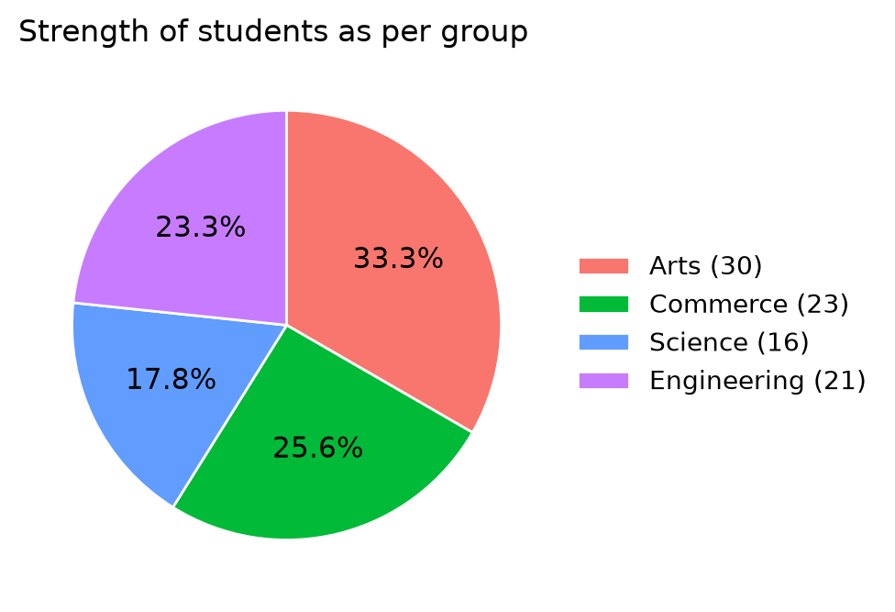
Figure: Pie chart of students per group (total 90)
- Total = 90; Arts is the biggest slice (30/90 = 33.3 %), Science the smallest (17.8 %).
Remember: Pie in ggplot = geom_bar(stat = "identity") + coord_polar("y").

Q9. Differentiate between the following plots as per the data type also explain how this plot can be interpreted: 1. Boxplot 2. Histogramme 3. Barplot 4. Scatterplot
2 Marks • Easy • CO3
Plot | Data type | R function | How to interpret
Boxplot | Numeric (optionally by a categorical group) | geom_boxplot() | Median line, box = middle 50 % (IQR), whiskers = range, dots = outliers
Histogram | One numeric (continuous) | geom_histogram() | Shape of distribution: centre, spread, skew, peaks
Barplot | One categorical | geom_bar() | Height = count of each category; bars have gaps
Scatterplot | Two numeric | geom_point() | Direction and strength of relationship, outliers

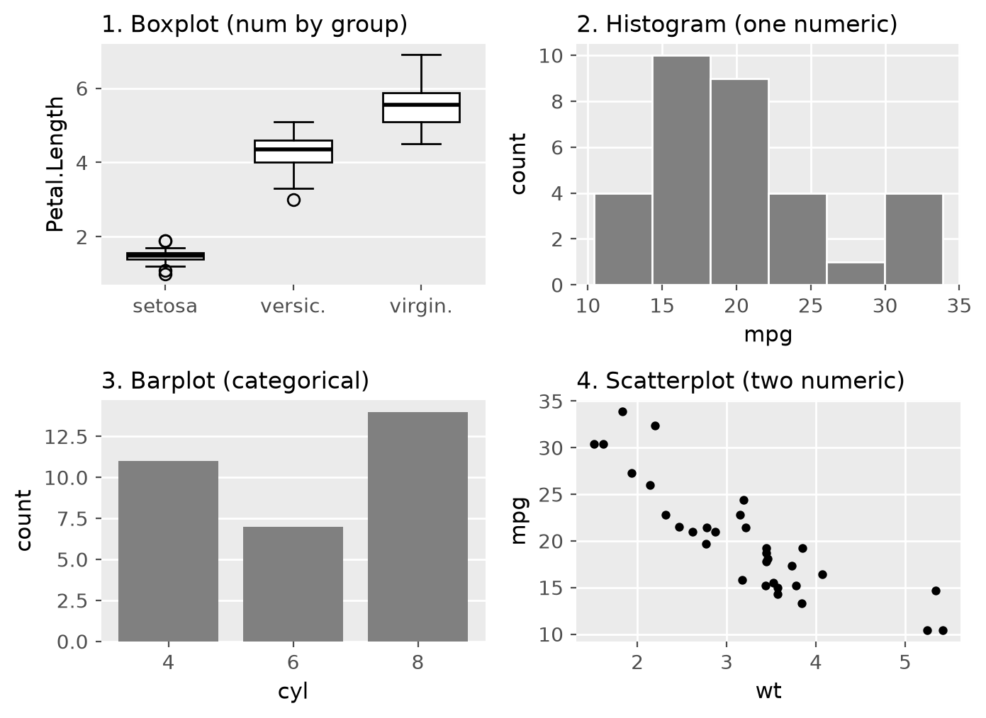
Figure: The four plot types
Remember: Histogram bars touch (numbers); bar-plot bars have gaps (categories).

Q10. Write syntax to get the following plot for data 'mpg' (stacked bar chart titled "Composition": x = factor(cyl), fill = factor(gear))
2 Marks • Easy • CO3
The plot shows cylinders 4, 6, 8 with gears 3, 4, 5 – these variables are in mtcars (the mpg data has no gear), so the plot is made from mtcars.
library(ggplot2)
ggplot(mtcars, aes(x = factor(cyl), fill = factor(gear))) +
geom_bar() + # stacked by default
ggtitle("Composition")
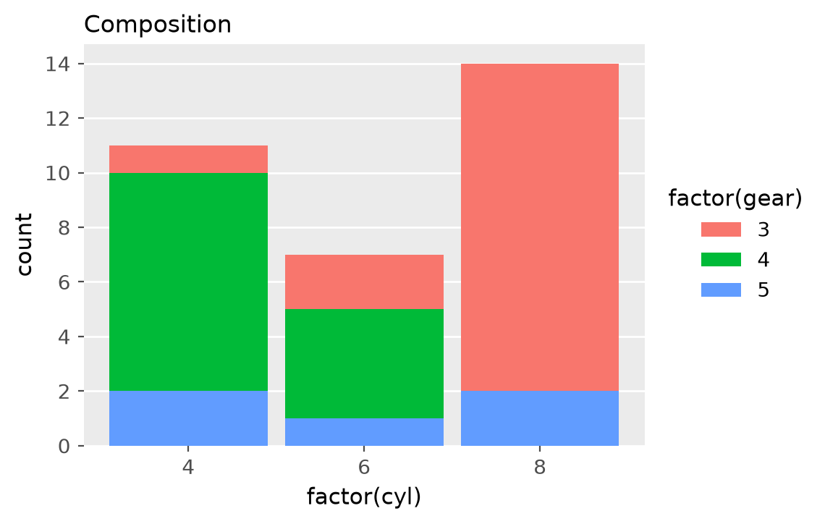
Figure: Stacked bar chart of cyl by gear (mtcars)
- 4-cyl: 11 cars (mostly 4 gears); 6-cyl: 7 cars; 8-cyl: 14 cars (12 with 3 gears, 2 with 5 gears).
- factor() makes the numbers act as categories.
Remember: fill = a second category → stacked bars.

Q11. What combination of carat, cut, color, and clarity results in the highest diamond prices?
2 Marks • Easy • CO3
Group the diamonds data (ggplot2) by the three quality grades, average the price, and sort.
library(dplyr); library(ggplot2)
diamonds %>%
group_by(cut, color, clarity) %>%
summarise(avg_price = mean(price), avg_carat = mean(carat), n = n()) %>%
arrange(desc(avg_price)) %>% head()
diamonds[which.max(diamonds$price), ] # single costliest diamond
ggplot(diamonds, aes(carat, price, color = clarity)) + geom_point(alpha = 0.3)
Findings:
- Carat is the strongest driver – the top-priced groups are always the ones with the largest average carat.
- For the same carat, better colour (D–F) and better clarity (IF, VVS1) with a good cut raise the price.
- The costliest single diamond (USD 18,823) is a 2.29-carat Premium, colour I, VS2 – big size beats grade.
Remember: Size first, then colour and clarity.

Q12. Create a data to get count of diamonds to get color variations across different clarity grades. (Use data Diamonds)
2 Marks • Easy • CO3
A two-way frequency table (colour × clarity) gives the counts; a mosaic plot or stacked bar shows it.
cc <- as.data.frame(table(diamonds$color, diamonds$clarity))
names(cc) <- c("color", "clarity", "count")
# dplyr: diamonds %>% count(clarity, color)
ggplot(diamonds, aes(x = clarity, fill = color)) + geom_bar(position = "fill")
mosaicplot(table(diamonds$clarity, diamonds$color), color = TRUE, main = "Clarity vs Color")
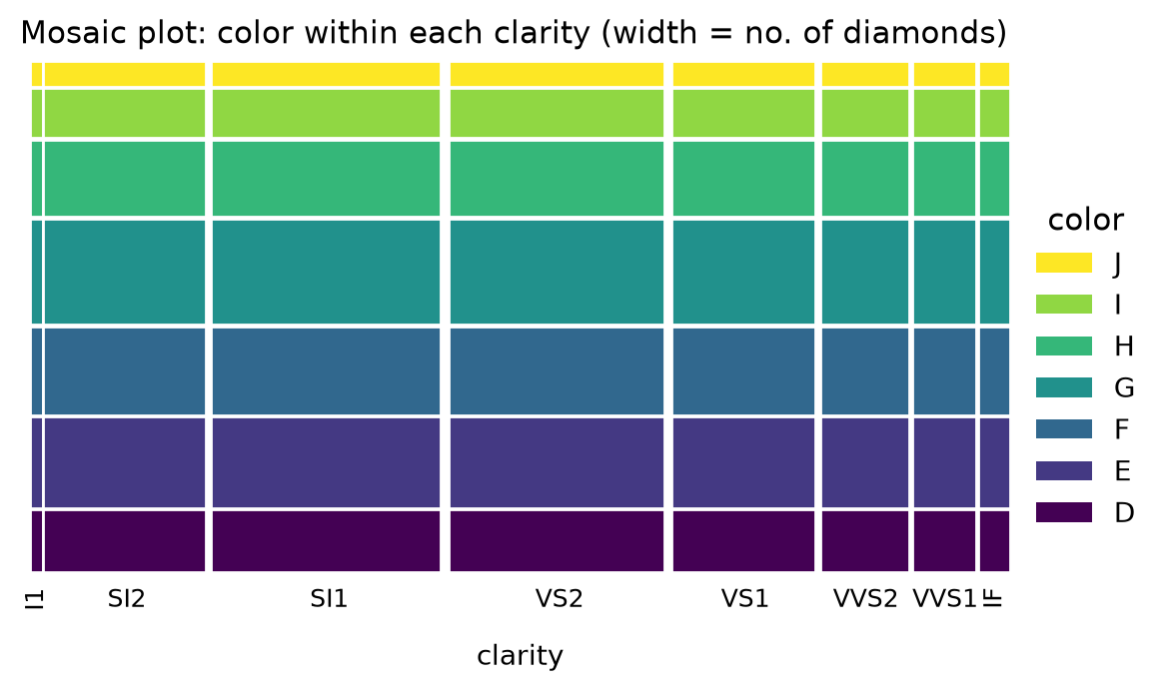
Figure: Mosaic plot – column width = number of diamonds in each clarity (shares approximate)
- In a mosaic plot width = size of the clarity group, height of each tile = share of each colour.
- SI1 and VS2 are the largest clarity groups; I1 and IF are the smallest.
Remember: Mosaic = area shows the count of each combination.

Q13. How many diamonds exist in the dataset for each color grade, compare it. (Use data Diamonds)
2 Marks • Easy • CO3
table(diamonds$color)
ggplot(diamonds, aes(x = color, fill = color)) + geom_bar() +
labs(title = "Diamonds per colour grade")
D | E | F | G | H | I | J
6775 | 9797 | 9542 | 11292 | 8304 | 5422 | 2808

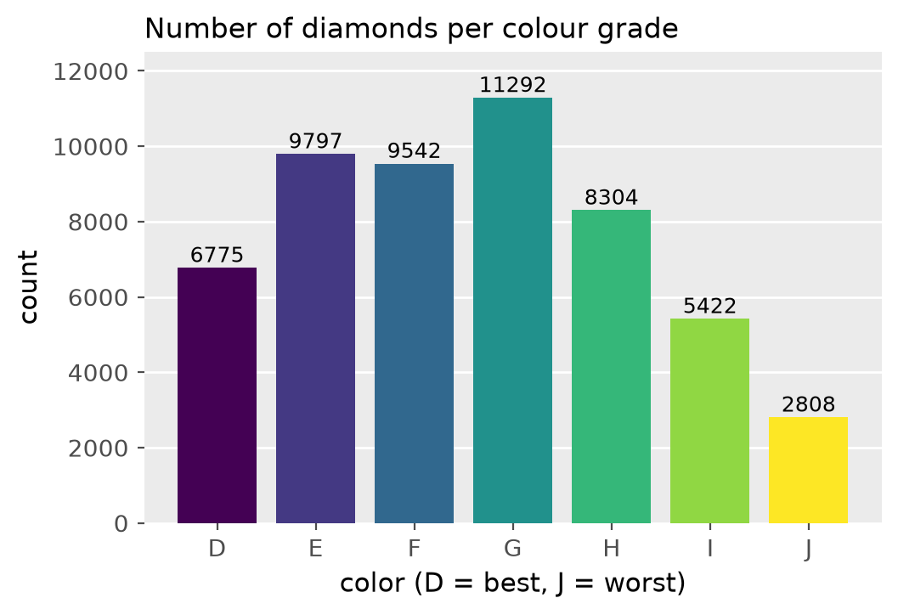
Figure: Count of diamonds per colour grade
- G is the most common grade (11,292), followed by E and F.
- J (worst colour) is the rarest (2,808); D (best colour) is also fairly few.
- Total = 53,940 diamonds.
Remember: "G is the Giant, J is the Junior".

Q14. Does the impact of carat weight on price differ depending on the diamond's cut quality (Fair, Good, Very Good, etc.)?
2 Marks • Easy • CO3
Draw carat vs price with a separate trend line for each cut (colour = cut) or facets.
ggplot(diamonds, aes(x = carat, y = price, color = cut)) +
geom_point(alpha = 0.2) +
geom_smooth(se = FALSE) +
labs(title = "Carat vs Price by Cut")
# or + facet_wrap(~ cut)
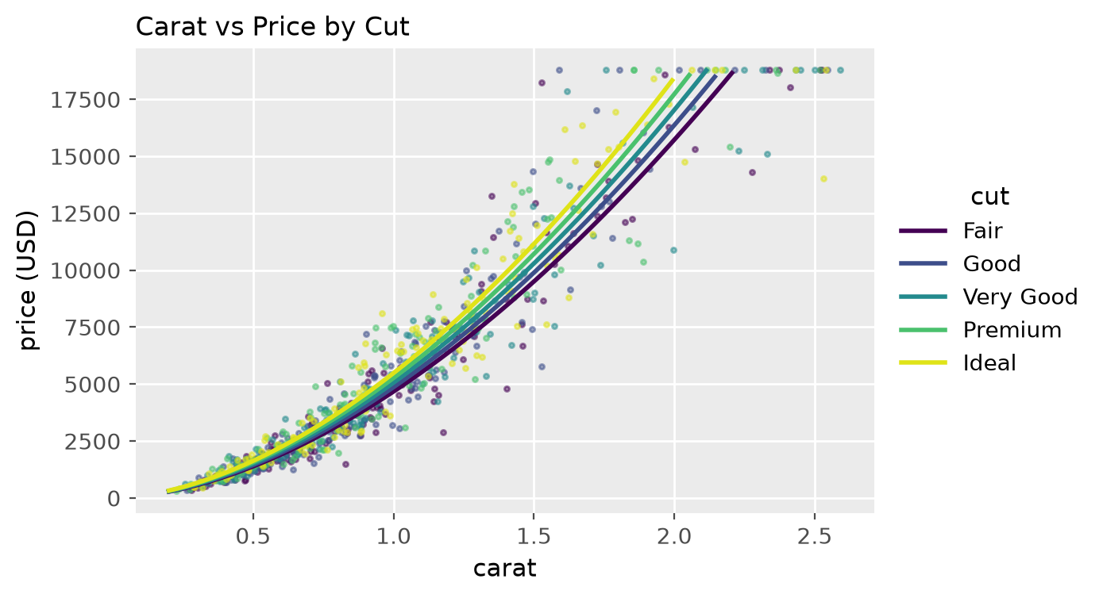
Figure: Carat vs price, one line per cut (illustrative)
- Price rises steeply with carat for every cut.
- At the same carat, Ideal/Premium lines lie slightly above Fair, so better cut gives a little extra price, but the effect of cut is small compared with carat.
Remember: Lines nearly parallel → cut changes price a little, carat changes it a lot.

Q15. 500 students are enrolled for sports as follows (Cricket 121, Baseball 90, Hockey 110, Athletics 91, Chess 88). Write the code to describe the participation with Pie chart. Also, tell significance of Pie chart for Data visualization.
2 Marks • Easy • CO3
sports <- c(Cricket = 121, Baseball = 90, Hockey = 110, Athletics = 91, Chess = 88)
pct <- round(sports / sum(sports) * 100, 1)
pie(sports, labels = paste0(names(sports), " ", pct, "%"),
col = rainbow(5), main = "Sports participation (500 students)")
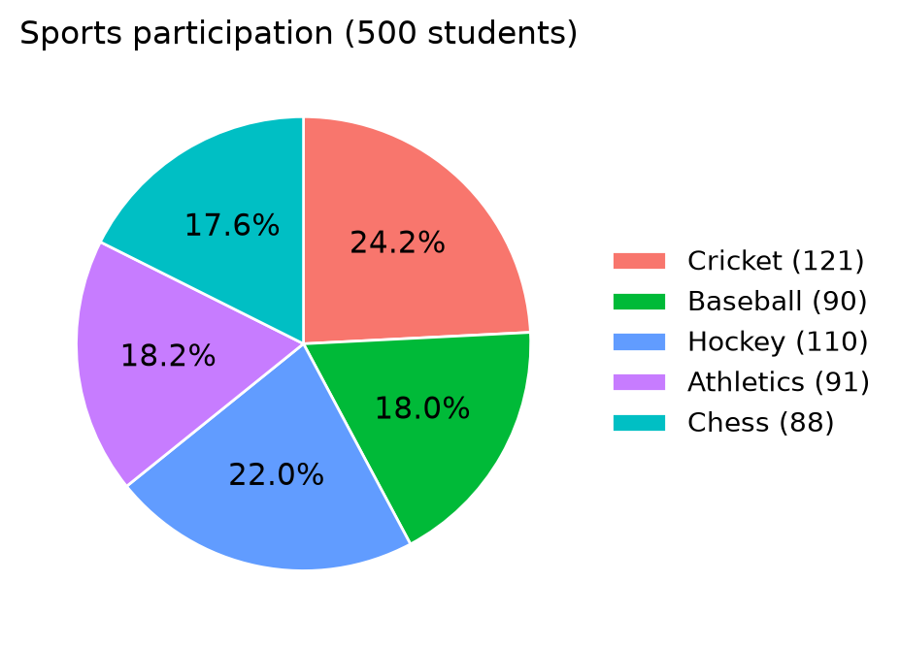
Figure: Pie chart of sports participation
Significance of a pie chart:
- Shows part-to-whole: each slice = share of the total (Cricket 24.2 %, Hockey 22 %, Chess 17.6 %).
- Easy for non-technical readers; best for few categories (≤ 6).
- Not good for close values – use a bar chart then.
Remember: Pie = parts of 100 %.

Q16. How does the distribution of diamond color vary across different clarity grades, and which color grades are more in all clarity categories?
2 Marks • Easy • CO3
Use a proportional stacked bar (each clarity bar = 100 %) so colour shares can be compared.
ggplot(diamonds, aes(x = clarity, fill = color)) +
geom_bar(position = "fill") +
labs(y = "Proportion", title = "Colour share within each clarity")
prop.table(table(diamonds$clarity, diamonds$color), margin = 1)
Figure: Colour within each clarity (mosaic view)
- The colour mix is similar in every clarity grade – no grade is made only of one colour.
- G, E and F take the largest shares in almost every clarity category (G is highest overall).
- J has the smallest share everywhere.
Remember: position = "fill" compares shares, not counts.

Q17. What is the relationship between a diamond's carat weight and its price? Does the price increase linearly with carat?
2 Marks • Easy • CO3
ggplot(diamonds, aes(x = carat, y = price)) +
geom_point(alpha = 0.2) + geom_smooth()
cor(diamonds$carat, diamonds$price) # about 0.92
Figure: Carat vs price – curved, fan-shaped
- Strong positive relationship (r ≈ 0.92): heavier diamonds cost more.
- Not linear: the cloud bends upward – price rises faster than carat (curved), and spread grows at high carat.
- Taking logs (log(price) ~ log(carat)) makes it almost a straight line.
Remember: Double the carat → more than double the price.

Q18. Identify the error and rewrite the correct code to create a scatter plot using the mtcars dataset. ggplot(mtcars, aes(x = wt, y = mpg)) + geom_point
2 Marks • Easy • CO3
Error: geom_point is a function and is written without brackets (), so no layer is added (R prints the function or gives an error). Also load ggplot2 first.
library(ggplot2)
ggplot(mtcars, aes(x = wt, y = mpg)) + geom_point()
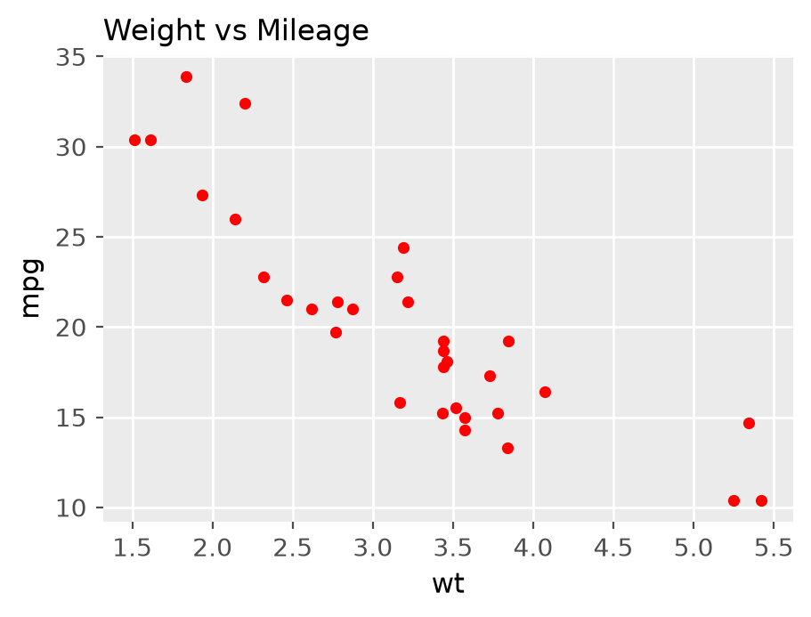
Figure: Scatter of wt vs mpg (mtcars)
- Output: heavier cars (high wt) give lower mpg – negative relationship.
Remember: Every geom ends with ().

Q19. Identify the error and rewrite the correct code to create a scatter plot using the iris dataset. ggplot(iris, aes(x = Sepal.Length, y = Petal.Length)) + geom_point(color = blue)
2 Marks • Easy • CO3
Error: a fixed colour name is text, so it must be in quotes. Without quotes R looks for an object called blue → "object 'blue' not found".
ggplot(iris, aes(x = Sepal.Length, y = Petal.Length)) +
geom_point(color = "blue")
- Fixed colour (same for all points) → outside aes(), in quotes.
- Colour by a variable → inside aes(), no quotes (e.g. aes(color = Species)).
Remember: Constant in quotes outside aes; variable inside aes.

Q20. Identify the error and rewrite the correct code to give a title to the scatter plot. ggplot(mtcars, aes(x = wt, y = mpg)) + geom_point() + ggtitle = "Weight vs Mileage"
2 Marks • Easy • CO3
Error: ggtitle is a function, not a variable; it cannot be assigned with =. The title must be passed as an argument inside brackets.
ggplot(mtcars, aes(x = wt, y = mpg)) +
geom_point() +
ggtitle("Weight vs Mileage")
# same: + labs(title = "Weight vs Mileage")
Remember: Ggplot parts are added with + and called with ().

Q21. Differentiate between geom_point() and geom_line() with suitable applications.
4 Marks • Moderate • CO3
Both are geometric layers of ggplot2 that use x and y aesthetics, but they draw the data differently.
Point | geom_point() | geom_line()
Draws | Separate dots, one per row | Dots joined by a line in order of x
Plot made | Scatter plot | Line chart / time-series
Data | Two numeric variables, no order needed | x is ordered (time, date, sequence)
Shows | Relationship, clusters, outliers | Trend, rise and fall over time
Example | ggplot(mtcars, aes(wt, mpg)) + geom_point() | ggplot(economics, aes(date, unemploy)) + geom_line()
Application | Weight vs mileage, height vs weight | Monthly sales, stock price, temperature over days

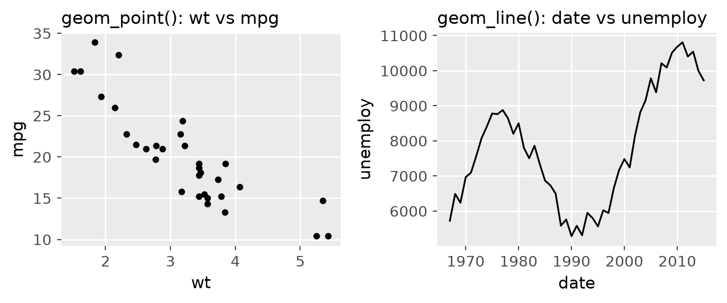
Figure: geom_point() vs geom_line()
- They can be combined: geom_line() + geom_point() shows a trend and marks each observation.
- Joining unordered scatter data with geom_line() gives a meaningless zig-zag.
Conclusion: use points to study relationships, lines to study change over an ordered variable.
Remember: Point = "who goes with whom", Line = "what happens over time".

Q22. Comment on frequency according to the status of the houses and show it with a graph. Also give title 'Count of House as per Status' for the graph
4 Marks • Moderate • CO3
Status of IndianHouses is a categorical variable (Ready_to_move / Almost_ready), so its frequency is found with table() and shown with a bar chart.
houses <- read.csv("IndianHouses.csv")
table(houses$Status) # frequency of each status
prop.table(table(houses$Status)) * 100 # percentage
ggplot(houses, aes(x = Status, fill = Status)) +
geom_bar() +
labs(title = "Count of House as per Status", x = "Status", y = "Count")
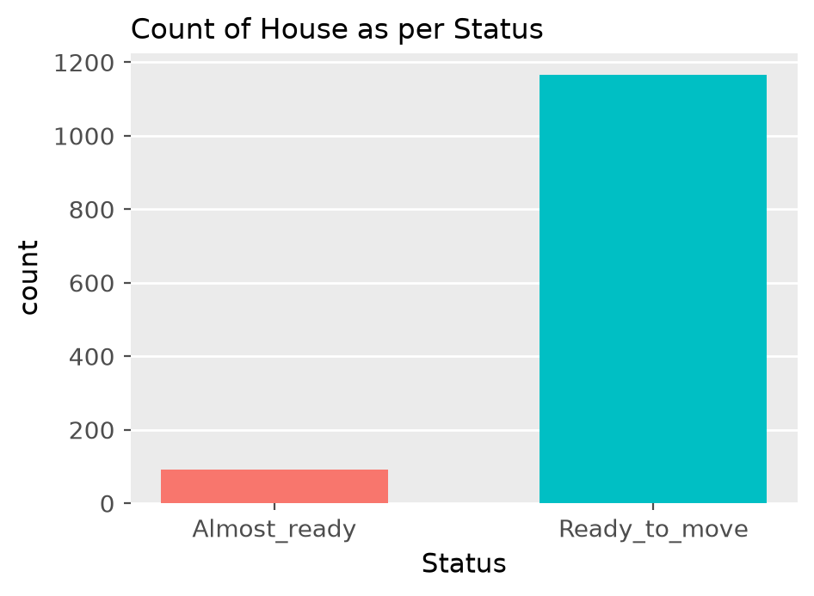
Figure: Count of houses per status (illustrative)
Comment on frequency:
1. The Ready_to_move bar is far taller – most listed houses are ready for possession.
2. Almost_ready (under construction) houses form only a small share.
3. Buyers have many ready options; builders list fewer incomplete projects.
4. Since the classes are very unequal, any comparison of prices by status should use averages, not totals.
Remember: Frequency of a category = table() + geom_bar().

Q23. Why is ggplot used as an effective package for data visualization? Describe all the components of ggplot
4 Marks • Moderate • CO3
ggplot2 (tidyverse) builds plots using the Grammar of Graphics: a plot is made by adding independent layers with +.
Why effective:
- Same simple syntax for every plot type; easy to add/remove layers.
- Automatic legends, scales and good-looking default theme.
- Grouping by colour, shape, size and facets in one argument.
- Built-in statistics (smooth lines, counts, densities) and publication-quality output.
Components (7 layers):
1. Data – the data frame: ggplot(mtcars).
2. Aesthetics – mapping of variables to x, y, colour, size, fill: aes(x = wt, y = mpg).
3. Geometries – the shape drawn: geom_point(), geom_bar(), geom_boxplot().
4. Facets – small multiples by a category: facet_wrap(~ gear).
5. Statistics – summaries computed: geom_smooth(method = "lm"), stat_summary().
6. Coordinates – axis system: coord_flip(), coord_polar().
7. Themes – non-data look: theme_bw(), labs(), ggtitle().
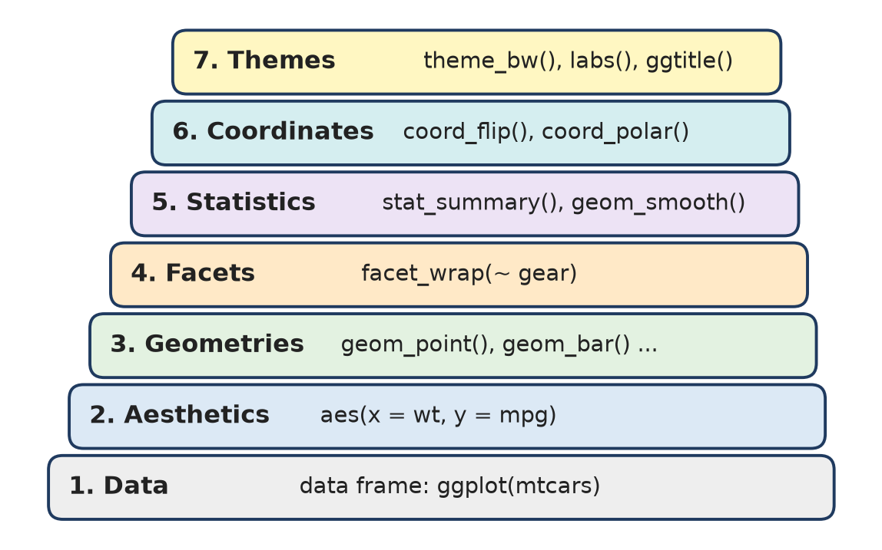
Figure: Layers of a ggplot (grammar of graphics)
ggplot(mtcars, aes(wt, mpg, color = factor(cyl))) + geom_point() +
geom_smooth(method = "lm") + facet_wrap(~ am) + theme_bw()
Remember: "Data Aesthetics Geometry Facets Stats Coordinates Theme" – Don't Always Go For Silly Colour Themes.

Q24. Whether suggested job roles are affected by extra courses done, visualize it and comment on the same
4 Marks • Moderate • CO3
Both variables are categorical (Suggested.Job.Role, Extra.courses.did = yes/no), so use a grouped bar chart (or a proportional bar / mosaic plot) and a cross-table.
job <- read.csv("students_placement_Data.csv")
tab <- table(job$Suggested.Job.Role, job$Extra.courses.did)
prop.table(tab, margin = 1) # share of yes/no within each role
ggplot(job, aes(y = Suggested.Job.Role, fill = Extra.courses.did)) +
geom_bar(position = "dodge") +
labs(title = "Suggested Job Role vs Extra Courses", fill = "Extra courses")
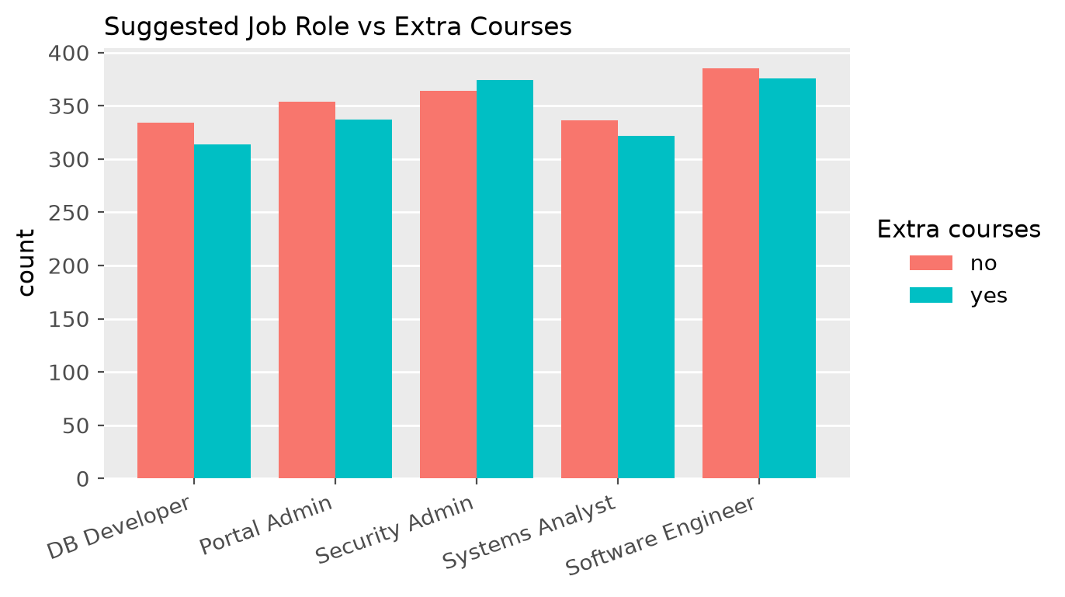
Figure: Job role by extra courses (illustrative, 5 roles shown)
Comment:
1. For each role the "yes" and "no" bars are of almost equal height.
2. The yes/no proportions are about the same in every role.
3. So the suggested job role is not noticeably affected by doing extra courses; other variables (subject percentages, skills ratings) matter more.
4. A chi-square test (chisq.test(tab)) can confirm it statistically.
Remember: Equal bar pairs in every group = no association.

Q25. What is the Jitter plot? Explain uses of it? Write a syntax to get the following Jitter plot for variable 'cyl' and 'displ' of 'mpg' data. If the same command runs multiple times is there any change observed in the output plot?
4 Marks • Moderate • CO3
A jitter plot is a scatter plot in which a small random noise is added to each point's position so that points with the same (or very close) values do not sit on top of each other.
Uses:
- Removes over-plotting when x is discrete (like cyl = 4, 5, 6, 8).
- Shows how many observations lie at each value and their spread.
- Often drawn over a boxplot to show raw data.
library(ggplot2)
ggplot(mpg, aes(x = cyl, y = displ)) +
geom_jitter(width = 0.3, height = 0.1) +
labs(title = "Jitter plot of cyl vs displ")
# same as geom_point(position = "jitter")
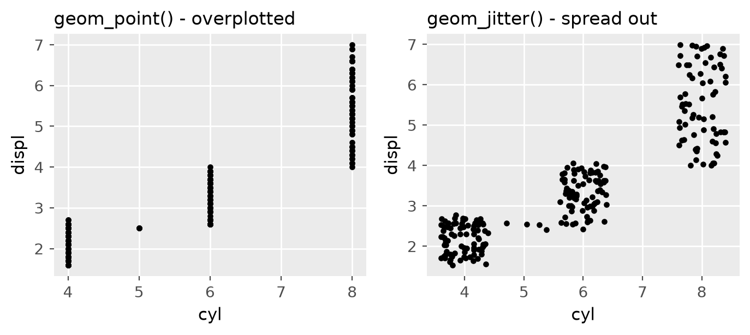
Figure: Normal points overlap; jitter spreads them
Running again: Yes, the plot changes slightly every time, because the noise is random. The general pattern (more cylinders → larger displacement) stays the same. To get the same picture each time use set.seed(1) before plotting or position_jitter(seed = 1).
Remember: Jitter = "shake the points a little"; seed fixes the shake.

Q26. What information can be obtained from a box plot? Explain with suitable points
4 Marks • Moderate • CO3
A box plot (box-and-whisker plot) summarises a numeric variable by its five-number summary: minimum, Q1, median, Q3, maximum.
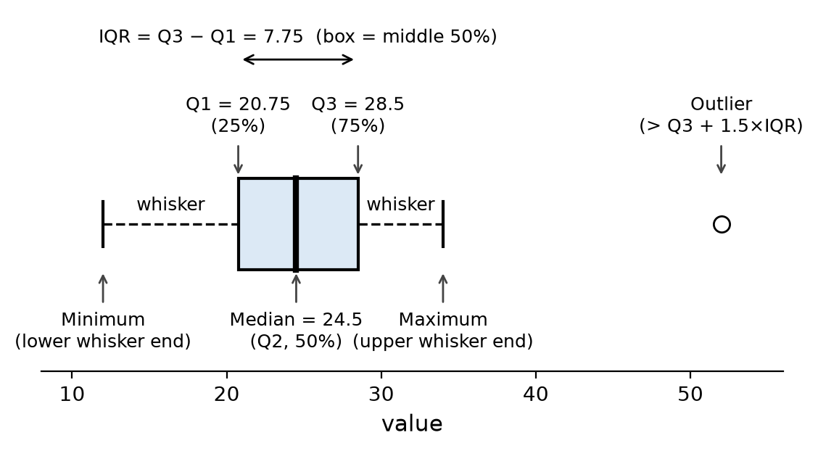
Figure: Parts of a box plot
Information obtained:
1. Centre – the thick line is the median (50 % of data below it).
2. Spread – box length = IQR = Q3 − Q1, the middle 50 % of data; a longer box = more variation.
3. Range – whiskers reach the smallest and largest values within 1.5 × IQR of the box.
4. Outliers – points beyond the whiskers (below Q1 − 1.5×IQR or above Q3 + 1.5×IQR).
5. Skewness – median near the bottom of the box / longer upper whisker → right skew; median near the top → left skew; centred → symmetric.
6. Group comparison – side-by-side boxes compare groups.
boxplot(mpg ~ cyl, data = mtcars, col = "lightblue")
ggplot(mtcars, aes(factor(cyl), mpg)) + geom_boxplot()
Remember: Box = middle half, line = middle value, dots = misfits.

Q27. Find the trend between two variables 'etest_p' and 'mba_p', and put suitable labels. What inference can be derived from it.
4 Marks • Moderate • CO3
Trend between two numeric variables of the Placement data → scatter plot with a regression (trend) line.
placement <- read.csv("Placement_Data_Full_Class.csv")
ggplot(placement, aes(x = etest_p, y = mba_p)) +
geom_point() +
geom_smooth(method = "lm", se = FALSE, color = "blue") +
labs(title = "Trend between E-test % and MBA %",
x = "Employability test percentage", y = "MBA percentage")
cor(placement$etest_p, placement$mba_p)
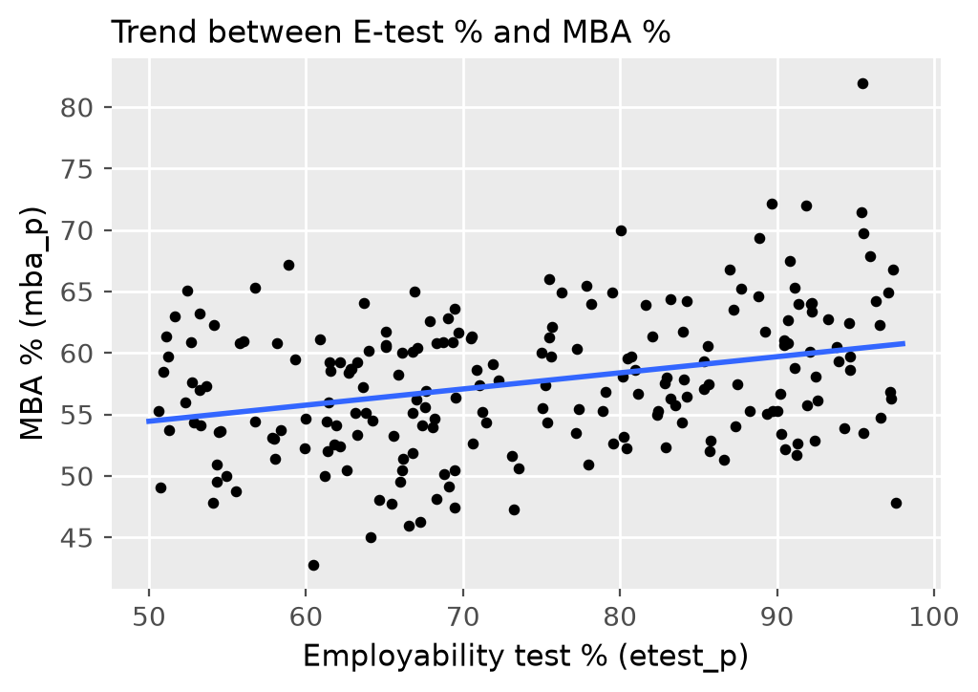
Figure: E-test % vs MBA % with trend line (illustrative)
Inference:
1. The line slopes slightly upward → a weak positive trend.
2. Students with higher employability test scores tend to have slightly higher MBA %.
3. Points are widely scattered around the line, so the relationship is weak (small r); etest_p alone cannot predict mba_p well.
4. No strong outliers change the trend.
Remember: Gentle slope + wide scatter = weak relationship.

Q28. Write the R syntax to: 1. Create a scatter plot with wt on the X-axis and mpg on the Y-axis.
4 Marks • Moderate • CO3
library(ggplot2)
ggplot(mtcars, aes(x = wt, y = mpg)) + # wt on x, mpg on y
geom_point(color = "red") + # red points
ggtitle("Weight vs Mileage")
# base R:
plot(mtcars$wt, mtcars$mpg, col = "red", pch = 19,
xlab = "wt", ylab = "mpg", main = "Weight vs Mileage")
Figure: Scatter plot of wt vs mpg
Explanation:
- ggplot() gives the data (mtcars); aes() maps wt → x and mpg → y.
- geom_point() draws one point per car (32 cars).
- Interpretation: points fall from top-left to bottom-right → strong negative relationship (r = −0.87): heavier cars give lower mileage. The two lightest cars give about 30 mpg; the heaviest (about 5.4 thousand lb) give about 10 mpg.
Remember: aes(x, y) first, then the geom.

Q29. Write the R syntax to: 1. Display the count of each flower species. 2. Give different colours to the bars. 3. Add the title "Flower Species Count".
4 Marks • Moderate • CO3
library(ggplot2)
ggplot(iris, aes(x = Species, fill = Species)) + # fill = Species → different colours
geom_bar() + # counts each species
ggtitle("Flower Species Count")
# base R:
barplot(table(iris$Species), col = c("red", "green", "blue"),
main = "Flower Species Count")
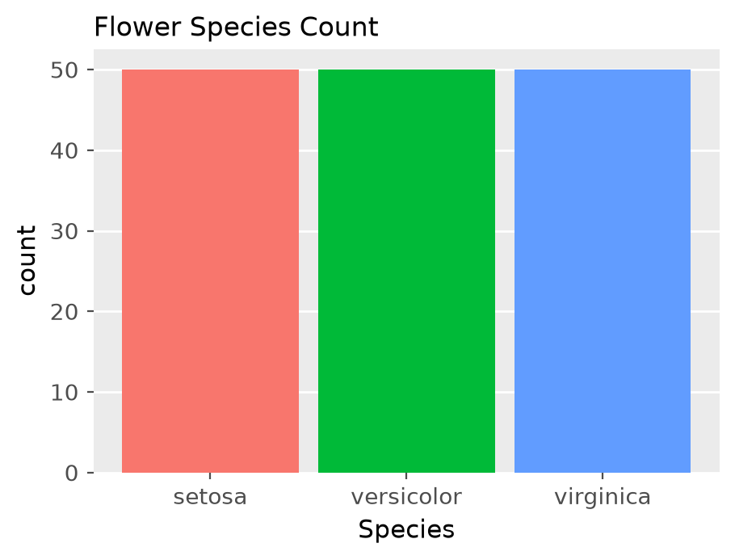
Figure: Count of each iris species
Explanation:
- geom_bar() counts rows for each level of Species – no y variable is needed.
- fill = Species inside aes() gives each bar its own colour and adds a legend.
- Output: three equal bars of 50 each (setosa, versicolor, virginica) – the iris data is balanced (150 flowers).
Remember: fill colours the inside of bars; color only the border.

Q30. Write the R syntax to: 1. Display Petal.Length for each flower species. 2. Create a box plot. 3. Give the boxes a green fill colour.
4 Marks • Moderate • CO3
ggplot(iris, aes(x = Species, y = Petal.Length)) +
geom_boxplot(fill = "green") # fixed fill colour, in quotes
# base R:
boxplot(Petal.Length ~ Species, data = iris, col = "green")
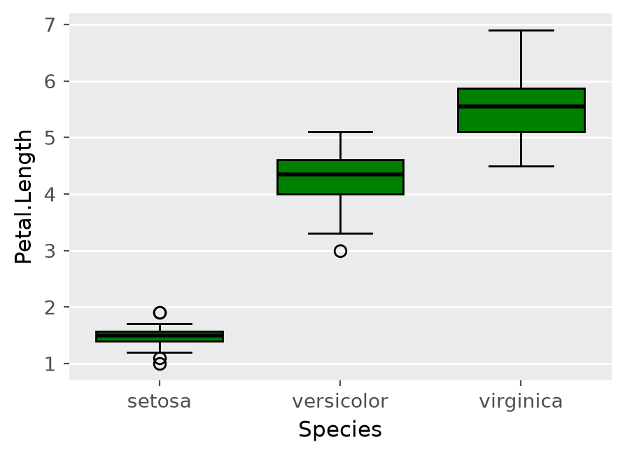
Figure: Box plot of Petal.Length by species
Interpretation:
1. Setosa has the shortest petals (median ≈ 1.5 cm) and very small spread, with a few outliers.
2. Versicolor median ≈ 4.35 cm; virginica longest, median ≈ 5.55 cm.
3. The boxes do not overlap → petal length clearly separates the species.
4. Virginica has the largest spread (tallest box).
Remember: Fixed fill → in geom_boxplot(); fill by group → in aes().

Q31. Write the R syntax to: 1. Display Sepal.Length on the X-axis. 2. Display Petal.Length on the Y-axis. 3. Represent each species using a different colour.
4 Marks • Moderate • CO3
ggplot(iris, aes(x = Sepal.Length,
y = Petal.Length,
color = Species)) + # colour mapped to a variable
geom_point()
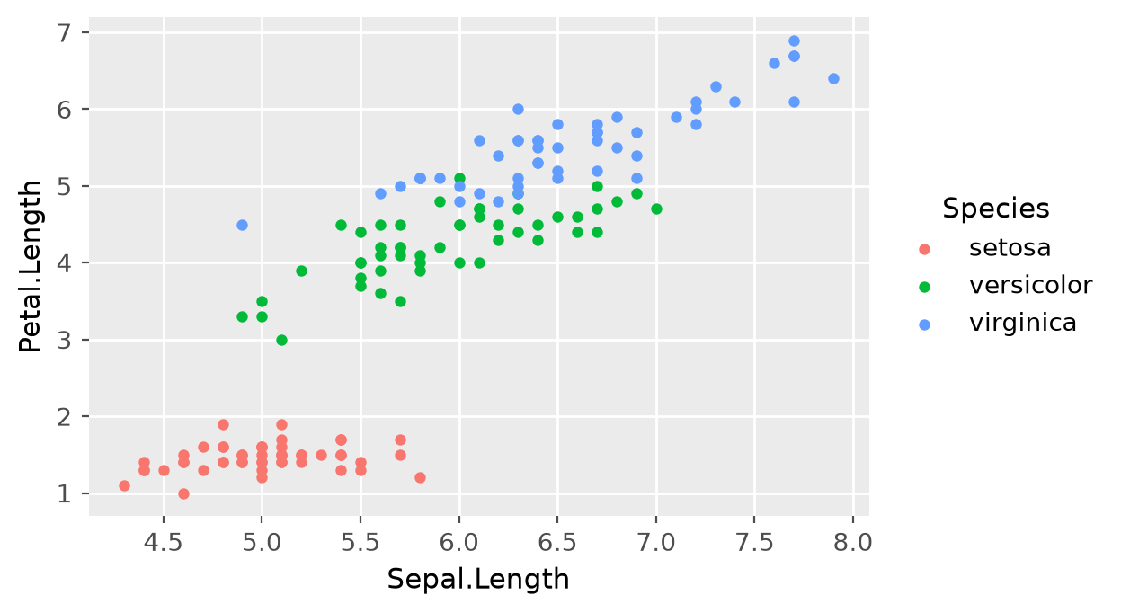
Figure: Sepal.Length vs Petal.Length coloured by species
Explanation and inference:
- color = Species is inside aes() because colour depends on data; ggplot adds the legend automatically.
- Overall positive relationship: longer sepals go with longer petals.
- Setosa forms a separate cluster at bottom-left (short petals); versicolor and virginica overlap a little but virginica is larger.
- The plot shows that species can be identified from these two measurements.
Remember: Colour by a column = inside aes().

Q32. Identify the error and rewrite the correct code to create a scatter plot with different colours for different species. Incorrect code: ggplot(iris, aes(x = Sepal.Length, y = Petal.Length)) + geom_point(color = Species)
4 Marks • Moderate • CO3
Error: color = Species is written outside aes(). Outside aes() ggplot expects a fixed value (like "red"), so it searches for an object Species in the workspace → "object 'Species' not found".
Rule:
- Mapping a variable to colour → inside aes().
- Setting one constant colour → outside aes(), in quotes.
Correct code:
ggplot(iris, aes(x = Sepal.Length, y = Petal.Length,
color = Species)) +
geom_point()
# also correct: geom_point(aes(color = Species))
Figure: Corrected plot – one colour per species
- Now each species gets its own colour and a legend appears.
Remember: "Map inside, set outside."

Q33. Write the R syntax to: 1. Display date on the X-axis. 2. Display unemploy on the Y-axis. 3. Draw the line in blue colour.
4 Marks • Moderate • CO3
The economics data (ggplot2) has monthly US data from 1967; date is a Date and unemploy is the number unemployed (thousands). Ordered time data → line chart.
library(ggplot2)
ggplot(economics, aes(x = date, y = unemploy)) +
geom_line(color = "blue") +
labs(title = "Unemployment over time", x = "Date", y = "Unemployed (thousands)")
Interpretation of the plot:
1. Unemployment shows an overall rising trend from about 3,000 thousand (late 1960s) to over 15,000 thousand around 2010.
2. Clear peaks (about 1975, 1982, 1992, 2003 and the biggest around 2009–2010) match economic recessions.
3. After each peak the line falls → recovery periods.
4. A line chart is right because x (time) is ordered.
Remember: Time on x → geom_line().

Q34. What is the relationship between a diamond's carat weight and its price? Does the price increase linearly with carat?
4 Marks • Moderate • CO3
Same as Q17 above. Extra points for 4 marks:
ggplot(diamonds, aes(x = carat, y = price)) +
geom_point(alpha = 0.1) +
geom_smooth(method = "lm", color = "red") + # straight line
geom_smooth(color = "blue") # curved (loess/gam) line
ggplot(diamonds, aes(log(carat), log(price))) + geom_point(alpha = 0.1)
- Strong positive relationship (r ≈ 0.92; a straight line explains about 85 % of variation, R² ≈ 0.85).
- The blue curved line bends upward away from the red straight line → price grows faster than linearly; the straight line under-predicts large stones and gives negative prices for very small ones.
- Spread of price increases with carat (heteroscedasticity, fan shape).
- Price clusters at "magic" sizes (0.5, 1.0, 1.5, 2.0 carat).
- After a log–log transformation the relation becomes almost linear.
Remember: Curve, not line – log both to straighten.

Q35. Write syntax to get the following plot for data 'Sales' (scatter plot of x vs y with points coloured by group A, B, C)
4 Marks • Moderate • CO3
The plot is a scatter plot: numeric x (0 to 1) on the X-axis, numeric y on the Y-axis, and the categorical variable group (A, B, C) shown by colour.
library(ggplot2)
Sales <- read.csv("Sales.csv") # columns: x, y, group
ggplot(Sales, aes(x = x, y = y, color = group)) +
geom_point() +
labs(x = "x", y = "y", color = "group")
Reading the plot:
1. Group A (red) lies mostly at low x and low y, B (green) in the middle, C (blue) at high x and high y.
2. Overall there is a positive relationship between x and y.
3. The groups overlap at their edges but form three clusters.
Remember: Third variable as colour turns a scatter into a grouped scatter.

Q36. Write 5 inferences from following Boxplot for Frequencies of passenger as per their gender and Class in Titanic.
5 Marks • Difficult • CO3
as.data.frame(Titanic) has 32 rows (Class × Sex × Age × Survived) with a Freq count. Each box therefore summarises only 4 counts (child/adult × survived yes/no) for one class–sex pair.
library(ggplot2)
td <- as.data.frame(Titanic)
ggplot(td, aes(x = Freq, y = Sex)) +
geom_boxplot() +
facet_wrap(~ Class)
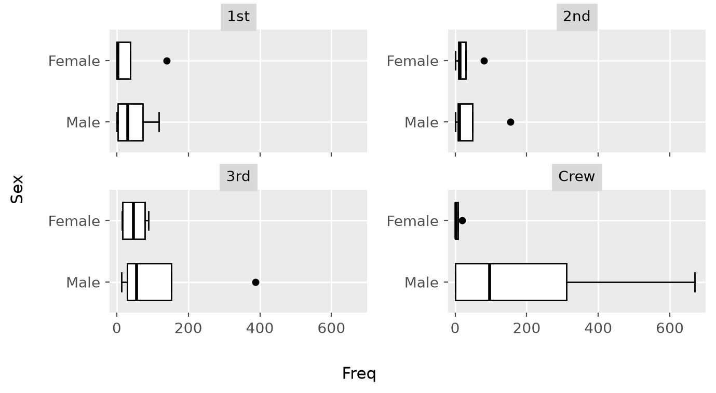
Figure: Freq by Sex for each Class (Titanic)
Five inferences:
1. Crew males have by far the widest box and longest whisker (up to 670 – adult male crew who died); the crew was mostly men.
2. Crew females are almost a single line near 0 – very few women in the crew (only 23).
3. In 3rd class, males have a bigger spread and an outlier at 387 (adult males who died) – 3rd-class men suffered the most deaths.
4. In 1st class, the female box is tiny but has an outlier at 140 (adult women who survived) – most 1st-class women survived.
5. In every class the male boxes lie further right/are wider than female boxes, meaning male counts were larger and more uneven; all boxes start near 0 because child groups are very small.
Conclusion: counts are highly unequal and right-skewed; adult men (especially crew and 3rd class) dominate the deaths.
Remember: Each box = 4 numbers; outliers = the big adult groups.

Q37. Write interpretation of the following plot (box plot "Miles per Gallon for All Vehicles")
5 Marks • Difficult • CO3
Values read from the plot:
Part | Value (mpg)
Minimum (lower whisker) | ≈ 9
Q1 | ≈ 16.5
Median | ≈ 24
Q3 | ≈ 29
Maximum (upper whisker) | ≈ 44

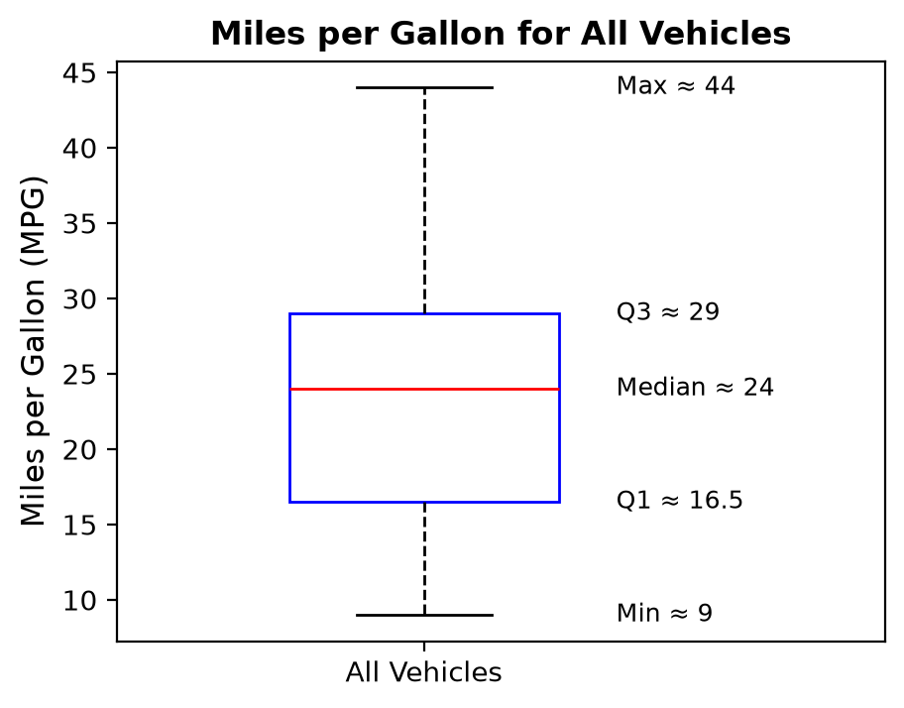
Figure: Re-drawn box plot with values
Interpretation:
1. Typical mileage (median) is about 24 mpg; half the vehicles give more, half less.
2. IQR = 29 − 16.5 = 12.5 mpg → the middle 50 % of vehicles lie between 16.5 and 29 mpg; moderate spread.
3. Range = 44 − 9 = 35 mpg – vehicles differ a lot (from heavy trucks to economical cars).
4. No outliers – all values are within 1.5 × IQR of the box (upper fence = 29 + 18.75 = 47.75; lower fence = −2.25).
5. Shape: the upper whisker (15) is twice as long as the lower one (7.5) → a few vehicles have very high mileage, so the distribution is slightly right-skewed in the tails, although the median sits a bit above the box centre.
boxplot(mpg_data$MPG, col = "white", border = "blue",
main = "Miles per Gallon for All Vehicles", ylab = "Miles per Gallon (MPG)")
Conclusion: most vehicles give 16–29 mpg, with a long tail of high-mileage vehicles.
Remember: Read the 5 numbers first, then talk centre, spread, outliers, skew.

Q38. Write interpretation of the following plot (stacked bar chart "Compare sales strategy": Products A–D for Strategies 1–5)
5 Marks • Difficult • CO3
It is a stacked bar chart: total bar height = total sales of a strategy; coloured segments = sales of each product. Approximate values read from the graph:
Strategy | A | B | C | D | Total
1 | 97 | 100 | 140 | 75 | ≈ 412
2 | 102 | 143 | 140 | 157 | ≈ 542
3 | 118 | 78 | 160 | 149 | ≈ 505
4 | 90 | 78 | 160 | 174 | ≈ 502
5 | 115 | 100 | 137 | 23 | ≈ 375

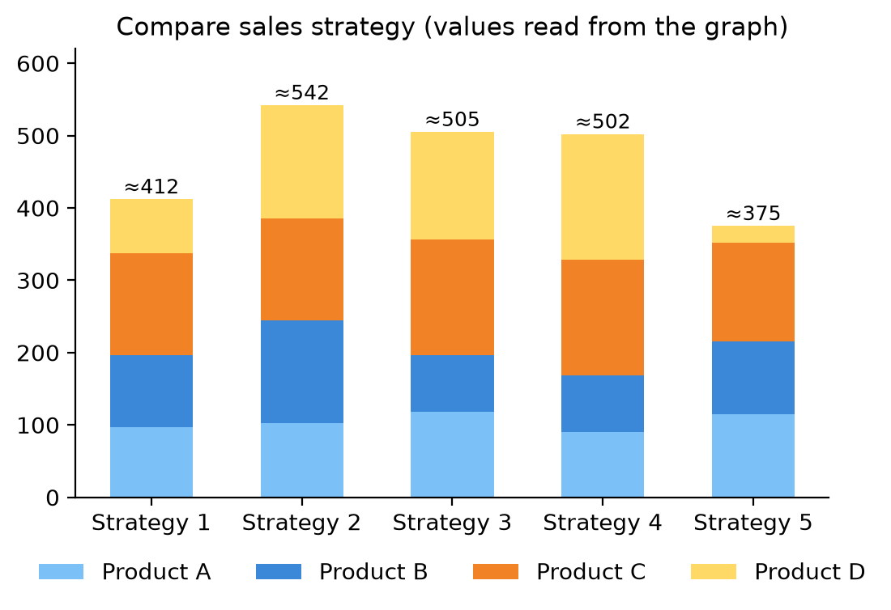
Figure: Re-drawn stacked bar chart
Interpretation:
1. Strategy 2 gives the highest total sales (≈ 540); Strategy 5 the lowest (≈ 375).
2. Product C is steady (≈ 140–160) under every strategy – it does not depend on strategy.
3. Product D changes the most: very high in Strategies 2–4 (≈ 150–175) but almost zero in Strategy 5 – D drives the differences in totals.
4. Product B is best under Strategy 2 (≈ 143); Product A stays about 90–120 everywhere.
5. Strategies 3 and 4 have similar totals (≈ 500) but 4 relies more on D.
ggplot(sales, aes(x = Strategy, y = Sales, fill = Product)) +
geom_bar(stat = "identity") # stacked
Conclusion: choose Strategy 2; avoid Strategy 5, which kills Product D sales.
Remember: Stacked bar → compare totals by height, products by segment size.

Q39. Write interpretation of the following plot (density plot of mpg by factor(gear))
5 Marks • Difficult • CO3
The plot shows density curves of mpg (mtcars) for cars with 3, 4 and 5 gears. Area under each curve = 1; a high peak means many cars at that mileage.
ggplot(mtcars, aes(x = mpg, color = factor(gear))) + geom_density()
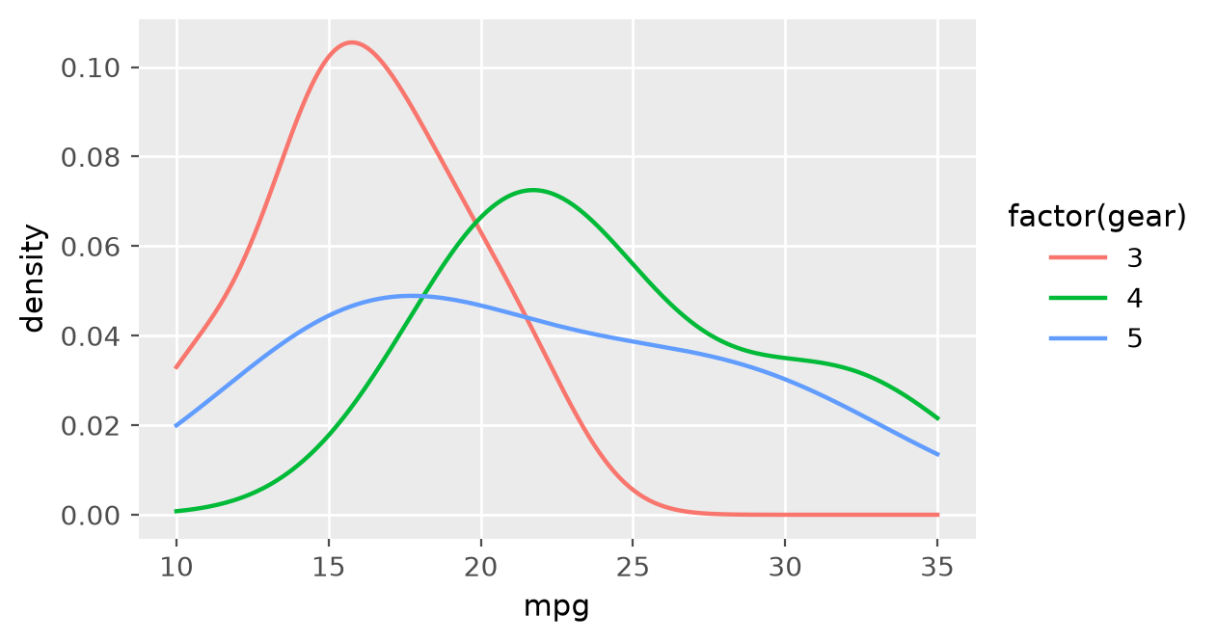
Figure: Density of mpg by number of gears
Interpretation:
1. 3-gear cars (red) have a tall, narrow peak at about 15–16 mpg → low mileage and little variation (mostly heavy 8-cylinder cars; mean 16.1).
2. 4-gear cars (green) peak at about 22 mpg → best typical mileage (mean 24.5); the curve has a right tail up to 34 mpg.
3. 5-gear cars (blue) have a low, flat, wide curve from about 12 to 32 mpg → mileage varies a lot (sports cars and light cars both have 5 gears; mean 21.4).
4. The 3-gear curve is right-skewed with little overlap with the 4-gear curve; 4- and 5-gear curves overlap a lot.
5. More gears do not always mean better mileage: 4 gears are better than 5 on average.
Conclusion: gear type is linked to mileage – 3-gear cars are clearly the least economical.
Remember: Tall narrow curve = consistent; flat wide curve = varied.

Q40. Write interpretation of the following plot (scatter plot of Sales vs Temperature °C)
5 Marks • Difficult • CO3
The plot is a scatter plot of daily sales ($) against temperature (°C) for 12 days (the classic ice-cream sales example). Approximate points: (12 °C, $185) … (25 °C, $614).
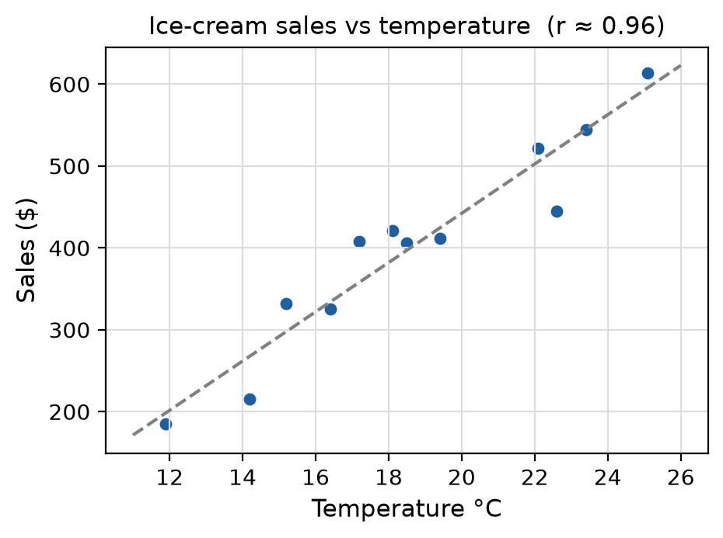
Figure: Re-drawn scatter with trend line
Interpretation:
1. Direction: points rise from bottom-left to top-right → positive relationship – warmer days bring more sales.
2. Form: points lie close to a straight line → linear relationship.
3. Strength: very strong (r ≈ 0.96 from the read values); temperature explains most of the variation in sales (R² ≈ 0.9).
4. Rate: sales go up by roughly $30 per 1 °C (about $185 at 12 °C to $614 at 25 °C).
5. Outliers: the point at about 22.6 °C with $445 is a little below the trend but not a real outlier.
ggplot(df, aes(x = Temperature, y = Sales)) + geom_point() +
geom_smooth(method = "lm", se = FALSE)
cor(df$Temperature, df$Sales)
Conclusion: the shop should stock more on hot days; temperature is a good predictor of sales (correlation, not proof of cause).
Remember: Describe a scatter by Direction, Form, Strength, Outliers.

Q41. The following table shows the mean and standard deviation of car mileage (mpg) based on transmission type (Automatic: mean 27, SD 2.3; Manual: mean 18.1, SD 4.17) for the dataset mtcars in R. Write any four inferences based on the mean and standard deviation.
5 Marks • Difficult • CO3
Using the table as given:
Transmission | Mean | SD | CV = SD ÷ Mean × 100
Automatic | 27 | 2.3 | 8.5 %
Manual | 18.1 | 4.17 | 23.0 %

Inferences:
1. Automatic cars have the higher average mileage (27 mpg vs 18.1 mpg).
2. The difference is 27 − 18.1 = 8.9 mpg in favour of automatic cars.
3. Manual cars have the higher SD (4.17) → their mileage varies more from car to car.
4. Automatic cars are more consistent (SD 2.3, CV 8.5 % vs 23 %): their values lie close to the mean.
library(dplyr)
mtcars %>% group_by(am) %>% summarise(Mean = mean(mpg), SD = sd(mpg))
Note: in the real mtcars data (am = 0 automatic, 1 manual) the R output is Automatic 17.15 (SD 3.83) and Manual 24.39 (SD 6.17) – see Unit IV Q33; the conclusions then reverse (manual cars give better mileage). In the exam, write inferences from the table that is printed.
Conclusion: by the given table, automatic cars are both more economical and more consistent.
Remember: Mean → "which is higher", SD → "which is more consistent".

Q42. The following table shows the mean and standard deviation of ozone concentration based on month from the inbuilt dataset airquality in R (May 23.62/22.22, June 29.44/18.21, July 59.12/31.64, August 60.00/39.68, September 31.45/24.14). Write any four inferences based on the mean and standard deviation.
5 Marks • Difficult • CO3
Month | Mean (ppb) | SD | CV %
May | 23.62 | 22.22 | 94.1
June | 29.44 | 18.21 | 61.9
July | 59.12 | 31.64 | 53.5
August | 60.00 | 39.68 | 66.1
September | 31.45 | 24.14 | 76.8

Inferences:
1. August has the highest mean ozone (60) and May the lowest (23.62).
2. Ozone is highest in July–August (summer, hot and sunny) – about double the May/June/September levels; it rises from May to August and falls in September.
3. August has the largest SD (39.68) → greatest day-to-day variation; June has the lowest SD (18.21).
4. Relative to the mean (CV), May is most variable (94 %) and July is most stable (53.5 %).
airquality %>% group_by(Month) %>%
summarise(Mean = mean(Ozone, na.rm = TRUE), SD = sd(Ozone, na.rm = TRUE))
(na.rm = TRUE is needed because Ozone has 37 missing values.)
Conclusion: ozone pollution is a summer problem and is also most unpredictable in late summer.
Remember: Compare SD for absolute spread, CV for relative spread.

Q43. The following table shows the mean and standard deviation of tooth length based on supplement type (OJ: 20.66, SD 6.61; VC: 16.96, SD 8.27) from the inbuilt dataset ToothGrowth in R. Write any four inferences based on the mean and standard deviation.
5 Marks • Difficult • CO3
ToothGrowth has 60 guinea pigs: tooth length (len), supplement (supp = OJ orange juice or VC ascorbic acid) and dose.
Supplement | Mean | SD | CV %
OJ | 20.66 | 6.61 | 32.0
VC | 16.96 | 8.27 | 48.8

Inferences:
1. OJ gives longer teeth on average (20.66 vs 16.96).
2. The difference is 20.66 − 16.96 = 3.70 units.
3. VC has the larger SD (8.27) → results under vitamin C vary more.
4. OJ results are more consistent – lower SD and lower CV (32 % vs 48.8 %).
aggregate(len ~ supp, data = ToothGrowth, FUN = function(x) c(mean = mean(x), sd = sd(x)))
boxplot(len ~ supp, data = ToothGrowth, col = c("orange", "lightgreen"))
Note: the means do not account for dose (0.5, 1, 2 mg); the OJ advantage is mainly seen at the lower doses.
Conclusion: orange juice is the better and more reliable supplement for tooth growth in this data.
Remember: Higher mean = better effect, lower SD = more reliable.

Q44. Write four inferences based on given boxplot (shootarea for nitrogen levels low, medium, high).
5 Marks • Difficult • CO3
Approximate values read from the plot:
Nitrogen | Min | Q1 | Median | Q3 | Max | Outlier
low | 5 | 30 | 40 | 62 | 88 | ≈ 115
medium | 10 | 35 | 63 | 97 | 137 | –
high | 55 | 92 | 130 | 160 | 190 | –

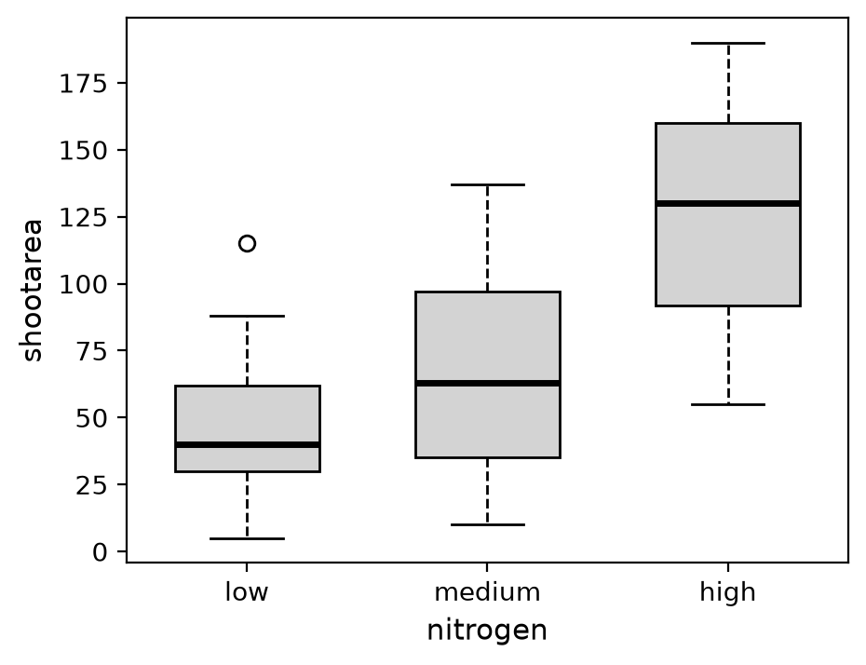
Figure: Re-drawn box plot of shoot area by nitrogen
Four inferences:
1. Shoot area increases with nitrogen: median ≈ 40 (low) → 63 (medium) → 130 (high).
2. Spread grows with nitrogen: IQR ≈ 32 (low), 62 (medium), 68 (high) – plant response is more varied at higher doses.
3. Low nitrogen has one outlier (≈ 115), a plant growing unusually well; low group is right-skewed (median near the bottom of the box).
4. The high box hardly overlaps the low box → the effect of high nitrogen is clear; medium overlaps both.
boxplot(shootarea ~ nitrogen, data = flower, col = "lightgrey")
Conclusion: more nitrogen gives larger shoot area, but with more variability.
Remember: Compare medians (level), box heights (spread), dots (outliers).

Q45. Density Plot showing 'price' distribution as per 'number_of_doors' and coefficient of skewness for price distribution as per number of doors is given (four: 1.574059, two: 1.935925) for the data set 'Car_Price'. Write a syntax to get following plots and coefficient of skewness for price as per number of doors and also comment on the skewness of the price
5 Marks • Difficult • CO3
library(ggplot2); library(dplyr); library(moments)
Car_Price <- read.csv("CarPrice.csv")
# density plot by number of doors
ggplot(Car_Price, aes(x = price, fill = doornumber)) +
geom_density(alpha = 0.5) +
labs(title = "Price distribution by number of doors", x = "Price", y = "Density")
# coefficient of skewness per group
Car_Price %>%
group_by(num_of_doors = doornumber) %>%
summarise(Coeff_Skewness = skewness(price))
(Use the door column name of your file, e.g. doornumber with values "two"/"four".)
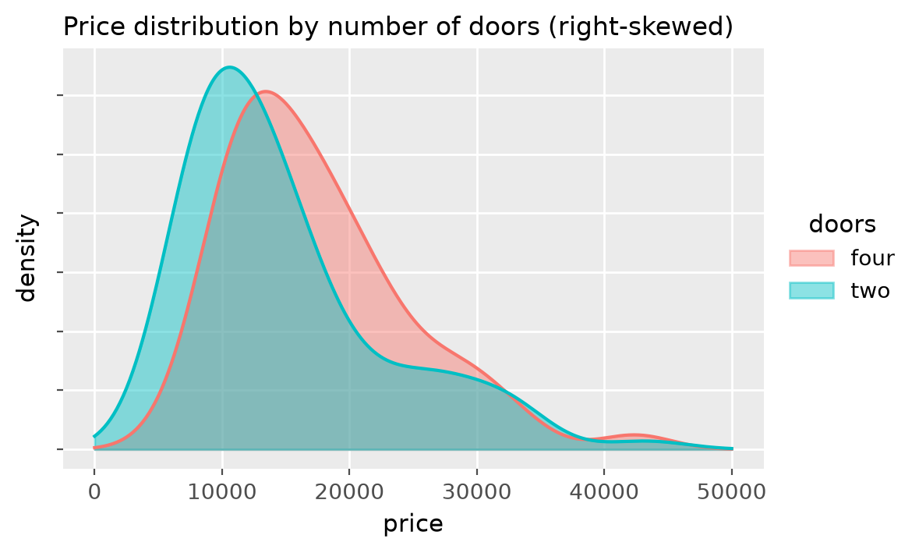
Figure: Price density by number of doors (illustrative)
Comment on skewness:
1. Both coefficients are positive and greater than 1 → price is highly positively (right) skewed for both groups.
2. Most cars are in the low-price range; a few luxury cars form a long right tail.
3. Two-door cars (1.94) are more skewed than four-door cars (1.57) – the two-door group includes a few very expensive sports cars.
4. Because of skewness, mean > median; the median is the better "typical price", and a log transformation would make price nearly normal for regression.
Conclusion: car prices are right-skewed, more strongly for two-door models.
Remember: Skew > 1 = highly skewed; tail side gives the sign.

Q46. Find the mistake in the code and rewrite again to generate the given graph. Also write inferences for it. ggplot(bodyPerformance, aes(x = height_cm, y = weight_kg)) + geom(color = "purple") + facet_wrap(gender) + labs(title = Height vs. Weight, xlab = "Height (cm)", ylab = "Weight (kg)")
5 Marks • Difficult • CO3
Mistakes:
Wrong | Why | Correct
geom(color = "purple") | no function called geom | geom_point(color = "purple")
facet_wrap(gender) | facet needs a formula | facet_wrap(~ gender)
title = Height vs. Weight | text must be in quotes | title = "Height vs. Weight"
xlab =, ylab = inside labs() | labs uses x and y | x = "Height (cm)", y = "Weight (kg)"

Correct code:
library(ggplot2)
ggplot(bodyPerformance, aes(x = height_cm, y = weight_kg)) +
geom_point(color = "purple", shape = 18) + # diamond-shaped points as in the graph
facet_wrap(~ gender) +
labs(title = "Height vs. Weight", x = "Height (cm)", y = "Weight (kg)")
Inferences:
1. In both panels (F and M) weight increases with height → positive relationship.
2. Males are taller and heavier: their cloud is centred near 170–180 cm, 70–80 kg; females near 160 cm, 55–60 kg.
3. The male cloud is steeper and more spread, so weight varies more among men.
4. A few isolated points (very heavy or very light for their height) are outliers.
5. Facetting by gender avoids overlap and makes comparison easy.
Remember: Geom needs a name, facet needs a ~, text needs quotes.

Q47. Write three inferences for the following plot for 'mtcars' dataset where mpg is miles per gallon and wt is weight. Also, write the command to obtain the given graph
5 Marks • Difficult • CO3
The graph is a scatter plot of wt vs mpg with diamond-shaped points, a blue linear regression line and a grey 95 % confidence band, titled "Weight vs Miles per Gallon".
library(ggplot2)
ggplot(mtcars, aes(x = wt, y = mpg)) +
geom_point(shape = 18) +
geom_smooth(method = "lm") + # se = TRUE (default) gives the grey band
ggtitle("Weight vs Miles per Gallon")
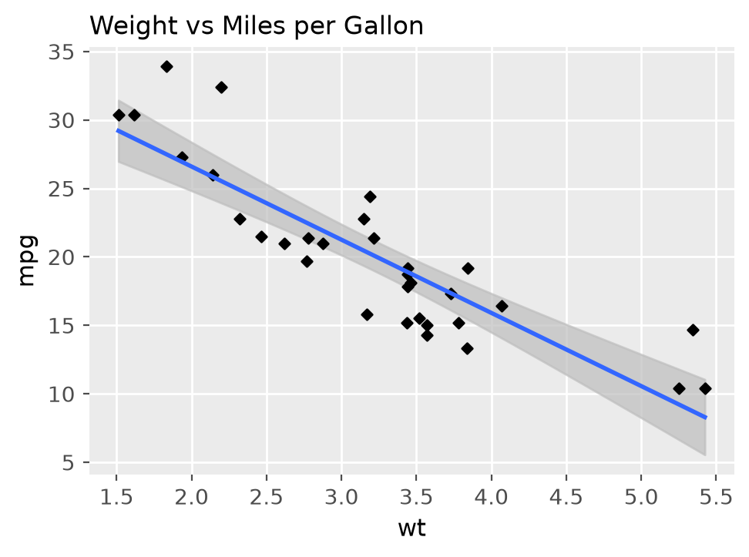
Figure: wt vs mpg with regression line and confidence band
Three inferences:
1. Negative relationship: the line slopes downward – as weight increases, mileage decreases (r = −0.87, strong).
2. Lighter cars give more mileage: cars under 2.5 (thousand lb) give about 25–34 mpg; cars above 5 give about 10–15 mpg.
3. Rate of fall: the fitted line is mpg = 37.29 − 5.34 × wt, so each extra 1000 lb reduces mileage by about 5.3 mpg; weight explains about 75 % of mileage variation (R² = 0.753).
Extra: the grey band is narrow in the middle and wider at the ends (fewer cars there); a few cars (e.g. near wt 5.3, mpg 14.7) lie above the line.
Remember: Grey band = uncertainty of the line, from se = TRUE.

Q48. Identify the error and correct the following code to create a scatter plot of Sepal.Length against Petal.Length, with different colours for each species. ggplot(iris, aes(x = Petal.Length, y = Sepal.Length)) + geom_point(color = Species)
5 Marks • Difficult • CO3
Error: color = Species is placed outside aes(). Outside aes() ggplot treats color as one fixed value and looks for an object called Species → Error: object 'Species' not found. Colour that depends on a column must be an aesthetic mapping.
Correct code:
library(ggplot2)
ggplot(iris, aes(x = Petal.Length, y = Sepal.Length,
color = Species)) +
geom_point() +
labs(title = "Sepal.Length against Petal.Length",
x = "Petal.Length", y = "Sepal.Length")
Figure: Same data, axes swapped in this question
(The picture has Sepal.Length on x; this question puts Petal.Length on x and Sepal.Length on y – "Sepal.Length against Petal.Length".)
Inferences:
1. Positive relationship – longer petals go with longer sepals.
2. Setosa forms a separate cluster (petals 1–2 cm).
3. Versicolor and virginica overlap slightly; virginica has the largest flowers.
Remember: Map inside aes(), set outside – same fix as Q32.

Q49. Correct the code to display a histogram of mpg with a density curve. ggplot(mtcars, aes(x = mpg)) + geom_histogram(fill = "orange") + geom_density()
5 Marks • Difficult • CO3
Problem: geom_histogram() plots counts on the y-axis (values up to about 4–5), while geom_density() plots density (values about 0.05). On the count scale the density curve appears as an almost flat line near zero, so both cannot be compared.
Fix: put the histogram on the density scale using y = after_stat(density) so the bar areas sum to 1, like the density curve.
ggplot(mtcars, aes(x = mpg, y = after_stat(density))) +
geom_histogram(fill = "orange", alpha = 0.5) + # bins = 30 by default
geom_density(color = "blue", linewidth = 1)
# older ggplot2: aes(y = ..density..) and size = 1
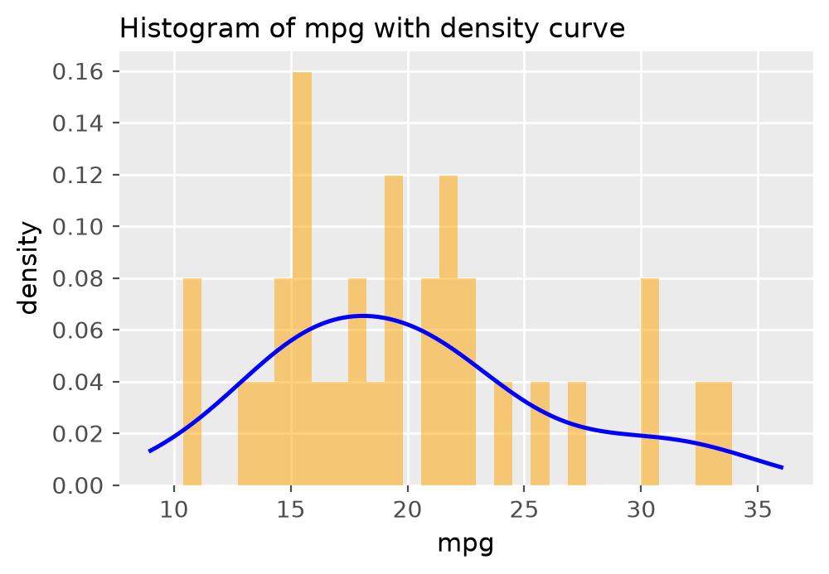
Figure: Histogram on density scale with density curve
Inferences:
1. Most cars give 15–22 mpg; the curve peaks near 18 mpg.
2. A right tail up to 34 mpg → mpg is positively skewed (skewness ≈ 0.64; mean 20.09 > median 19.2).
3. 30 bins for 32 cars is too many (gaps); bins = 8 or binwidth = 3 gives a cleaner histogram.
Remember: Histogram + density curve → both must use density on y.

Q50. Correct the following code to display the relationship between disp and mpg with a linear regression line. ggplot(mtcars, aes(x = disp, y = mpg)) + geom_point() + geom_smooth(method = lm, se = FALSE)
5 Marks • Difficult • CO3
Error: the method name should be given as a character string "lm". (The standard documented form is method = "lm"; recent ggplot2 also accepts the function lm, but in the exam write it in quotes.)
Correct code:
ggplot(mtcars, aes(x = disp, y = mpg)) +
geom_point() +
geom_smooth(method = "lm", se = FALSE) # straight line, no grey band
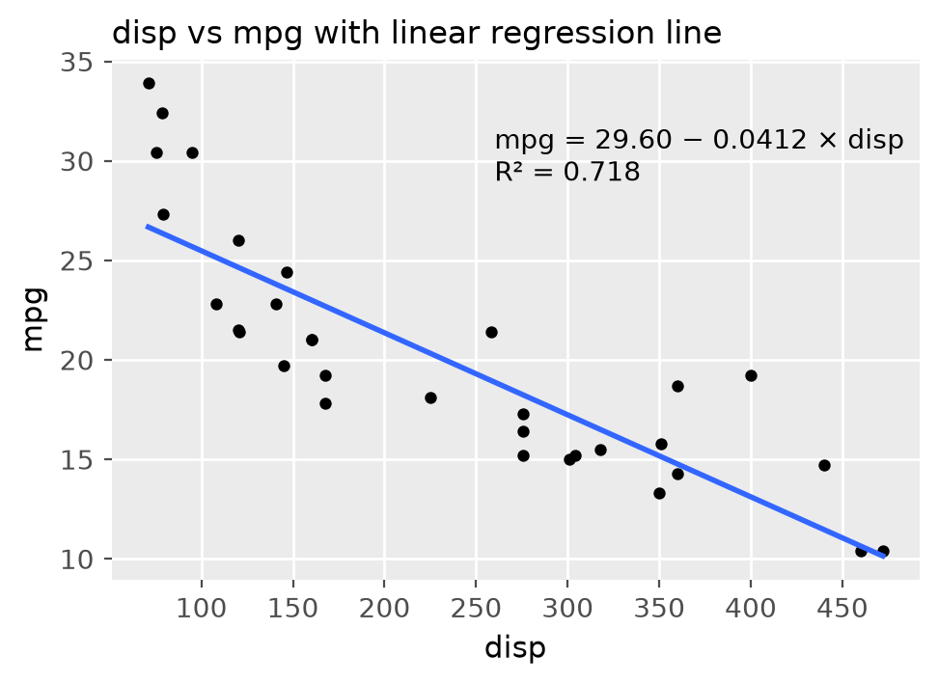
Figure: disp vs mpg with linear regression line
Explanation:
- geom_smooth() adds a fitted line; method = "lm" = linear model (straight line); without it a curved loess line is drawn.
- se = FALSE removes the confidence band.
Inferences:
1. Strong negative relationship (r = −0.85): bigger engines (displacement) give lower mileage.
2. Fitted line: mpg = 29.60 − 0.0412 × disp; R² = 0.718 (72 % of variation explained).
3. Points curve a little at the ends (above the line at very small and very large disp), so the true relation is slightly non-linear.
Remember: Smoothing method names go in quotes – "lm", "loess", "glm".

Quick Revision – Unit III
Term | Key fact
Bar chart | Counts of a categorical variable – geom_bar(); bars have gaps
Histogram | Distribution of one numeric variable – geom_histogram(); bars touch
Box plot | Min, Q1, median, Q3, max; IQR = Q3 − Q1; outlier beyond 1.5 × IQR
Grouped box plot | aes(x = group, y = value) + geom_boxplot() compares groups
Scatter plot | Two numeric variables – direction, form, strength, outliers
Line chart | Ordered x (time) – geom_line()
Mosaic plot | Two categorical variables; tile area = count – mosaicplot(table(a, b))
Pie chart | Part-to-whole; ggplot: geom_bar(stat = "identity") + coord_polar("y")
Violin / density | Shape of the distribution; wide = many values
Jitter | Random shake to stop over-plotting; changes each run unless seed set
aes() rule | Map a variable inside aes(); set a constant outside, in quotes
ggplot layers | Data, Aesthetics, Geometry, Facets, Statistics, Coordinates, Theme
facet_wrap(~ g) | One panel per group; needs ~
geom_smooth | method = "lm" straight line; se = FALSE removes grey band
Histogram + density | Use aes(y = after_stat(density))

Unit IV: Data Analysis

Q1. What is significance of skewness and kurtosis in data analysis
2 Marks • Easy • CO4
Skewness measures the asymmetry of a distribution; kurtosis measures its peakedness and tail weight compared with the normal curve.
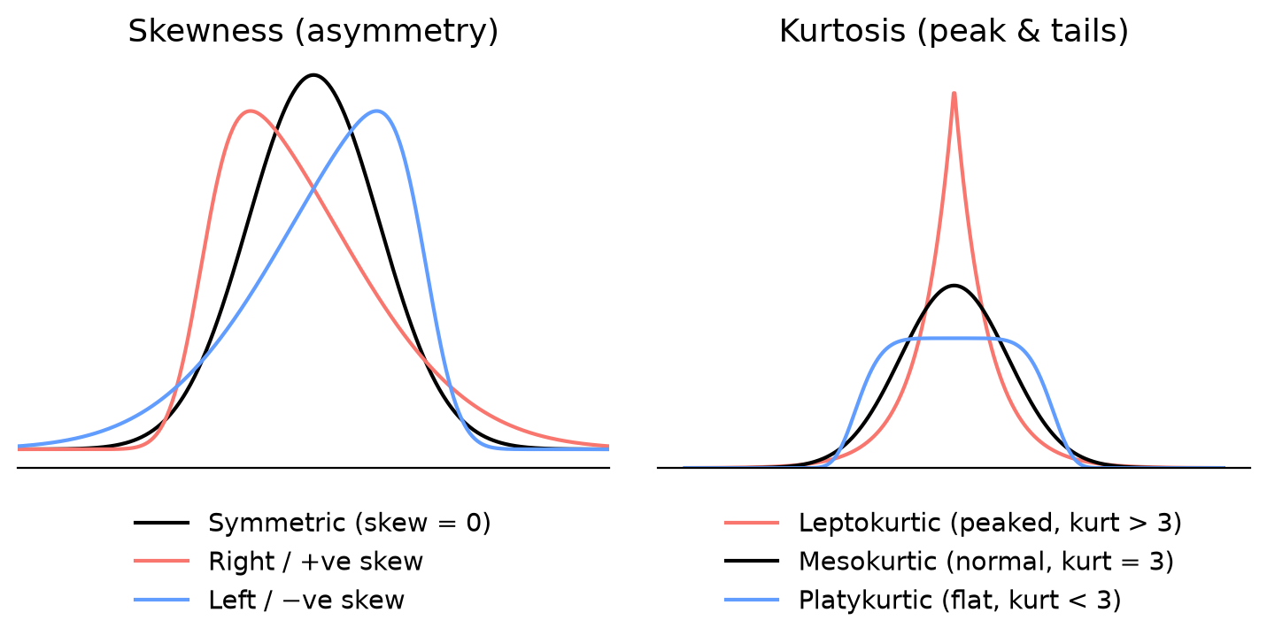
Figure: Skewness and kurtosis shapes
Significance:
- Skewness = 0 symmetric; > 0 right tail (mean > median, e.g. income); < 0 left tail (mean < median).
- Kurtosis (Pearson, moments::kurtosis): = 3 mesokurtic (normal), > 3 leptokurtic (sharp peak, heavy tails, more outliers), < 3 platykurtic (flat).
- They tell whether data is normal, which average to use (median for skewed data), whether to transform (log) and whether outliers are likely.
Remember: Skew = "which side is the tail", Kurtosis = "how tall is the peak".

Q2. If for two groups of employees, data of dispersion for High-Income and Easy-income Earners is as follows (SD 100,000 and 5,000; CV 16.66 and 14.28; Mean 600,000 and 35,000). If the number of observation are same in both the groups which measure of dispersion to be used. Write inferences from the following table.
2 Marks • Easy • CO4
("Easy-income" means low-income earners.) The means are very different (6,00,000 vs 35,000), so SD cannot be compared directly; use the Coefficient of Variation (CV).
CV = SD ÷ Mean × 100 → High: 100000 ÷ 600000 × 100 = 16.67 %; Low: 5000 ÷ 35000 × 100 = 14.29 %.
Inferences:
- In absolute terms high-income SD is 20 times bigger – but that is mainly due to bigger incomes.
- Relative to the mean, high-income earners are slightly more variable (16.66 % > 14.28 %).
- Low-income earners are more homogeneous/consistent in income.
Remember: Different means → compare CV, not SD.

Q3. If for two groups of employees, data of dispersion for High-Income and Easy-income Earners is as follows. If the number of observation are same in both the groups which measure of dispersion to be used. Write inferences from the following table.
2 Marks • Easy • CO4
Same as Q2 above. Use the coefficient of variation; high-income group CV 16.66 % > low-income 14.28 %, so incomes of high earners vary slightly more and low earners are more uniform.
Remember: CV is unit-free, so it compares groups of different size of values.

Q4. If for two groups of employees, data of dispersion for High-Income and Easy-income Earners is as follows. If the number of observation are same in both the groups which measure of dispersion to be used. Write inferences from the following table.
2 Marks • Easy • CO4
Same as Q2 above. Extra point: since n is equal and the units are the same (rupees) but the means differ greatly, CV is the fair measure; by CV the low-income group is more consistent.
Remember: Higher CV = less consistent.

Q5. Describe the relationship between the variables 'car_price' and 'horsepower' of engine in the following scatter plot, also write syntax to get following plot if data set name is 'Car_price'
2 Marks • Easy • CO4
library(ggplot2)
ggplot(Car_price, aes(x = horsepower, y = price)) +
geom_point() +
geom_smooth(method = "lm") # blue line with grey band
Relationship:
- Points and line go upward → strong positive linear relationship: more horsepower, higher price.
- Most cars are 50–120 hp and below 20,000; spread of price increases at high horsepower (luxury cars far above the line near 180 hp).
- A few points (e.g. ≈ 200 hp at a low price) are outliers.
Remember: Line up = positive; wider band at the ends = less certainty.

Q6. What is the correlation coefficient? How would it help in the understanding of the relationship between two variables?
2 Marks • Easy • CO4
The (Karl Pearson) correlation coefficient r measures the strength and direction of the linear relationship between two numeric variables; −1 ≤ r ≤ +1.
Formula: r = Σ(x − x̄)(y − ȳ) ÷ √[Σ(x − x̄)² × Σ(y − ȳ)²]
Small example: x = 1, 2, 3, 4, 5; y = 3, 4, 6, 8, 9 → x̄ = 3, ȳ = 6; Σ(x−x̄)(y−ȳ) = 16; Σ(x−x̄)² = 10; Σ(y−ȳ)² = 26 → r = 16 ÷ √260 = 0.99.
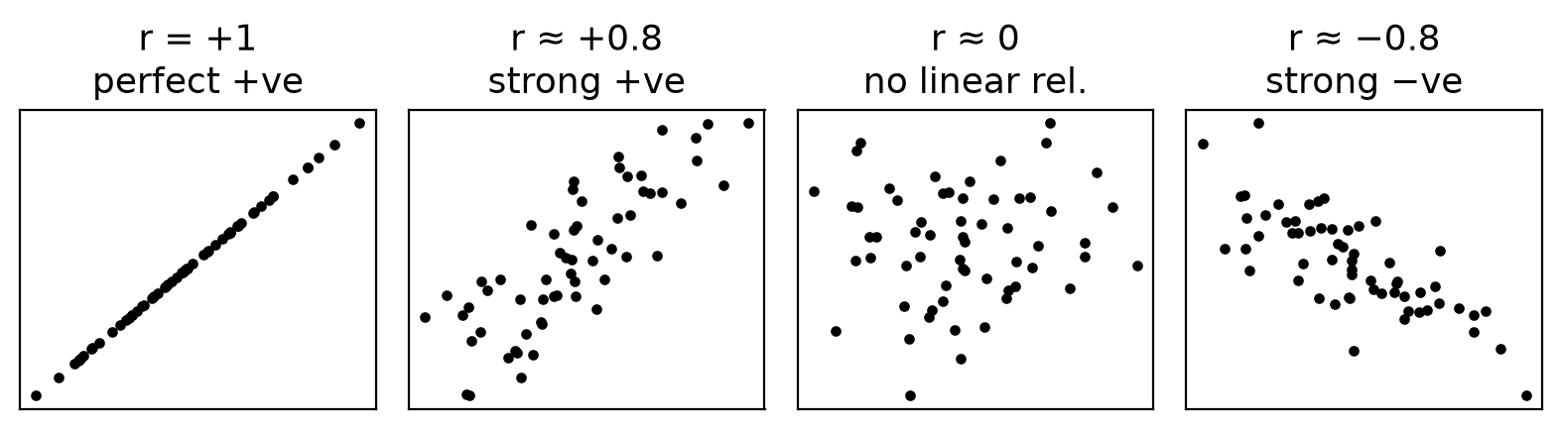
Figure: Scatter shapes for different r
Helps by: sign → direction; size → strength (|r| > 0.7 strong, 0.3–0.7 moderate, < 0.3 weak); r = 0 → no linear relation. In R: cor(x, y).
Remember: Correlation is not causation.

Q7. Write the code to generate the following corrplot for 'airquality' data set. Comment on the correlation of Ozone with other variables.
2 Marks • Easy • CO4
library(corrplot)
M <- cor(airquality[, 1:4], use = "complete.obs") # Ozone, Solar.R, Wind, Temp
corrplot(M, method = "number")
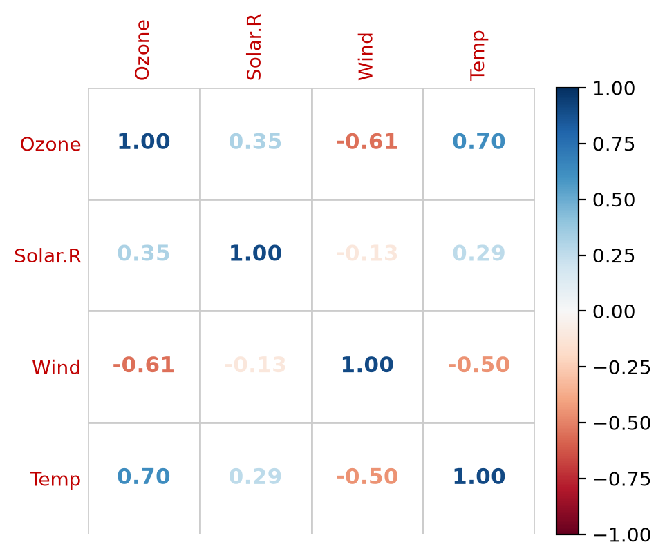
Figure: Correlation plot of airquality
Ozone with others:
- Temp 0.70 – strong positive: hot days have more ozone.
- Wind −0.61 – moderate/strong negative: wind disperses ozone.
- Solar.R 0.35 – weak positive: sunlight helps ozone form a little.
Remember: use = "complete.obs" because Ozone and Solar.R have NAs.

Q8. What is the use of sampling in inferential statistics? Explain methods of sampling.
2 Marks • Easy • CO4
Sampling is selecting a small part (sample) of a population to study it. Inferential statistics uses the sample to draw conclusions (estimate, test hypotheses) about the whole population – saving time, cost and effort when a census is impossible.
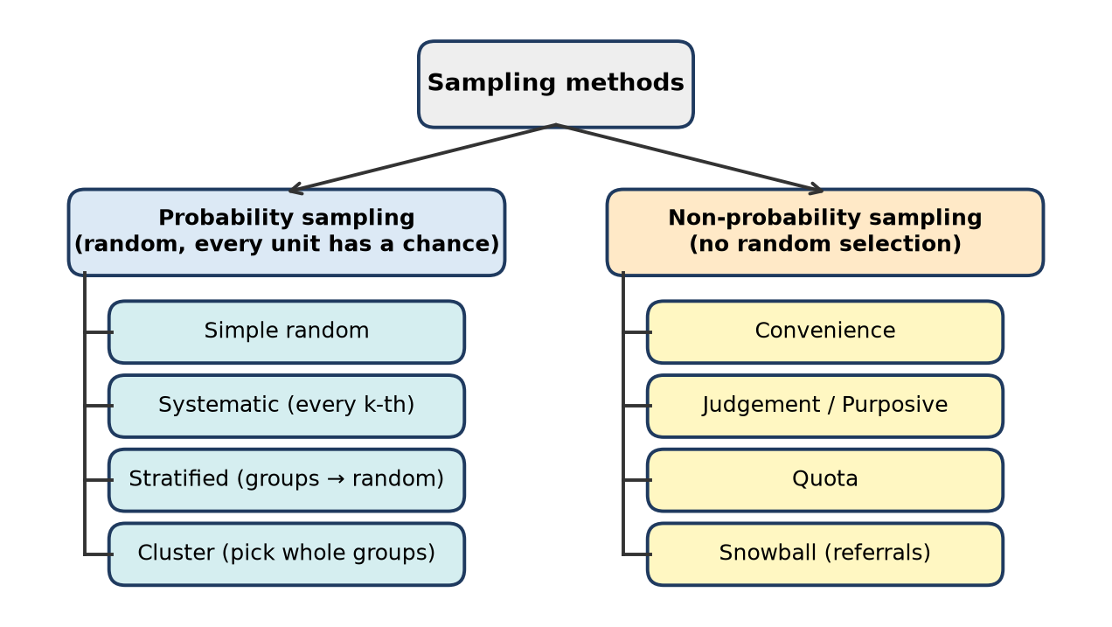
Figure: Sampling methods
- Probability: simple random (sample()), systematic (every k-th), stratified (random from each group), cluster (whole groups).
- Non-probability: convenience, judgement, quota, snowball.
sample(1:100, 10) # simple random sample
iris %>% group_by(Species) %>% slice_sample(n = 5) # stratified
Remember: Good sample = random + representative.

Q9. What is the difference between probability and nonprobability sampling?
2 Marks • Easy • CO4
Basis | Probability sampling | Non-probability sampling
Selection | Random; every unit has a known non-zero chance | Based on judgement or convenience
Bias | Low | High (selection bias)
Generalisation | Results can be generalised to the population | Cannot be generalised reliably
Cost / time | More | Less, quick
Examples | Simple random, systematic, stratified, cluster | Convenience, judgement, quota, snowball

Use probability sampling for research conclusions; non-probability for pilot studies.
Remember: Probability = "lottery", Non-probability = "whoever is handy".

Q10. Write an R command to calculate the skewness of the variable mpg from the inbuilt dataset mtcars.
2 Marks • Easy • CO4
install.packages("moments") # once
library(moments)
skewness(mtcars$mpg)
# [1] 0.6404399
- $ selects one column; skewness() comes from the moments package (base R has none).
- Result ≈ 0.64 > 0 → mpg is moderately right-skewed: a few cars have very high mileage (30–34 mpg), so mean (20.09) > median (19.2).
Remember: Skewness is in moments (or e1071), not base R.

Q11. Identify the error in the following R code and rewrite it correctly. library(moments); skewness(mtcars)
2 Marks • Easy • CO4
Error: the whole data frame mtcars is given instead of one variable. Skewness describes the distribution of a single numeric variable (moments returns 11 separate values for a numeric data frame, which is not what the question wants).
library(moments)
skewness(mtcars$mpg) # 0.6404399
# all columns, if really needed: sapply(mtcars, skewness)
Remember: Statistics of one variable → data$column.

Q12. Consider the following R code: library(moments); x <- c(10, 20, 30, 40, 50, 60); result <- skewness(x); print(result). What is the purpose of the skewness() function?
2 Marks • Easy • CO4
skewness() measures the asymmetry of the distribution of the data about its mean.
Formula (moments): skewness = m3 ÷ m2^1.5, where m2 = Σ(x − x̄)²/n and m3 = Σ(x − x̄)³/n.
For this x: mean = 35; deviations −25, −15, −5, 5, 15, 25 are symmetric, so Σ(x − x̄)³ = 0.
print(result)
# [1] 0
- 0 → perfectly symmetric; positive → right tail; negative → left tail.
Remember: Equally spaced values always give skewness 0.

Q13. Write an R command to calculate the skewness of the variable Ozone from the airquality dataset after removing missing values.
2 Marks • Easy • CO4
library(moments)
skewness(na.omit(airquality$Ozone))
# same: skewness(airquality$Ozone, na.rm = TRUE)
- Ozone has 37 NA values; without removing them the result is NA.
- The result is positive (about 1.2) → ozone is right-skewed: most days have low ozone and a few days very high (mean 42.1 > median 31.5).
Remember: NA in → NA out; remove NAs first.

Q14. Write an R command to calculate the kurtosis of the variable mpg from the mtcars dataset.
2 Marks • Easy • CO4
library(moments)
kurtosis(mtcars$mpg)
# [1] 2.799467
- moments gives Pearson kurtosis (normal = 3).
- 2.80 < 3 → mpg is slightly platykurtic: a little flatter than normal with lighter tails (excess kurtosis = 2.80 − 3 = −0.20).
Remember: Moments: compare with 3; e1071/psych: compare with 0.

Q15. Identify the error in the following R code and rewrite it correctly. library(moments); kurtosis(iris)
2 Marks • Easy • CO4
Error: the whole iris data frame is passed. It contains the factor column Species, for which kurtosis is not meaningful (gives NA with warnings), and the question needs one variable.
library(moments)
kurtosis(iris$Sepal.Length)
# for all numeric columns: sapply(iris[, 1:4], kurtosis)
Remember: Kurtosis only for numeric columns.

Q16. Consider the following R code: library(moments); x <- c(5, 10, 15, 20, 25, 30); k <- kurtosis(x); print(k). What does the kurtosis() function measure?
2 Marks • Easy • CO4
kurtosis() measures the peakedness and tail heaviness of the distribution: kurtosis = m4 ÷ m2².
Working: mean = 17.5; deviations ±2.5, ±7.5, ±12.5
- m2 = 2(6.25 + 56.25 + 156.25) ÷ 6 = 437.5 ÷ 6 = 72.92
- m4 = 2(39.06 + 3164.06 + 24414.06) ÷ 6 = 55234.4 ÷ 6 = 9205.7
- k = 9205.7 ÷ 72.92² = 1.73
print(k)
# [1] 1.731429
1.73 < 3 → platykurtic (flat, like a uniform distribution – values are evenly spread).
Remember: Evenly spread data = flat = kurtosis below 3.

Q17. Consider the following output: library(moments); x <- c(10, 20, 30, 40, 50); skewness(x). What can you infer about the distribution?
2 Marks • Easy • CO4
skewness(x)
# [1] 0
- Mean = 30 = median; deviations −20, −10, 0, 10, 20 cancel out, so Σ(x − x̄)³ = 0.
- Skewness = 0 → the distribution is symmetric; neither tail is longer.
- Mean = median = mode position; no outliers pull the mean.
Remember: Skew 0 ⇔ mirror image about the mean.

Q18. Consider the following output: library(moments); x <- c(10, 12, 15, 18, 50); skewness(x). What does positive skewness indicate?
2 Marks • Easy • CO4
skewness(x)
# [1] 1.376128
- Mean = 105 ÷ 5 = 21, median = 15 → mean > median.
- The value 50 is far above the rest and creates a long right tail.
- Positive skewness = right-skewed distribution: most values are small, a few are very large; the mean is pulled to the right, so the median is the better average.
Remember: Tail to the right → skew positive → mean > median.

Q19. Write an R command to calculate the correlation between mpg and disp variables from the inbuilt dataset mtcars.
2 Marks • Easy • CO4
cor(mtcars$mpg, mtcars$disp)
# [1] -0.8475514
# same: with(mtcars, cor(mpg, disp))
- r ≈ −0.85 → strong negative correlation: cars with larger engine displacement give lower mileage.
- Default method is Pearson; method = "spearman" gives rank correlation.
Remember: cor(data$x, data$y) – both columns need data$.

Q20. Identify the error in the following R code and rewrite it correctly. cor(mtcars$mpg, disp)
2 Marks • Easy • CO4
Error: disp is not a separate object; it is a column inside mtcars. R gives Error: object 'disp' not found.
cor(mtcars$mpg, mtcars$disp)
# [1] -0.8475514
Other correct forms: with(mtcars, cor(mpg, disp)) or cor(mtcars[, c("mpg", "disp")]).
Remember: Every column name needs its data frame.

Q21. What is the role of measures of central tendency in descriptive statistics? What are the criteria to use either of mean, median or mode as central tendency for the given data?
4 Marks • Moderate • CO4
A measure of central tendency is a single value that represents the centre or typical value of a data set.
Role:
- Summarises large data in one number; allows comparison of groups (average mpg of automatic vs manual).
- Base for other measures (variance, SD, skewness are measured around the mean).
Worked example: x = 2, 3, 3, 5, 7
- Mean = Σx ÷ n = 20 ÷ 5 = 4
- Median (middle value of sorted data, n odd) = 3
- Mode (most frequent) = 3
x <- c(2, 3, 3, 5, 7)
mean(x); median(x)
names(which.max(table(x))) # mode (no built-in mode function)
Criteria for choice:
Use | When
Mean | Numeric, roughly symmetric data without outliers (marks, height)
Median | Skewed data or outliers (income, house price); ordinal data
Mode | Categorical data (most common colour, brand) or most frequent size

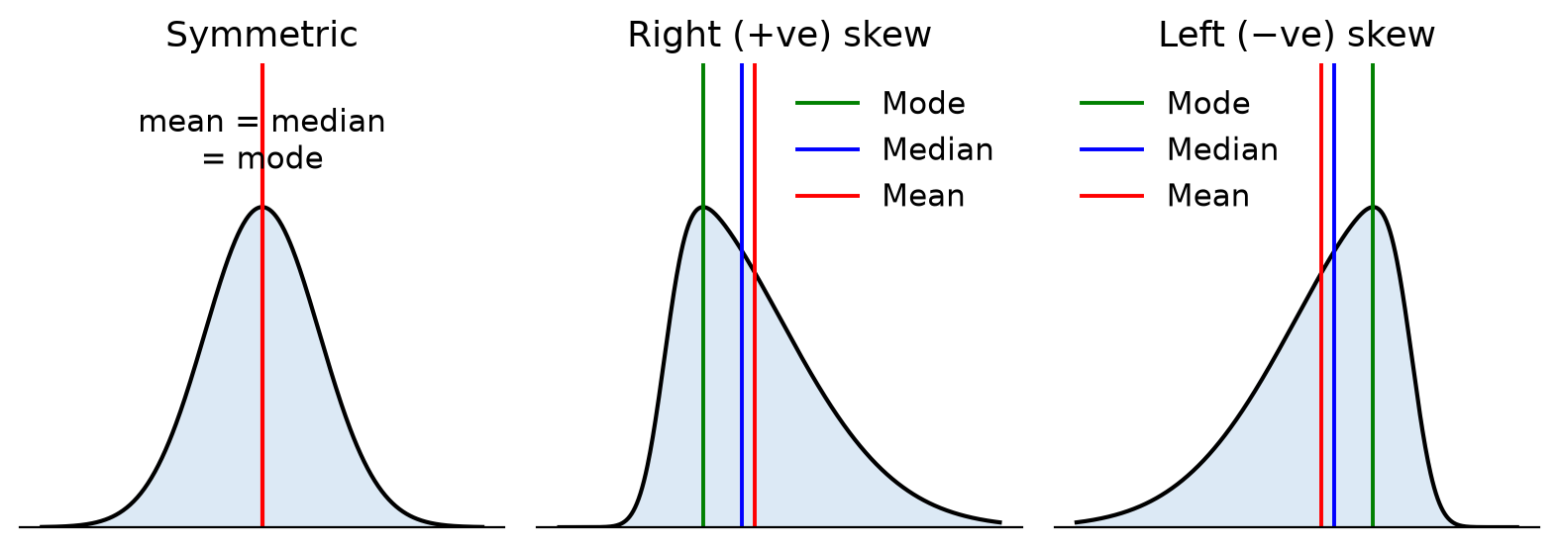
Figure: Mean, median and mode in skewed data
Remember: Symmetric → Mean, Skewed → Median, Categories → Mode.

Q22. What is significance of measure of variability in Data analysis. Explain standard deviation in detail.
4 Marks • Moderate • CO4
Variability (dispersion) tells how spread out the values are around the centre. Two groups can have the same mean but very different spreads.
Significance: shows consistency/reliability (low spread = consistent), how representative the mean is, risk (stock returns), quality control, and it is needed for tests and regression. Measures: range, IQR, variance, SD, CV.
Standard deviation (SD) = square root of the average squared deviation from the mean.
- Sample SD (R's sd()): s = √[Σ(x − x̄)² ÷ (n − 1)]
- Same unit as the data; SD = 0 means all values equal.
Worked example: x = 2, 4, 4, 4, 5, 5, 7, 9 → x̄ = 40 ÷ 8 = 5
- (x − x̄)² = 9, 1, 1, 1, 0, 0, 4, 16 → sum = 32
- Variance = 32 ÷ 7 = 4.571 → SD = √4.571 = 2.14
x <- c(2, 4, 4, 4, 5, 5, 7, 9)
var(x); sd(x) # 4.571429 2.13809
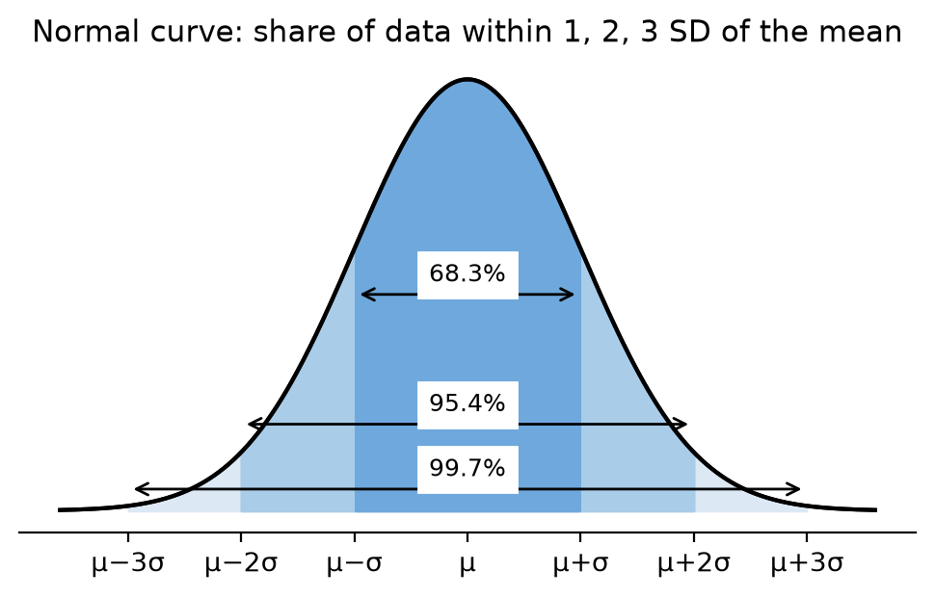
Figure: Normal curve: 68–95–99.7 rule
For normal data about 68 % of values lie within ±1 SD, 95 % within ±2 SD and 99.7 % within ±3 SD.
Remember: SD = "average distance from the mean".

Q23. For data set 'Car_price' write a syntax to get correlation of the following variable and also below correlation plot. Comment on the correlation of all variables with 'price'
4 Marks • Moderate • CO4
library(corrplot)
Car_price <- read.csv("CarPrice.csv")
vars <- Car_price[, c("wheel_base", "length", "curb_weight", "engine_size", "price")]
M <- cor(vars, use = "complete.obs")
round(M, 2)
corrplot(M, method = "number")
(Use the column names exactly as in your file, e.g. wheelbase, carlength, curbweight, enginesize in some versions.)
Correlation with price (from the plot):
Variable | r with price | Meaning
engine_size | 0.87 | Strongest positive – bigger engine, costlier car
curb_weight | 0.83 | Strong positive – heavier cars cost more
length | 0.69 | Moderate positive
wheel_base | 0.58 | Moderate positive (weakest of the four)

Other observations: all correlations are positive (blue). Predictors are also strongly related to each other (wheel_base–length 0.88, length–curb_weight 0.88, curb_weight–engine_size 0.85) → multicollinearity; in a multiple regression we should not use all of them together. Engine size alone is the best single predictor of price.
Remember: Read the price row/column; biggest |r| = best predictor.

Q24. A data set provides measurements of the diameter, height and volume of timber in 31 felled black cherry trees. Following is data of descriptive analysis (Std.Dev, Min, Q1, Median, Q3, Max, MAD, IQR, CV for Girth, Height, Volume). Make inferences from dispersion measures for variables Girth (Diameter), height and Volume
4 Marks • Moderate • CO4
This is the inbuilt trees data (Girth is actually the diameter in inches, Height in ft, Volume in cubic ft).
Measure | Girth | Height | Volume
SD | 3.14 | 6.37 | 16.44
Range (Max − Min) | 12.3 | 24 | 66.8
IQR | 4.20 | 8.00 | 17.90
CV | 0.24 | 0.08 | 0.54

Inferences:
1. Volume is the most variable (CV 0.54 = 54 %, IQR 17.9, range 66.8) – tree volume differs a lot from tree to tree.
2. Height is the least variable (CV 8 %) – trees are of fairly similar height (63–87 ft).
3. Girth has moderate relative variation (CV 24 %).
4. SDs cannot be compared directly because units differ – so CV is used.
5. Volume is right-skewed: Q3 − median = 14.1 but median − Q1 = 5.1, and max 77 is far above Q3 → a few very large trees. Girth also has a slightly longer upper part (Q3 − median 3.1 vs 1.9); Height is nearly symmetric (4 and 4).
6. MAD (robust spread) is smaller than SD for Volume (11.56 vs 16.44), again showing the effect of large values.
sapply(trees, function(v) c(SD = sd(v), IQR = IQR(v), MAD = mad(v), CV = sd(v)/mean(v)))
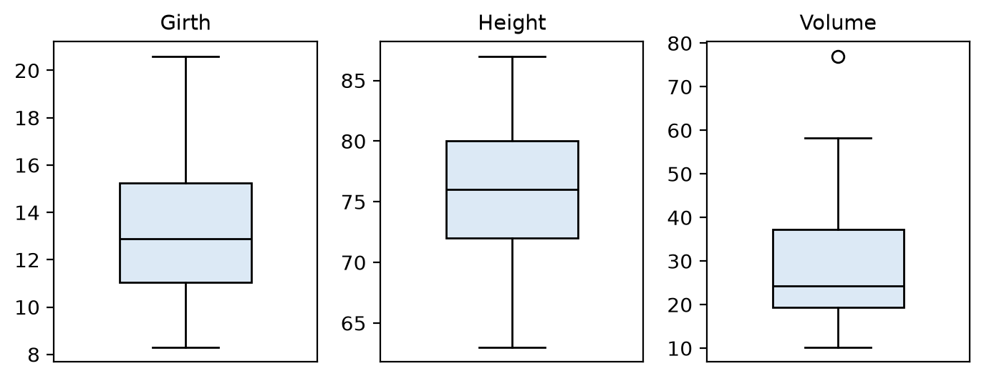
Figure: Box plots of trees variables
Remember: Different units → compare CV.

Q25. Write syntax to get average of 'Freq' as per the 'Class' for dataset 'Titanic' which has shown in table (1st 40.625/58.08, 2nd 35.625/54.27, 3rd 88.250/124.59, Crew 110.625/235.51). Freq shows number of passengers as per class. Comment on variation in frequencies Class wise
4 Marks • Moderate • CO4
Titanic is a 4-way table; convert it to a data frame (32 rows: Class, Sex, Age, Survived, Freq).
library(dplyr)
td <- as.data.frame(Titanic)
td %>% group_by(Class) %>%
summarise(Avg_Freq = mean(Freq), StDev_Freq = sd(Freq))
# base R: aggregate(Freq ~ Class, data = td, FUN = mean)
Each class has 8 cells, so Avg_Freq = class total ÷ 8 (e.g. 1st: 325 ÷ 8 = 40.625).
Class | Mean | SD | CV %
1st | 40.625 | 58.08 | 143.0
2nd | 35.625 | 54.27 | 152.3
3rd | 88.250 | 124.59 | 141.2
Crew | 110.625 | 235.51 | 212.9

Comment:
1. Crew has the highest average (885 people ÷ 8) and by far the largest SD and CV – counts are extremely uneven (670 adult men died, but 0 children).
2. 3rd class is the largest passenger class (mean 88.25) with large spread.
3. 2nd class has the smallest average (285 people).
4. In every class SD > mean (CV > 100 %) – frequencies vary hugely between sex/age/survival groups.
Remember: SD bigger than mean = very uneven groups.

Q26. How Skewness and Kurtosis will help to describe distribution of the data. Write syntax to get values of Skewness and Kurtosis for distribution of variable 'wind' [that describes speed of wind] of the dataset 'storms'.
4 Marks • Moderate • CO4
Mean and SD tell the centre and spread; skewness and kurtosis describe the shape.
Skewness (symmetry):
- = 0 symmetric; > 0 long right tail (mean > median); < 0 long left tail.
- |skew| < 0.5 nearly symmetric, 0.5–1 moderate, > 1 high.
Kurtosis (peak and tails, moments version):
- = 3 mesokurtic (normal); > 3 leptokurtic – tall peak, heavy tails, more extreme values; < 3 platykurtic – flat.
They help to check normality, choose mean vs median, decide on transformations, and judge the chance of extreme values (very strong storms).
library(dplyr) # storms data comes with dplyr
library(moments)
skewness(storms$wind, na.rm = TRUE)
kurtosis(storms$wind, na.rm = TRUE)
hist(storms$wind, main = "Wind speed of storms", xlab = "Wind (knots)")
Expected reading: most records are weak storms (low wind) and only a few are major hurricanes, so the skewness of wind comes out positive (right-skewed); the kurtosis value is compared with 3 to say whether extreme winds are more common than in a normal distribution.
Figure: Shapes for skewness and kurtosis
Remember: Centre (mean) + spread (SD) + shape (skew, kurtosis) = full description.

Q27. Correlation matrix of 'storms' data is given (wind, pressure, lat, long). Write inferences from the correlation matrix.
4 Marks • Moderate • CO4
Pair | r | Inference
wind – pressure | −0.929 | Very strong negative
pressure – lat | −0.110 | Very weak negative
lat – long | 0.115 | Very weak positive
pressure – long | 0.041 | Almost zero
wind – long | −0.032 | Almost zero
wind – lat | −0.007 | No relation

Inferences:
1. Wind and pressure are very strongly negatively correlated (−0.93): as the central air pressure of a storm falls, wind speed rises – stronger storms have lower pressure. One variable can predict the other well (see Q45, R² = 0.86).
2. Location (lat, long) is almost unrelated to wind or pressure (|r| ≤ 0.11) – storm strength does not depend linearly on where it is.
3. Small negative pressure–lat (−0.11): slightly lower pressure at higher latitudes, but practically negligible.
4. Diagonal values are 1 (each variable with itself); the matrix is symmetric.
5. Only wind and pressure should be used together in a regression; lat/long add little.
cor(storms[, c("wind", "pressure", "lat", "long")], use = "complete.obs")
Remember: |r| near 1 = strong, near 0 = none.

Q28. Explain uses of qnorm, pnorm and dnorm commands for probability distribution
4 Marks • Moderate • CO4
R has four functions for every distribution: d (density), p (probability/cumulative), q (quantile), r (random). For the normal distribution (default mean = 0, sd = 1):
Function | Gives | Example | Output
dnorm(x, mean, sd) | Height of the normal curve (density) at x | dnorm(0) | 0.3989423
pnorm(q, mean, sd) | Area to the left: P(X ≤ q) | pnorm(1.96) | 0.9750021
qnorm(p, mean, sd) | Value x with area p to its left (inverse of pnorm) | qnorm(0.975) | 1.959964
rnorm(n, mean, sd) | n random normal numbers | rnorm(5) | random

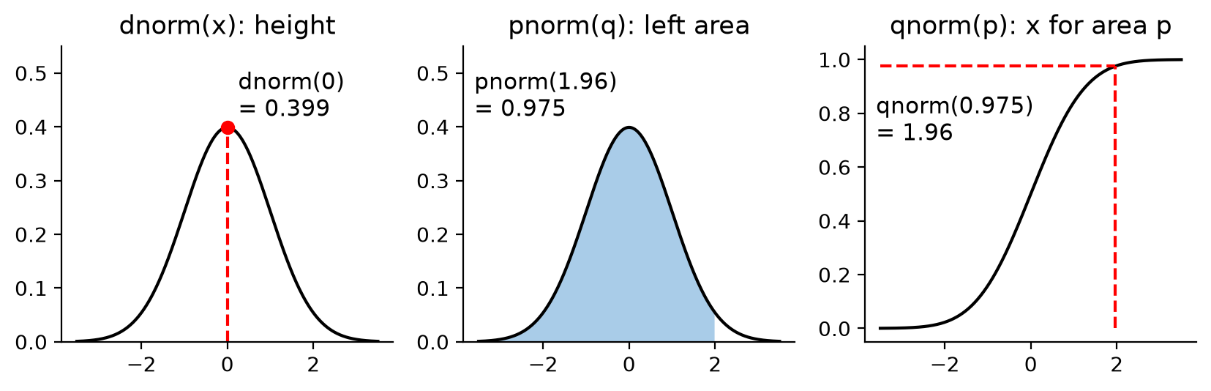
Figure: dnorm, pnorm and qnorm
Uses with an example (marks with mean 60, SD 10):
- pnorm(70, 60, 10) = 0.8413 → 84.1 % students score ≤ 70; 1 - pnorm(70, 60, 10) = 15.9 % score above 70.
- qnorm(0.95, 60, 10) = 76.45 → top 5 % cut-off mark.
- dnorm() is used to draw the bell curve: curve(dnorm(x), -3, 3).
- qnorm() gives critical values (1.96 for 95 % confidence).
Remember: d = height, p = probability (area), q = quantile (cut-off).

Q29. A data set provides measurements of the diameter, height and volume of timber in 31 felled black cherry trees. Standard deviation of diameter, height and volume is as given (3.138, 6.372, 16.438). Also its graphical representation in histogram is given. Comment about the central tendency and dispersion in data of all three variables
4 Marks • Moderate • CO4
sapply(trees, mean); sapply(trees, median); sapply(trees, sd)
par(mfrow = c(1, 3))
hist(trees$Girth); hist(trees$Height); hist(trees$Volume)
Variable | Mean | Median | SD | CV %
Girth (diameter, in) | 13.25 | 12.9 | 3.14 | 23.7
Height (ft) | 76.0 | 76.0 | 6.37 | 8.4
Volume (cu ft) | 30.17 | 24.2 | 16.44 | 54.5

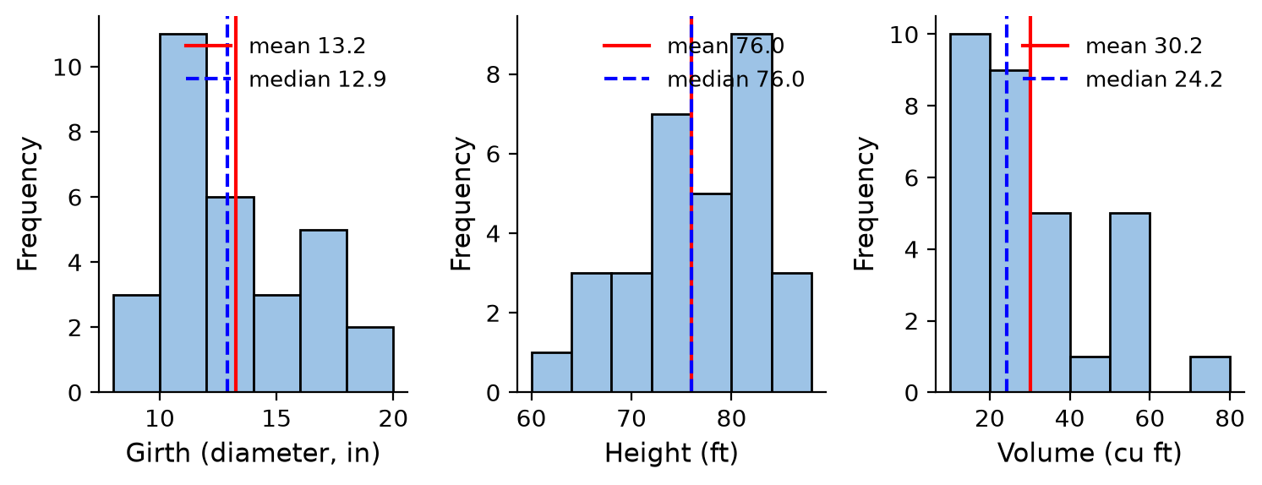
Figure: Histograms of trees variables with mean and median
Central tendency:
- Height: mean = median = 76 → symmetric; 76 ft is a good typical height.
- Girth: mean 13.25 slightly > median 12.9 → mild right skew; most trees 10–14 in.
- Volume: mean 30.17 much > median 24.2 → right-skewed; the median is the better typical value.
Dispersion:
- Volume has the largest SD and CV (54.5 %) → most variable; a few very big trees (up to 77).
- Height has the smallest relative spread (CV 8.4 %) → most uniform.
- Girth is in between (CV 23.7 %).
Remember: Mean ≈ median → symmetric; mean > median → right tail.

Q30. A data set provides measurements of the diameter, height and volume of timber in 31 felled black cherry trees. Following is Correlation Matrix for numerical data (Diameter–Height 0.519, Diameter–Volume 0.967, Height–Volume 0.598). Comment about correlation ship among variables
4 Marks • Moderate • CO4
cor(trees)
library(corrplot); corrplot(cor(trees), method = "number")
Pair | r | Strength
Diameter – Volume | 0.967 | Very strong positive
Height – Volume | 0.598 | Moderate positive
Diameter – Height | 0.519 | Moderate positive

Comments:
1. Diameter and Volume are almost perfectly related (0.97): volume can be predicted very accurately from diameter (r² = 0.935 → 93.5 % of variation explained).
2. Height and Volume are moderately related (0.60, r² = 0.36) – height alone is a weaker predictor (see Q47).
3. Diameter and Height are moderately related (0.52) – taller trees tend to be thicker, but not always.
4. All relations are positive: every variable increases with the others.
5. Since volume ≈ cross-section × height, the best model uses both: lm(Volume ~ Girth + Height, data = trees); the moderate diameter–height correlation means little multicollinearity.
Remember: R² tells the share of variation explained.

Q31. Write the code to generate the following corrplot for 'mtcars' data set, where mpg: miles per gallon, cyl: number of cylinders, hp: horsepower of engine, wt: weight of engine. Comment on the correlation of mpg with other variables.
4 Marks • Moderate • CO4
library(corrplot)
M <- cor(mtcars[, c("mpg", "cyl", "hp", "wt")])
round(M, 2)
corrplot(M, method = "number") # numbers coloured by value
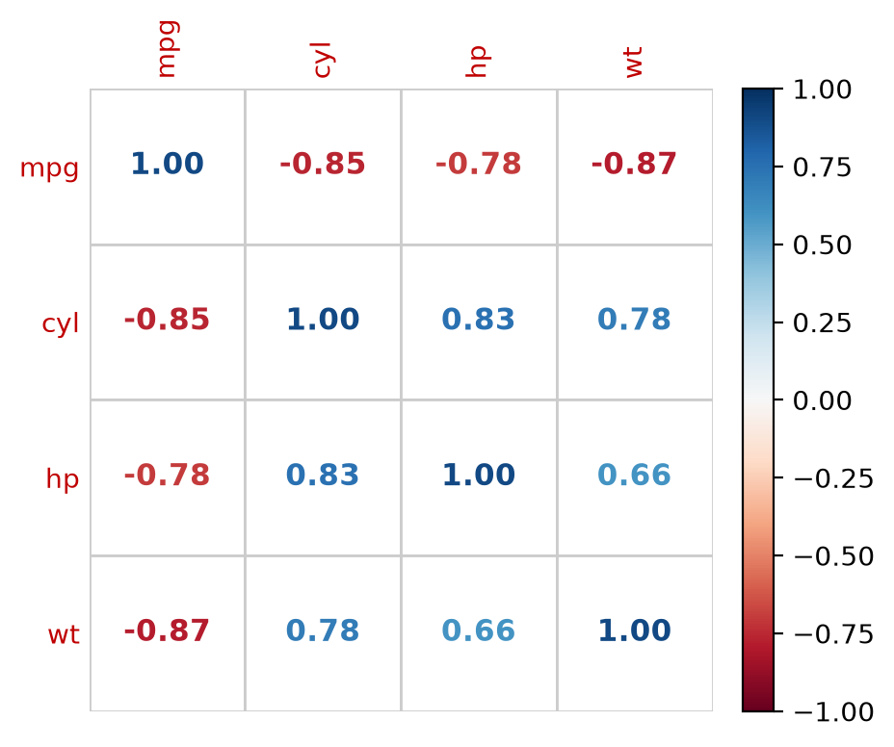
Figure: corrplot of mpg, cyl, hp, wt
Correlation of mpg with others (all negative, red):
Variable | r | Meaning
wt | −0.87 | Strongest: heavier cars give much lower mileage
cyl | −0.85 | More cylinders → lower mileage
hp | −0.78 | More powerful engines → lower mileage

Other comments:
- cyl, hp and wt are positively correlated with each other (cyl–hp 0.83, cyl–wt 0.78, hp–wt 0.66): big cars have more cylinders and power.
- So they carry overlapping information (multicollinearity); weight is the best single predictor of mpg (R² = 0.75).
Remember: Everything that makes a car "bigger" lowers mpg.

Q32. What is regression analysis? What is the importance of regression analysis in data analysis? Write syntax to find regression analysis between one dependent and one independent variable from a dataset
4 Marks • Moderate • CO4
Regression analysis finds a mathematical equation that describes how a dependent variable (y) changes with one or more independent variables (x). Simple linear regression: ŷ = b0 + b1·x (b0 = intercept, b1 = slope).
Importance: predicts future values (sales, price), measures the effect of x on y (slope), tests if the effect is significant (p-value), measures fit (R²), supports decision making.
Least-squares formulas: b1 = Σ(x − x̄)(y − ȳ) ÷ Σ(x − x̄)²; b0 = ȳ − b1·x̄
Worked example (x = study hours 1–5, y = marks 3, 4, 6, 8, 9): x̄ = 3, ȳ = 6, Σ(x−x̄)(y−ȳ) = 16, Σ(x−x̄)² = 10 → b1 = 1.6, b0 = 6 − 1.6×3 = 1.2 → ŷ = 1.2 + 1.6x; prediction for x = 6: 10.8; r = 0.992, R² = 0.985.
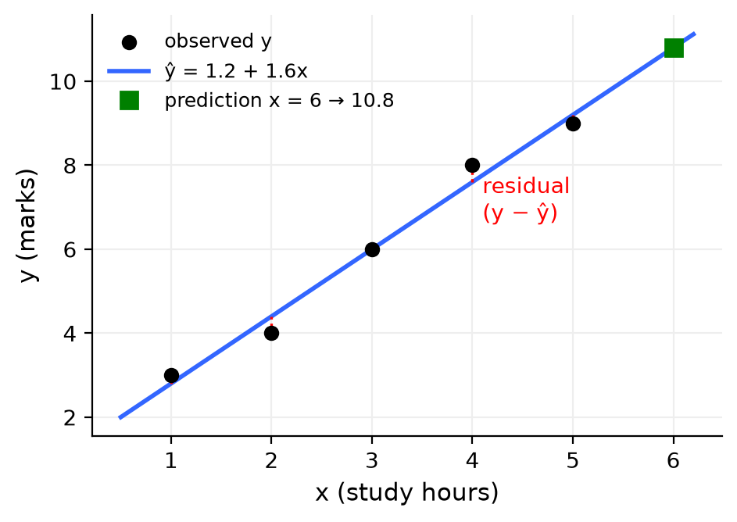
Figure: Fitted line, residuals and prediction
model <- lm(mpg ~ wt, data = mtcars) # y ~ x
summary(model) # coefficients, p-values, R-squared
# mpg = 37.285 - 5.344 * wt ; R-squared = 0.7528
predict(model, data.frame(wt = 3)) # 21.25
Remember: lm(y ~ x) – "y depends on x".

Q33. The following table shows the mean and standard deviation of car mileage (mpg) based on transmission type (Automatic 17.15, SD 3.83; Manual 24.39, SD 6.17) for the dataset mtcars in R. Write any four inferences based on the mean and standard deviation.
4 Marks • Moderate • CO4
mtcars %>% group_by(am) %>% summarise(Mean = mean(mpg), SD = sd(mpg)) # am: 0 = automatic, 1 = manual
Transmission | Mean | SD | CV %
Automatic | 17.15 | 3.83 | 22.3
Manual | 24.39 | 6.17 | 25.3

Inferences:
1. Manual cars give higher average mileage (24.39 vs 17.15 mpg).
2. The difference is 24.39 − 17.15 = 7.24 mpg (about 42 % more).
3. Manual cars have the larger SD (6.17) → their mileage varies more (manual group has both small economy cars and sports cars).
4. Automatic cars are more consistent – smaller SD and slightly smaller CV (22.3 % vs 25.3 %).
Conclusion: manual cars generally give better mileage; automatic cars give more uniform mileage. (Part of the difference is because automatic cars in mtcars are heavier.)
Remember: Higher mean = better on average; lower SD = more consistent.

Q34. The following table shows the mean and standard deviation of diamond prices (in USD) based on cut quality for the diamonds dataset in R. Write any four inferences based on the mean and standard deviation.
4 Marks • Moderate • CO4
diamonds %>% group_by(cut) %>% summarise(Mean = mean(price), SD = sd(price))
Cut | Mean | SD | CV %
Fair | 4358.76 | 3560.39 | 81.7
Good | 3928.86 | 3681.59 | 93.7
Very Good | 3981.76 | 3935.86 | 98.8
Premium | 4584.26 | 4349.20 | 94.9
Ideal | 3457.54 | 3808.40 | 110.1

Inferences:
1. Premium cut has the highest mean price ($4584.26); Ideal – the best cut – has the lowest ($3457.54).
2. Premium has the largest SD (4349.20) → widest price variation; Fair has the smallest SD (3560.39).
3. Relative to mean, Ideal is most variable (CV 110 %) and Fair least (82 %).
4. SDs are almost as large as the means in every group → prices are highly spread and right-skewed (few very costly stones).
Conclusion: better cut does not mean higher average price – Ideal diamonds are usually smaller in carat, and carat drives price more than cut.
Remember: When a "better" group is cheaper, look for a hidden variable (carat).

Q35. The following table shows the mean and standard deviation of tooth length based on supplement type (OJ 20.66, SD 6.61; VC 16.96, SD 8.27) for the inbuilt dataset ToothGrowth in R. Write any four inferences based on the mean and standard deviation.
4 Marks • Moderate • CO4
ToothGrowth %>% group_by(supp) %>% summarise(Mean = mean(len), SD = sd(len))
Supplement | Mean | SD | CV %
OJ | 20.66 | 6.61 | 32.0
VC | 16.96 | 8.27 | 48.8

Inferences:
1. OJ (orange juice) gives the higher average tooth length (20.66 vs 16.96).
2. OJ is ahead by 20.66 − 16.96 = 3.70 units (about 22 % more).
3. VC has the larger SD (8.27) → more variation in tooth growth.
4. OJ is more consistent – smaller SD and CV (32 % vs 48.8 %).
Conclusion: OJ gives longer and more consistent tooth growth than VC (a t-test, t.test(len ~ supp, data = ToothGrowth), can check if the difference is significant).
Remember: Mean → effect, SD → reliability.

Q36. Write a program to get correlation matrix for the data 'storms' given below. Assume that there is NA values present in the data. Also find corrplot with correlation matrix. (Mention required package)
5 Marks • Difficult • CO4
Packages: dplyr (contains the storms data and select()), corrplot (correlation plot).
# install.packages(c("dplyr", "corrplot"))
library(dplyr)
library(corrplot)
data(storms)
st <- storms %>% select(lat, long, wind, pressure) # numeric columns only
colSums(is.na(st)) # check missing values
# Method 1: use only complete rows
M <- cor(st, use = "complete.obs")
# Method 2: drop NA rows first
# M <- cor(na.omit(st))
# Method 3: pairwise deletion
# M <- cor(st, use = "pairwise.complete.obs")
round(M, 3) # correlation matrix
corrplot(M, method = "number", type = "full") # numbers
corrplot(M, method = "circle", type = "upper") # circles
Explanation:
1. cor() works only on numeric columns, so name (text) is removed with select().
2. If any value is NA, cor() returns NA; use = "complete.obs" removes rows with NA (listwise), "pairwise.complete.obs" uses all available pairs.
3. corrplot() draws the matrix: blue = positive, red = negative; size/colour intensity = strength.
Expected result: wind–pressure ≈ −0.93 (very strong negative); lat and long show almost no correlation with wind or pressure (see Q27).
Remember: Numeric only + handle NA + corrplot = complete correlation analysis.

Q37. First 5 entries from data 'msleep' related to the mammals sleep dataset of carnivore, omnivore or herbivore. Write a syntax to visualize the relation between sleep_total and bodywt. Also comment on it.
5 Marks • Difficult • CO4
msleep (ggplot2) has 83 mammals: vore, sleep_total (hours/day), brainwt, bodywt (kg). Body weight ranges from about 0.005 kg to 6654 kg (African elephant), so a log scale on x is needed.
library(ggplot2)
ggplot(msleep, aes(x = bodywt, y = sleep_total, color = vore)) +
geom_point(size = 2) +
scale_x_log10() + # spreads tiny and huge animals
geom_smooth(method = "lm", se = FALSE, color = "black") +
labs(title = "Total sleep vs Body weight",
x = "Body weight (kg, log scale)", y = "Total sleep (hours)", color = "Diet")
cor(log10(msleep$bodywt), msleep$sleep_total)
From the 5 rows given: the omnivore of 0.019 kg sleeps 14.9 h and the 0.48 kg omnivore 17 h, while the 600 kg herbivore (cow) sleeps only 4 h and the 50 kg carnivore 12.1 h.
Comments:
1. There is a negative relationship: heavier mammals sleep less, small mammals sleep more.
2. On the raw scale the points crowd near zero; after log10 the downward trend is clear and roughly linear.
3. Herbivores are spread over the whole range – large grazers (cow, elephant, horse) sleep the least (2–4 h), perhaps because they need long feeding time and must watch for predators.
4. Carnivores and insectivores of similar size tend to sleep longer.
5. The relationship is moderate, not perfect – diet and other factors also matter.
Remember: Very wide range of values → use a log scale.

Q38. Write a syntax to get average of 'sleep_total' and average & coefficient of variation of 'bodywt' as per eating nature (vore). Compare variation of bodywt as per vore type.
5 Marks • Difficult • CO4
library(dplyr); library(ggplot2) # msleep is in ggplot2
msleep %>%
group_by(vore) %>%
summarise(Count = n(),
Average_sleep = mean(sleep_total),
Avg_weight = mean(bodywt),
CV_bodywt = sd(bodywt) / mean(bodywt))
Output (given):
vore | Count | Average_sleep | Avg_weight | CV_bodywt
carni | 19 | 10.38 | 90.75 | 2.006
herbi | 32 | 9.51 | 366.88 | 3.391
insecti | 5 | 14.94 | 12.92 | 2.042
omni | 20 | 10.93 | 12.72 | 1.942
NA | 7 | 10.19 | 0.86 | 1.560

Comparison of variation of bodywt:
1. Herbivores have the highest CV (3.39 → SD is 3.4 times the mean) – they range from tiny rodents to the elephant (6654 kg), so body weight is extremely variable; their mean (366.9 kg) is pulled up by a few giants.
2. Insectivores (2.04) and carnivores (2.01) have similar, also very high variation.
3. Omnivores (1.94) vary a little less; the NA group (diet unknown, 7 small animals) varies least (1.56).
4. All CVs are greater than 1 → body weight is highly right-skewed in every group; the median would be a better average.
5. Sleep: insectivores sleep the most (14.9 h), herbivores the least (9.5 h).
Remember: CV > 1 means SD bigger than mean – extremely spread data.

Q39. A data set provides measurements of the diameter, height and volume of timber in 31 felled black cherry trees, coefficient of kurtosis and density curves are given below (Girth −0.71, Height −0.72, Volume 0.25). Write minimum 3 comments on distribution of the data based on kurtosis
5 Marks • Difficult • CO4
The given values are excess kurtosis (kurtosis − 3; normal = 0), e.g. from e1071::kurtosis() or psych::describe().
library(e1071)
sapply(trees, kurtosis)
ggplot(trees, aes(Girth)) + geom_density() # similarly Height, Volume
Variable | Excess kurtosis | Type
Girth | −0.71 | Platykurtic
Height | −0.72 | Platykurtic
Volume | 0.25 | Slightly leptokurtic (near mesokurtic)

Figure: Kurtosis types
Comments:
1. Girth (−0.71) is platykurtic – flatter than normal with light tails; values are spread fairly evenly (the density shows a peak near 12 in and a shoulder near 16–18 in, i.e. two size groups).
2. Height (−0.72) is also platykurtic – a broad, rounded peak around 76–80 ft and no extreme heights; heights are evenly spread from 63 to 87 ft.
3. Volume (0.25) is close to normal peakedness but slightly leptokurtic – a sharp peak around 20 cu ft and a long right tail (largest tree 77 cu ft), so extreme values are more likely than for girth or height.
4. Negative kurtosis for Girth and Height means few outliers; for Volume the tail suggests checking outliers and possibly a log transformation before modelling.
Conclusion: Girth and Height are flat and outlier-free; Volume is peaked and right-tailed.
Remember: Negative excess kurtosis = flat; positive = peaked with heavier tails.

Q40. 'faithful' is the data set involving 'waiting' [time between eruptions] and 'eruptions' [the duration of the eruptions] for the Old Faithful geyser. Statistical Analysis is given in the table (eruptions: skewness −0.4158, kurtosis 1.4994, mean 3.488, SD 1.141; waiting: skewness −0.4163, kurtosis 1.8574, mean 70.90, SD 13.59). Also, related graphs are given. Write the inferences based on skewness and kurtosis.
5 Marks • Difficult • CO4
library(moments)
sapply(faithful, skewness); sapply(faithful, kurtosis)
ggplot(faithful, aes(eruptions)) + geom_density()
ggplot(faithful, aes(waiting)) + geom_density()
Inferences:
1. Skewness ≈ −0.42 for both → both are moderately negatively (left) skewed: the larger peak is on the right (long eruptions ≈ 4.5 min, long waits ≈ 80 min) and the smaller group of short values forms the left tail.
2. Kurtosis 1.50 and 1.86 (moments, normal = 3) → both are strongly platykurtic – very flat compared with the normal curve, with no sharp single peak.
3. The low kurtosis is caused by bimodality: the density curves show two peaks – eruptions near 2 min and 4.5 min; waiting near 55 min and 80 min.
4. So the geyser has two modes of behaviour: short eruptions followed by short waits and long eruptions followed by long waits.
5. The mean is misleading: mean eruption 3.49 min and mean waiting 70.9 min fall in the valley between the peaks, where few observations occur. SD (1.14 min, 13.6 min) is large because the data is split into two groups.
6. The data is not normal; analyses assuming normality (or a single average) are unsuitable – treat the two clusters separately.
Remember: Very low kurtosis + two humps = bimodal data; report both modes, not the mean.

Q41. The CO2 uptake and concentration of six plants from 'Quebec' and six plants from 'Mississippi' was measured at several levels of ambient CO2. Correlation matrix plantwise is given below (Quebec r = 0.710, Mississippi r = 0.471). Write a syntax to get this output and also comment on correlation.
5 Marks • Difficult • CO4
The inbuilt CO2 data has columns Plant, Type (Quebec/Mississippi), Treatment, conc, uptake.
# correlation matrix for each Type
quebec <- subset(CO2, Type == "Quebec")
missis <- subset(CO2, Type == "Mississippi")
round(cor(quebec[, c("conc", "uptake")]), 3)
round(cor(missis[, c("conc", "uptake")]), 3)
# in one step
by(CO2[, c("conc", "uptake")], CO2$Type, cor)
# dplyr: one number per type
library(dplyr)
CO2 %>% group_by(Type) %>% summarise(r = cor(conc, uptake))
# visual check
library(ggplot2)
ggplot(CO2, aes(conc, uptake, color = Type)) + geom_point() + geom_smooth(se = FALSE)
Comments:
1. For Quebec plants r = 0.71 → strong positive correlation: CO2 uptake rises as ambient concentration rises.
2. For Mississippi plants r = 0.47 → only moderate positive correlation.
3. Quebec plants respond more consistently to extra CO2 (r² = 0.50 vs 0.22: concentration explains 50 % of uptake variation in Quebec but only 22 % in Mississippi).
4. The relation is not linear – uptake increases quickly at low concentrations and then levels off (saturates), so Pearson r understates the real link.
5. Mississippi plants (especially chilled ones) have lower uptake, which weakens their correlation.
Conclusion: plant origin affects how strongly CO2 uptake depends on concentration – stronger for Quebec.
Remember: Split by group → by() or group_by() + cor().

Q42. Write a syntax to get following statistical analysis of average of 'sleep_total' and 'bodywt', similarly coefficient of variation 'bodywt' as per eating nature (vore) of the 'msleep' dataset. Compare variation of bodywt as per vore type.
5 Marks • Difficult • CO4
Same as Q38 above, but here CV is shown in percent and there is no Count column.
library(dplyr); library(ggplot2)
msleep %>%
group_by(vore) %>%
summarise(Avg.sleep = mean(sleep_total),
Avg.bodywt = mean(bodywt),
COV.bodywt = sd(bodywt) / mean(bodywt) * 100)
# base R:
aggregate(cbind(sleep_total, bodywt) ~ vore, data = msleep, FUN = mean)
vore | Avg.sleep | Avg.bodywt | COV.bodywt (%)
carni | 10.38 | 90.75 | 200.6
herbi | 9.51 | 366.88 | 339.1
insecti | 14.94 | 12.92 | 204.2
omni | 10.93 | 12.72 | 194.2
NA | 10.19 | 0.86 | 156.0

Comparison:
1. Herbivores – most variable body weight (CV 339 %), because they include both mice and elephants.
2. Insectivores (204 %) and carnivores (201 %) – very high and similar variation.
3. Omnivores (194 %) – a little less; unknown diet (156 %) – least.
4. Every CV is above 100 % → body weights are extremely uneven and right-skewed; averages are pulled up by a few large animals.
Remember: CV % = SD ÷ mean × 100.

Q43. What is the difference between standard deviation and coefficient of variation? After conducting a systematic investigation on high-income earners and low-income earners in a community, a researcher has the following results (SD $100,000 and $5,000; CV 16.66 and 14.28; Mean $600,000 and $35,000). Then Analyse the outcomes.
5 Marks • Difficult • CO4
Basis | Standard deviation | Coefficient of variation
Meaning | Absolute spread around the mean | Relative spread (spread per unit of mean)
Formula | s = √[Σ(x − x̄)² ÷ (n − 1)] | CV = SD ÷ Mean × 100
Unit | Same unit as data ($) | No unit (%)
Comparison | Only for groups with same unit and similar means | Groups with different units or means
R | sd(x) | sd(x) / mean(x) * 100

Analysis of the outcomes:
- High-income: CV = 100,000 ÷ 600,000 × 100 = 16.67 %
- Low-income: CV = 5,000 ÷ 35,000 × 100 = 14.29 %
1. By SD, high-income earners look 20 times more variable ($100,000 vs $5,000) – this is misleading because their incomes are 17 times larger.
2. By CV, the two groups are fairly similar; high earners are only slightly more variable (16.66 % vs 14.28 %).
3. Low-income earners are more homogeneous – their incomes are closer to their average.
4. Inequality within each group is modest (CV below 20 %); the big inequality is between the groups (mean 600,000 vs 35,000).
5. For policy, the low-income group can be treated as one uniform group; high-income earners show more spread (e.g. tax slabs may need more levels).
Conclusion: when means differ widely, CV – not SD – is the correct measure for comparing dispersion.
Remember: SD answers "how many dollars apart?"; CV answers "how many percent apart?".

Q44. Take into account the data below (As a sample first 6 observations are given), where there are 5 different types of trees (Tree, age, circumference). Create a programme that will yield the mean, median, and standard deviation for each form of tree.
5 Marks • Difficult • CO4
This is the inbuilt Orange data: 35 rows, 5 trees × 7 ages, with circumference (mm).
# Method 1: dplyr
library(dplyr)
Orange %>%
group_by(Tree) %>%
summarise(Mean = mean(circumference),
Median = median(circumference),
SD = sd(circumference))
# Method 2: base R
aggregate(circumference ~ Tree, data = Orange,
FUN = function(x) c(Mean = mean(x), Median = median(x), SD = sd(x)))
# Method 3: tapply, one statistic at a time
tapply(Orange$circumference, Orange$Tree, mean)
Output (Tree is an ordered factor 3 < 1 < 5 < 2 < 4, so rows appear in that order):
Tree | Mean | Median | SD
3 | 94.00 | 108 | 42.98
1 | 99.57 | 115 | 43.29
5 | 111.14 | 125 | 58.86
2 | 135.29 | 156 | 66.32
4 | 139.29 | 167 | 71.90

Check for Tree 1: values 30, 58, 87, 115, 120, 142, 145 → sum = 697 → mean = 697 ÷ 7 = 99.57; middle (4th) value = 115.
Inferences: Tree 4 grows biggest and Tree 3 smallest; for every tree median > mean (early small circumferences pull the mean down → left skew), and larger trees also have larger SD.
Remember: group_by() + summarise() = statistics for each group.

Q45. A regression model is applied on 'storms' data set for variable 'Pressure' as dependant variable and 'wind' as independent variable. Write syntax to get this regression model. Write Null hypothesis and inferences from the given summary of the regression model.
5 Marks • Difficult • CO4
library(dplyr)
model <- lm(pressure ~ wind, data = storms)
summary(model)
Given output: Intercept = 1028 (SE 0.110, t = 9306, p < 2e-16); wind = −0.6827 (SE 0.00197, t = −347.1, p < 2e-16); RSE = 6.926 on 19064 df; R² = 0.8634; F = 1.205e+05, p < 2.2e-16.
Hypotheses:
- H0: β1 = 0 – wind speed has no linear effect on pressure.
- H1: β1 ≠ 0 – wind speed affects pressure.
Fitted equation: pressure = 1028 − 0.6827 × wind
Inferences:
1. p-value < 2e-16 (***) → far below 0.05, so reject H0: wind is a highly significant predictor of pressure.
2. Slope −0.68: every 1-knot increase in wind lowers central pressure by about 0.68 mb – strong storms have low pressure.
3. Intercept 1028 mb: the predicted pressure when wind = 0 (normal sea-level pressure).
4. R² = 0.8634 → wind explains 86 % of the variation in pressure – a very good fit (r = −0.93).
5. RSE = 6.93 mb → predictions are typically off by about 7 mb.
6. Prediction: wind = 100 knots → 1028 − 68.27 = ≈ 959.7 mb.
7. Huge df (19,064, i.e. 19,066 observations) make the estimates very precise (tiny standard errors).
Remember: p < 0.05 → reject H0 → the variable matters.

Q46. For variables concentration and uptake a data set 'CO2', summary of the regression model is given below. Comment on dispersion of residual, accuracy of the model and dependency of the variable (Residuals: Min −358.75, 1Q −177.93, Median −92.14, 3Q 140.33, Max 735.11; RSE 260.3 on 82 df; R² 0.2354, Adj R² 0.2261; F 25.25 on 1 and 82 DF, p = 2.906e-06)
5 Marks • Difficult • CO4
The residuals are in hundreds, which matches conc (95–1000 mL/L) as the response, so the model is:
model <- lm(conc ~ uptake, data = CO2) # 84 rows → 82 df
summary(model)
plot(model, which = 1) # residuals vs fitted
1. Dispersion of residuals:
- Residuals range from −358.75 to 735.11 – a very wide spread.
- Median = −92.14, not near 0; |1Q| = 178 and 3Q = 140 are unequal and the max is twice the |min| → residuals are right-skewed / not symmetric, so the normality assumption is doubtful.
- RSE = 260.3 – average prediction error of about 260 units, very large compared with the mean concentration (≈ 435).
2. Accuracy of the model:
- R² = 0.2354 → only 23.5 % of variation is explained; adjusted R² 0.226 is similar (one predictor).
- 76 % of variation is unexplained → the model is weak / poor for prediction. The true relation is curved (uptake levels off at high concentration), and plant Type and Treatment are missing.
3. Dependency:
- F = 25.25, p = 2.9 × 10⁻⁶ < 0.05 → reject H0 (slope = 0): concentration and uptake are significantly related (r = √0.2354 ≈ 0.49, moderate positive).
Conclusion: the variables are dependent, but a simple straight line describes the relationship poorly; add Type/Treatment or use a non-linear model.
Remember: Significant (small p) ≠ accurate (high R²).

Q47. Comment on below outputs of simple linear regression model for 'p value', 'R Squared', residual and their distribution (lm(Volume ~ Height, data = trees))
5 Marks • Difficult • CO4
Given output: Residuals: Min −21.274, 1Q −9.894, Median −2.894, 3Q 12.068, Max 29.852. Intercept −87.1236 (p = 0.0058, **), Height 1.5433 (SE 0.3839, t = 4.021, p = 0.000378, ***); RSE 13.4 on 29 df; R² 0.3579, Adj R² 0.3358; F = 16.16, p = 0.0003784.
Fitted equation: Volume = −87.12 + 1.543 × Height
p-value:
- p = 0.000378 < 0.05 → reject H0 (β1 = 0): height has a significant positive effect on volume.
- Each extra foot of height adds about 1.54 cubic ft of volume. E.g. Height 80 ft → −87.12 + 123.46 = 36.3 cu ft.
- The intercept (−87) has no practical meaning (no tree has height 0).
R-squared:
- R² = 0.358 → height explains only 36 % of variation in volume; adjusted R² = 0.336.
- Model is weak: Girth (diameter) is a far better predictor (r = 0.967).
Residuals and their distribution:
- RSE = 13.4 cu ft – large compared with mean volume 30.2.
- Median −2.89 (not 0); 3Q (12.07) > |1Q| (9.89) and Max (29.85) > |Min| (21.27) → residuals are right-skewed: some big trees are badly under-predicted.
- The residual plot shows a spreading (funnel) pattern → non-constant variance.
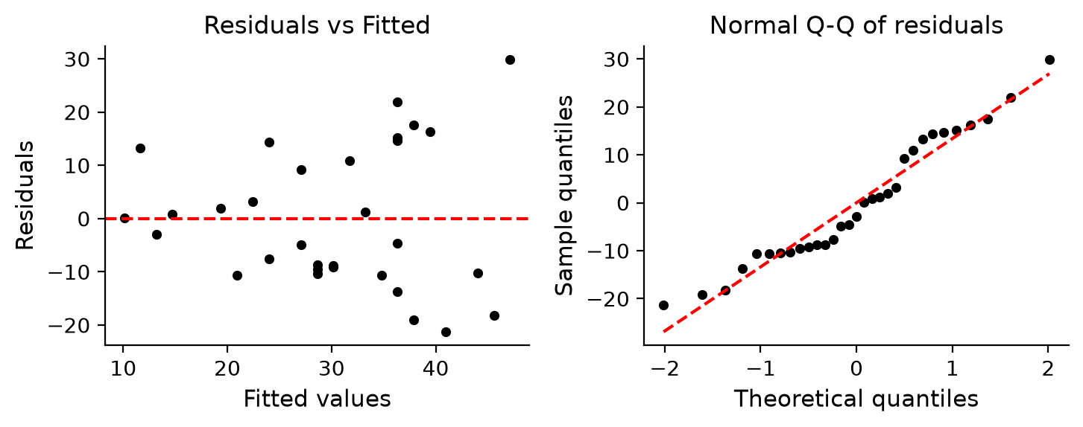
Figure: Residual plots for Volume ~ Height
model <- lm(Volume ~ Height, data = trees); summary(model)
par(mfrow = c(1, 2)); plot(model, which = 1:2)
Remember: Check p (is it significant?), R² (how much explained?), residuals (are assumptions OK?).

Q48. Following is the output of regression model applied for 'airquality' dataset where Ozone is dependent variable and Temp and Wind are independent variables. Write syntax for this regression model and also write the inferences from the given summary
5 Marks • Difficult • CO4
model <- lm(Ozone ~ Temp + Wind, data = airquality)
summary(model)
par(mfrow = c(2, 2)); plot(model) # model evaluation plots
Fitted multiple regression equation: Ozone = −71.03 + 1.840 × Temp − 3.056 × Wind
Inferences:
1. Temp (1.84, p = 3.15e-11, ***): holding wind constant, each 1 °F rise in temperature raises ozone by about 1.84 ppb – highly significant.
2. Wind (−3.06, p = 1.08e-05, ***): holding temperature constant, each 1 mph increase in wind lowers ozone by about 3.06 ppb – highly significant.
3. Intercept (−71.03, p = 0.0032, **) – only a mathematical constant (Temp = 0 °F is outside the data).
4. R² = 0.5687 → Temp and Wind together explain about 57 % of ozone variation; adjusted R² 0.5611 (penalised for 2 predictors).
5. F = 74.5, p < 2.2e-16 → the overall model is significant (at least one predictor matters).
6. RSE = 21.85 ppb on 113 df; 37 rows deleted due to missing Ozone, so 116 days were used.
7. Residuals: median −2.86, max 100.37 vs min −41.25 → right-skewed with some very high-ozone days under-predicted; a log(Ozone) model may fit better.
Prediction: Temp = 80 °F, Wind = 10 mph → −71.03 + 147.22 − 30.56 = ≈ 45.6 ppb.
Decision: hot, calm days carry the highest ozone risk – issue pollution alerts on such days.
Remember: In multiple regression each slope = effect "keeping the other variables fixed".

Q49. A regression model is applied on the dataset "mtcars" with mpg as dependent variable and disp as independent variable. Write the R syntax for the following output and any two inferences based on the output.
5 Marks • Difficult • CO4
model <- lm(mpg ~ disp, data = mtcars)
summary(model)
Given output: Intercept 29.599855 (p < 2e-16), disp −0.041215 (SE 0.004712, t = −8.747, p = 9.38e-10); RSE 3.251 on 30 df; R² 0.7183, Adj R² 0.709; F = 76.51, p = 9.38e-10. Residuals −4.89 to 7.23, median −0.96.
Fitted equation: mpg = 29.60 − 0.0412 × disp
Inferences:
1. Negative relationship: slope −0.0412 → every 1 cubic-inch increase in displacement lowers mileage by 0.041 mpg, i.e. about 4.1 mpg per 100 cu in. Bigger engines use more fuel.
2. Significant: p = 9.38 × 10⁻¹⁰ < 0.05 → reject H0 (β1 = 0); displacement is a significant predictor.
3. Model accuracy: R² = 0.7183 → 71.8 % of the variation in mpg is explained by disp; RSE 3.25 mpg is the typical prediction error.
4. Residuals: median −0.96, max 7.23 > |min| 4.89 → slightly right-skewed; some economy cars are under-predicted.
Prediction: disp = 200 → 29.60 − 8.24 = 21.36 mpg.
Figure: Fitted line for mpg ~ disp
Remember: Slope sign = direction; R² = goodness of fit.

Q50. A regression model is applied to the dataset diamonds in R, with price as the dependent variable and carat as the independent variable. 1. Write the R syntax to fit the regression model. 2. Write any two inferences based on the regression output.
5 Marks • Difficult • CO4
library(ggplot2) # diamonds data
model <- lm(price ~ carat, data = diamonds)
summary(model)
ggplot(diamonds, aes(carat, price)) + geom_point(alpha = 0.1) +
geom_smooth(method = "lm", color = "red")
Output (key values): Intercept ≈ −2256.36, carat ≈ 7756.43, both p < 2e-16; R² ≈ 0.849 (53,940 diamonds).
Fitted equation: price = −2256.36 + 7756.43 × carat
Inferences:
1. Positive relationship: each extra 1 carat increases the predicted price by about $7,756; heavier diamonds are much more expensive. The p-value < 2e-16 shows carat is highly significant.
2. R² ≈ 0.849 → about 84.9 % of the variation in diamond price is explained by carat alone – a strong model.
3. Prediction: 1 carat → −2256.36 + 7756.43 = ≈ $5,500.
4. Limitation: the negative intercept gives impossible negative prices for very small stones (below ≈ 0.29 carat), and the real relation is curved with increasing spread, so lm(log(price) ~ log(carat)) fits better; cut, colour and clarity can be added as predictors (multiple regression).
Remember: Big R² does not guarantee the right shape – always look at the plot.

Quick Revision – Unit IV
Term | Key fact
Sampling | Study a part to infer about the whole; probability (random) vs non-probability
Mean / Median / Mode | Symmetric → mean; skewed → median; categorical → mode
Standard deviation | s = √[Σ(x − x̄)² ÷ (n − 1)]; sd(x); same unit as data
Coefficient of variation | CV = SD ÷ Mean × 100; unit-free; compare groups with different means
Skewness | 0 symmetric; > 0 right tail (mean > median); moments::skewness()
Kurtosis | moments: 3 normal, > 3 leptokurtic, < 3 platykurtic; excess = kurtosis − 3
Correlation r | −1 to +1; cor(x, y, use = "complete.obs"); not causation
corrplot | corrplot(cor(df), method = "number") – blue +, red −
dnorm / pnorm / qnorm | Height / left area / cut-off value of normal curve
Simple regression | ŷ = b0 + b1x; b1 = Σ(x−x̄)(y−ȳ) ÷ Σ(x−x̄)²; b0 = ȳ − b1x̄; lm(y ~ x)
Multiple regression | lm(y ~ x1 + x2); each slope with others held fixed
p-value | < 0.05 → reject H0 (β = 0) → predictor is significant
R² | Share of variation in y explained by the model (0 to 1)
Residual | y − ŷ; should centre on 0, be symmetric, constant spread
Model evaluation plots | plot(model): residuals vs fitted, normal Q-Q

